# Estimates and drivers of protected species bycatch in the California set gillnet fishery

Yutian Fang1, James V. Carretta2, Christopher M. Free3,1

1 Bren School of Environmental Science and Management, University of California, Santa Barbara, Santa Barbara, CA, 93106, USA

2 Southwest Fisheries Science Center, National Marine Fisheries Service, La Jolla, CA, USA

3 Marine Science Institute, University of California, Santa Barbara, Santa Barbara, CA, 93106, USA

**\* Corresponding author:** Bren School of Environmental Science and Management, University of California, Santa Barbara, 2400 Bren Hall, Santa Barbara, CA 93106-5131; yutianfang@umail.ucsb.edu

## Abstract (246 of 250 words)

The identification of efficient management strategies that reduce protected species bycatch while also minimizing impacts on fishing livelihoods is a global conservation challenge. Identifying such strategies requires understanding levels of bycatch relative to management targets as well as the relationship between bycatch risk and potential management levers. In this study, we use ratio estimators to reconstruct bycatch of selected marine mammal and seabird species in the California ≥3.5” set gillnet fishery from 1981-2022 and random forest models to identify drivers and hotspots of bycatch risk. We find that bycatch has dropped precipitously since the 1980s as a result of management, but at significant costs to fisheries participation and revenues. Recent marine mammal bycatch ranges from 0.4% to 6.6% of the potential biological removal and marine mammal populations are recovering. Spatial-temporal drivers of bycatch risk were more important than fishing-related drivers of risk, suggesting that spatial-temporal closures would be more effective than mesh size or soak time restrictions at further limiting bycatch. For each species, we identified 2-5 hotspots of elevated bycatch risk as candidates for temporary seasonal closures. Bycatch risk for harbor seal (*Phoca vitulina*) and California sea lion (*Zalophus californianus*), the species facing the largest bycatch concerns, is especially high from April 1st to June 15th, suggesting that hotspot closures during this 2.5-month time period could be especially efficient. Our study also highlights the value of competing multiple modeling approaches to identify methods that best predict rare bycatch events.

**Keywords:** gillnet, bycatch, marine mammals, seabirds, area-based management

**Target journal:** [*Biological Conservation*](https://www.sciencedirect.com/journal/biological-conservation/publish/guide-for-authors)

**Important documents:** [Google Drive](https://drive.google.com/drive/folders/1ke-s8LYngA7RN1SplcQT07w545rHBtrC) | [presentation](https://docs.google.com/presentation/d/1e7mLwu0No2GovHhq2dluq6dmyE9HVtBUuO3I4Ya2gZI/edit) | [old text document](https://docs.google.com/document/d/1LglHsT6oqOF3ZQqmUr5WOZbOO9Rk0AI4CoUflPxr2z4/edit) | [cover letter](https://docs.google.com/document/d/1jWSM0Pht2OQqM1-joZLH-gifTIhEio20NmXUmYMVT4U/edit)

## Highlights

* We evaluate protected species bycatch in the California ≥3.5 inch set gillnet fishery
* Bycatch has declined precipitously due to management and reduced fishing effort
* Recent marine mammal bycatch ranges from 0.4-6.6% of the potential biological removal for ## marine mammal species/stocks
* Targeted time-area closures reduce bycatch better than mesh size or soak time limits
* Competing multiple modeling approaches improves predictions of rare bycatch events

## 1. Introduction

Bycatch, the accidental capture of non-target species in fisheries, presents a significant conservation and economic challenge [(Crowder and Murawski, 1998; Soykan et al., 2008)](https://www.zotero.org/google-docs/?mucY73). Bycatch of large-bodied, slow-growing, low-productivity species such as marine mammals, sea turtles, and seabirds [(Crowder and Murawski, 1998; Read et al., 2006; Soykan et al., 2008)](https://www.zotero.org/google-docs/?rBymbe) is of particularly high concern, as the mortality of individuals in these vulnerable populations, often recovering from historical exploitation, can threaten population collapse and even extinction [(Geijer and Read, 2013; Read et al., 2006)](https://www.zotero.org/google-docs/?7B1Y1r). As a result, many countries have established strict mandates to limit bycatch of vulnerable species, which can result in fisheries closures and other severe restrictions [(Crowder and Murawski, 1998; Senko et al., 2014)](https://www.zotero.org/google-docs/?JhhIUf). These management disruptions can have serious social, cultural, and economic impacts on fishing communities [(Smith et al., 2020)](https://www.zotero.org/google-docs/?NeXHnd). Due to the negative ecological, economic, and social impacts of fishery bycatch, bycatch avoidance is an important objective for global fishery management. A sustainably managed fishery with low bycatch can not only provide ecological benefits, but also social and economic benefits by providing a sustainable source of income, food, and nutrition.

To guide effective bycatch reduction policies, it is important to understand the magnitude of historical and recent bycatch as well as the drivers of bycatch in a fishery. Estimates of total bycatch are needed to determine whether bycatch exceeds management targets or is on pace to exceed targets in the near future [(Bjørge et al., 2013; Geijer and Read, 2013; Read et al., 2006)](https://www.zotero.org/google-docs/?gk8T53). Historical bycatch estimates also offer insights into the effectiveness of past management interventions, which provide useful benchmarks for adapting management in response to contemporary bycatch levels and trends. Understanding the drivers of bycatch risk is critical to guiding effective and efficient management adaptations. For example, determining whether bycatch is concentrated within specific areas or seasons can support the design of time-area closures that prevent fishing when and where risk is high while maintaining fishing opportunities elsewhere [(Lewison et al., 2014; O’Keefe et al., 2023; Soykan et al., 2008)](https://www.zotero.org/google-docs/?Num2ou). Similarly, gear restrictions, soak time restrictions, or time of day restrictions can be used to curb bycatch if there are strong relationships between bycatch risk and gear or other characteristics of fishing [(O’Keefe et al., 2023)](https://www.zotero.org/google-docs/?wC9LEE). Without this information, bycatch management must be precautionary to guarantee compliance with protected species legislation, which could forego considerable fisheries yields.

Because observer programs, which place trained scientists on fishing vessels to collect bycatch data, are costly and rarely cover all fishing trips, various analytical approaches have been developed to estimate unobserved bycatch and to evaluate drivers of bycatch. Ratio estimation, which assumes that the rate of bycatch in observed fishing trips is proportional to the rate for all fishing trips, is one of the most common strategies [(Cochran, 1977; Stock et al., 2019)](https://www.zotero.org/google-docs/?7eV4E3). The reliability of this simple approach increases if there are sufficient data to support estimates within meaningful spatial or temporal strata (e.g., regions, depth zones, seasons). However, ratio estimation can produce biased estimates if other factors (e.g., gear type, soak time, time of day) influence bycatch rates [(ICES, 2007)](https://www.zotero.org/google-docs/?RwYpTu), if the observed trips are not representative of the unobserved trips, or if low sample sizes lead to spuriously low or high bycatch rates within a stratum [(Martin et al., 2015; McCracken, 2004; Ortiz and Arocha, 2004; Rochet and Trenkel, 2005)](https://www.zotero.org/google-docs/?qUM3Af). Model-based approaches, which use statistical models to estimate bycatch, can overcome these limitations by incorporating a wider suite of covariates and are thought to produce better bycatch estimates [(Stock et al., 2019)](https://www.zotero.org/google-docs/?mROE9h). Additionally, these approaches can support management by identifying drivers of bycatch risk and by predicting detailed hotspots of risk [(Long et al., 2024; Lopez et al., 2024; Stock et al., 2019)](https://www.zotero.org/google-docs/?vGYjam).

The California set gillnet fishery presents an urgent need for bycatch estimation. The fishery occurs in southern California and targets California halibut (*Paralichthys californicus*), white seabass (*Atractoscion nobilis*), and Pacific angel shark (*Squatina californica*), among other species. It is currently listed as a Category II fishery under the U.S. Marine Mammal Protection Act (MMPA), indicating that it presents a medium bycatch threat to protected marine species [(NOAA, 2024)](https://www.zotero.org/google-docs/?QgrAhW). The bycatch of pinnipeds and small cetaceans, such as California sea lion (*Zalophus californianus*), harbor seal (*Phoca vitulina*), northern elephant seal (*Mirounga angustirostris*), and harbor porpoise (*Phocoena phocoena*), and seabird species such as common murre (*Uria aalge*) and Brandt’s cormorant (*Phalacrocorax penicillatus*) was high throughout the 1980s and 1990s, which spurred significant management interventions [(Forney et al., 2001; Julian and Beeson, 1998)](https://www.zotero.org/google-docs/?vUQ4T8). Bycatch in the fishery has not been assessed since 2012 [(Carretta et al., 2014)](https://www.zotero.org/google-docs/?6XsBnx) and there are concerns that bycatch may remain an issue [(Birch et al., 2023; Birch and Shester, 2023)](https://www.zotero.org/google-docs/?tDiQ0N).

A number of management actions have been taken to reduce bycatch in the California set gillnet fishery. During the 1980s, high bycatch of harbor porpoise, southern sea otters, and common murres in central California [(Barlow et al., 1994)](https://www.zotero.org/google-docs/?qLCUVM) led to a depth restriction that closed fishing inside of 40 fathoms (73 m) in 1987 [(Forney et al., 2001)](https://www.zotero.org/google-docs/?3HQq2u). This restriction shut down the fishery in the San Francisco area, effectively pushing it south of Pigeon Point and into Monterey Bay and Morro Bay (**Fig. 1A-2**). In 1990, the state adopted Proposition 132 [(CA Secretary of State, 1990)](https://www.zotero.org/google-docs/?maB2ht), which went into effect in 1994 and banned the fishery in mainland state waters (0-3 nautical miles) off southern California and in waters within 1 nautical mile or 70 fathoms of depth, whichever is less restrictive, around the Channel Islands to further reduce bycatch of protected marine species (FGC §8610.1-8610.16). In 2002, the state prohibited fishing inshore of 60 fathoms (110 m) from Pt Arguello to Pt. Reyes to reduce bycatch of sea otters, harbor porpoises, and other marine wildlife Central California (14 CCR §104.1). This pushed the fishery out of Monterey Bay and Morro Bay and down into Southern California (**Fig. 1A-4**). Currently, the fishery only operates in Southern California (south of Point Arguello) outside 3 nautical miles from the mainland and outside 1 nautical miles or shallower than 70 fathoms (whichever is less) from the Channel Islands.

Although these regulations have reduced bycatch in the fishery, they have greatly also reduced participation in the set gillnet fishery. The implementation of the 40-fathom depth restriction in 1987 triggered a precipitous decline in participation from ~400 vessels in 1987 to ~100 vessels in 1994. Since then, participation has further declined, with only ~40 vessels active in 2022, and the vast majority (>90%) of landings coming from just 13 vessels that year [(CDFW, 2023)](https://www.zotero.org/google-docs/?tx18DN) (**Fig. 1B**). Fishing effort has similarly decreased from an estimated ~15,000 days of fishing in 1987 to 1,000 days of fishing in 2022 (**Fig. 1C**). This reduction in effort has significantly reduced bycatch levels [(Carretta et al., 2014)](https://www.zotero.org/google-docs/?20Y0Fw) but at large costs to fishery revenues. Fleetwide revenues decreased from US$15 million in 1987 to only US$1 million in 2022 (**Fig. 1C**; both values in 2022 dollars). Despite declining fishing effort and bycatch, there are calls to place additional restrictions on the fishery to further avoid bycatch [(Birch et al., 2023; Birch and Shester, 2023)](https://www.zotero.org/google-docs/?qwosnV). Thus, there is a need to provide scientific guidance on management regulations that are likely to provide conservation benefits, while also avoiding unnecessary burdens on the fishing industry. This is especially important if new fishers attain inactive permits to broaden their fishing portfolios.

In this study, we reconstruct the bycatch of select marine mammals and seabirds in the California set gillnet fishery from 1981-2022 and identify drivers of bycatch that could be used to design management measures that effectively and efficiently reduce bycatch. We focus on six protected species commonly entangled in set gillnets: California sea lion, harbor seal, northern elephant seal, harbor porpoise, common murre, and Brandt’s cormorant. We use ratio estimation methods to reconstruct historical bycatch levels. These methods, which have been used to estimate bycatch in the fishery at various points in the past, provide a complete time series of bycatch estimates using methods approved for stock assessment and management. We then use random forest models to evaluate drivers of bycatch risk and to make predictions of spatial bycatch risk for four species of concern; Brandt’s cormorant and harbor porpoise were excluded due to poor model performance (**Table 2**). Based on these results, we make recommendations for how management could effectively manage bycatch risk through measures such as seasonal or spatial closures, depth restrictions, or gear restrictions.

## 2. Methods

### 2.1 The fishery

We defined the fishery using the definition in the MMPA List of Fisheries [(NOAA, 2023)](https://www.zotero.org/google-docs/?YYwbz5): the ≥3.5 inch mesh set gillnet fishery targeting California halibut, white seabass, Pacific angel shark, and other species. Although this definition deviates from historical studies, which frequently focused on the portion of the fishery using mesh sizes larger than 8.0 or 8.5 inches (**Table 1**), the MMPA definition provides the legal basis for bycatch management and is more consistent with historical regulations. Specifically, a minimum mesh size of 3.5 inches was set for white seabass in 1941, though it was increased to 6.0 inches in 1988 (FGC §8623(d)). Since 1989, California halibut and Pacific angel shark have been targeted using a minimum mesh size of 8.5 inches (FGC §8625(a)). The set gillnet fishery principally excluded by this definition is that for Pacific herring (*Clupea pallasii*), which used to occur in California using mesh sizes of 2.0 to 2.5 inches, though a directed fishery for herring has been banned since 2010 [(CDFW, 2019)](https://www.zotero.org/google-docs/?g4AkU9).

### 2.2 Data

#### 2.2.1 Observer data

We received observer data from 1983 to 2017 from the California Department of Fish and Wildlife (CDFW) and NOAA?. There was observer coverage in the California set gillnet fishery from 1983-1989 (San Francisco area and Monterey Bay only), 1990-1994 (coastwide), 1999-2000 (Monterey Bay area only), 2010-2013, and in 2017 (**Fig. 2**). The observer program was run by CDFW from 1983-1989 and by the National Oceanic and Atmospheric Administration (NOAA) from 1990 onwards. Observers collected information on the amount and fate of catch (kept, discarded, or damaged), the length composition of the catch, the location and time of the catch, and characteristics of the gear used to target the catch (**Fig. S2**). In the state observer data, we defined individual gillnet sets based on the date of fishing, the vessel, and the set number and built a unique identifier to link set-level information across state datasets (i.e., YYYY-MM-DD-VesselD-Set#). In the federal observer data, we defined individual gillnet sets based on the observer trip number and the set number and built a unique identifier to link set-level information across federal datasets (i.e., TripID-Set#).

Although historical reports document low levels of observer coverage in Morro Bay, Monterey Bay, and San Francisco in the 1980s (**Table 1**), the data that we received from CDFW excluded most of these observations. We digitized a small portion of the missing raw data – observations from Monterey Bay from 1987-1989 – from original CDFW data sheets that were given to a colleague at the Southwest Fisheries Science Center during the late 1990s for a reanalysis of historic bycatch rates in that region (Forney et al. 2001) (**Fig. 2**). We extracted summaries of bycatch rates from historical reportsfor years and regions missing raw data to support the ratio estimation analysis. **Figure 2C** illustrates the coverage of the available, recovered, and lost observer data.

We developed a series of simple assumptions to impute missing values for a few key variables (GPS coordinates, fishing depth, soak hour, mesh size) reported in the observer data (**Fig. S3A**). We assigned missing GPS coordinates using the centroid of the statistical block most frequently visited by the vessel – in order of preference – that week, month, or year based on the logbook data (described below). We derived missing fishing depths by extracting depths from 25-meter resolution bathymetry data [(CDFW, 2002)](https://www.zotero.org/google-docs/?USPCqs) (**Fig. S3B**). We reassigned missing soak hours the mode value for a vessel and target species (**Fig S3C**). We reassigned missing mesh sizes the mode for – in order of preference – the vessel and target species, the target species, or all vessels (**Fig. S3DE**). We assigned each GPS coordinate to the nearest statistical reporting block (see **Fig. 1A**), which allows points erroneously falling on land to be assigned a likely statistical block. We derived the distance from shore, a covariate used to explain bycatch rates in the random forest model, as the distance of each set to the nearest point on shore.

For each species of marine mammal, seabird, and sea turtle observed in the observer data, we calculated the total number of entanglements observed in the California set gillnet fishery (**Fig. 2**). Throughout this analysis, we focus on the six species with more than 50 observed entanglements: Common murre (2,381), California sea lion (1,372), harbor seal (519), Brandt’s cormorant (118), Northern elephant seal (78), and harbor porpoise (97).

#### 2.2.2 Logbook data

We received logbook data from the commercial gillnet fishery from 1981 to 2022 from CDFW (**Fig. 1**). These data describe vessel information (vessel name, unique identifier, permit number); when (date), where (block id), and how long (hours) a vessel fished; what fish it targeted; what type of gear it used (drift or set gillnet) and characteristics of this gear (length, mesh size, fishing depth; **Fig. S2**); what species it caught; and the amount (number and/or weight) and fate of this catch (kept, released, or lost, including the identity of predators preying on released fish). We attempted to identify individual fishing sets as the unique combination of vessel administration information (vessel name, either vessel id or boat number, permit number), where, when, and how long a vessel fished (block id, date, and fishing hours), and characteristics of the gear (net length, mesh size, and fishing depth). This analysis revealed an average of 1 set per trip, which is inconsistent with the 3 sets per trip documented in the more accurate observer data. We term these unique identifiers “pseudo-sets” and view them as roughly equivalent to a fishing trip (**Fig. S4**). We derived the distance from shore, a covariate used to explain bycatch rates in the random forest model, as the distance from the block centroid to the nearest point on shore given that exact locations are not reported.

We developed a series of simple assumptions to impute missing or unrealistic values for a few key variables (fishing depth, soak hour, mesh size) reported in the logbook data (**Fig. S5A**). We reassigned both missing (including 0 values) and unrealistic fishing depths, which we defined as depths exceeding the maximum depth in the reported fishing block, the median depth of the fishing block (**Fig. S5B**). We computed the median and maximum depths of each fishing block using 25-meter resolution bathymetry data [(CDFW, 2002)](https://www.zotero.org/google-docs/?VihIH0). We reassigned missing soak hours (including 0 values) the mode value for a vessel. We capped unrealistic soak times exceeding 96 hours (4 days) at 96 hours (**Fig. S5C**). We reassigned missing (including 0 values) and unrealistic mesh sizes, which we defined as mesh sizes exceeding 20 inches, using a hierarchical procedure (**Fig. S5DE**). For logbooks with both vessel identification and target species information, we assigned the mesh size most commonly used by the vessel when targeting that target species. For logbooks with only target species information (no vessel identification), we assigned the mesh size most commonly used when targeting that target species across all vessels (**Figs. S5 & S6**).

#### 2.2.3 Sea surface temperature

Because sea surface temperature (SST) is a common driver of the distributions of both target and bycatch species [(Hazen et al., 2018)](https://www.zotero.org/google-docs/?VvopFv), we used SST as an environmental covariate in the random forest models described below. We derived the SST associated with each set documented in the observer and logbook data using the NOAA 1/4° Daily Optimum Interpolation Sea Surface Temperature (OISST) dataset, which interpolates observations from different monitoring platforms (e.g., satellites, ships, buoys, and Argo floats) to provide a globally complete grid of SST from September 1, 1981 to present [(Huang et al., 2021)](https://www.zotero.org/google-docs/?HB1pCU). For sets reported in the observer data, we extracted the SST at the reported GPS location on the reported day of fishing. For sets reported in logbooks, we calculated the average SST in the reported block on the reported day of fishing.

### 2.3 Ratio estimation

We estimated annual bycatch for each study species using ratio estimators. Ratio estimators assume that the rate of bycatch in observed fishing trips is proportional to the rate of bycatch within all fishing trips within a given stratum [(Cochran, 1977)](https://www.zotero.org/google-docs/?ykFoIe). This assumption requires that the characteristics of observed trips do not systematically differ from the characteristics of all trips, which was confirmed by a two-sided Kolmogorov-Smirnov test (**Fig. S7)**. We used trips rather than sets as the sampling unit given the inability to identify unique sets in the logbooks data (**Fig. S4**). Under this approach, the bycatch rate for species *s* in stratum *i* (*rs,i*) is thus calculated as:

$r_{s,i}=\frac{k_{s,i}}{d_{s,i}}$

Where *ks,i* is the total number of individuals of species *s* entangled in observed trips occurring in strata *i* and *ds,i* is the total number of observed trips occurring in strata *i*. The total estimate of bycatch of species *s* in strata *i* (*ms,i*) is then calculated by multiplying the bycatch rate (*rs,i*) by the total number of trips to have occurred in the strata (*Di*):

Where the total number of trips (*Di*) is derived from the logbook data.

We estimated the variance in both processes through a two-step process. First, we estimated the variance of the bycatch rate ($σ_{r,s,i}^{2}$) through a bootstrap procedure. We sampled observed trips with replacement to match the total number of trips occurring in the strata (*Di*) and derived the bycatch rate for this randomly generated sample. We repeated this procedure 1,000 times and calculated the variance of the bycatch rate as the bootstrap sample variance. Second, we calculated the variance of the total bycatch estimate ($σ_{m,s,i}^{2}$) as:

$σ_{m,s,i}^{2}=D_{i}*σ_{r,s,i}^{2}$

Total bycatch estimates and their variances are summed across strata to generate annual estimates of bycatch across strata.

We calculated annual bycatch estimates using a seven-region stratification scheme (**Figs. 1A, S8**). This stratification scheme combines the scheme by Diamond and Hanan (1986) and Julian (1993) for areas north and south of Point Conception, respectively. Although early efforts to estimate bycatch in the California set gillnet fishery often stratified estimates by region and season (**Table 1**), later efforts found that observer coverage was often too limited to employ complex temporal stratification and that estimates between temporally stratified and unstratified approaches were generally similar (**Table 1**). Stratum-specific bycatch rates for years without observer coverage in the stratum are borrowed from the closest year (forwards or backwards) with observer coverage in the stratum (**Fig. 2C & S9)**. We collated annual bycatch estimates from past studies (**Table 1**) for comparison with our updated estimates (**Figs. S10-S12**).

### 2.4 Random forest modeling

#### 2.4.1 Model training

We used random forest classification models trained on the observer data to identify drivers of bycatch risk for each of the six study species. We considered eight attributes of fishing as potential drivers of bycatch risk: haul depth (fathoms), mesh size (inches), soak time (hours), latitude (°N), distance from shore (km), Julian day, sea surface temperature (°C), and whether the fishing occurs near an island (i.e, within 10 km of island coast). For each species, we classified an observed set as having (1) or not having (0) bycatch, and trained a classification model assuming a Bernoulli distribution in the response variable.

Because bycatch of protected species is rare, observed fishing sets show strong class imbalance towards sets without bycatch compared to sets with bycatch. To illustrate, the percent of observed sets with bycatch is as follows: California sea lion (1.02%), common murre (0.43%), harbor seal (0.43%), Brandt’s cormorant (0.09%), northern elephant seal (0.076%), and harbor porpoise (0.074%). Therefore, without a proper sample balancing method, predictions are likely to be biased towards the majority class (sets without bycatch), leading to an underestimation of bycatch risk. For this reason, we considered four approaches for accounting for class imbalance resulting from bycatch rarity.

The first three approaches employ different sample balancing methods: (1) downsampling, (2) upsampling, and (3) synthetic minority over-sampling (SMOTE), which uses a mixture of down and upsampling. The downsampling approach randomly removes observations of the majority group (sets without bycatch) to obtain equal representation of the majority and minority (sets with bycatch) group. The upsampling approach randomly samples observations from the minority group with replacement to obtain equal representation with the majority group. The synthetic minority over-sampling (SMOTE) approach both up-samples the minority group and down-samples the majority group. It up-samples the minority class by synthesizing new cases from its nearest five neighbors and down-samples the majority class by randomly drawing samples from that group. We created each balanced dataset using the *themis* package in R [(Hvitfeldt, 2023)](https://www.zotero.org/google-docs/?uTJoI9) and fit random forest models to these datasets using the *randomForests* package in R [(Liaw and Wiener, 2002)](https://www.zotero.org/google-docs/?Nmq9ma).

The fourth approach employs weighted random forests, which use observation weighting rather than sample balancing to elevate the importance of the minority class. In this “cost-sensitive” learning approach [(More and Rana, 2017)](https://www.zotero.org/google-docs/?qjAhtw), higher weights are assigned to minority observations so that the model receives a higher penalty for misclassifying these observations, helping to reduce bias towards the majority class. We evaluated multiple weighting schemes to optimize the predictive skill of this approach. Specifically, we assigned majority observations (sets without bycatch) a weight of 1 and assigned minority observations (sets with bycatch) weights of 25 to 200 in increments of 25. Thus, a total of 8 candidate weighted random forest models were evaluated as described below. We fit the weighted random forest model using the *ranger* package in R [(Wright and Ziegler, 2017)](https://www.zotero.org/google-docs/?Iv8IxA).

We trained each of the eleven candidate models (three balanced random forest models, eight weighted random forest models) on 80% of the observer data, withholding the remaining 20% for model testing. In training the models, we performed a grid search to identify the “mtry” hyperparameter – the number of variables to randomly sample as candidates at each node split – that maximizes Cohen’s kappa under 10-fold cross validation (**Fig. S13**). While accuracy measures the proportion of correctly classified categorizations, Cohen’s kappa measures the proportion of correct classifications while accounting for the probability of being correct by chance and is a better measure of predictive skill, especially for imbalanced datasets [(Cohen, 1968)](https://www.zotero.org/google-docs/?8QfMHK). Although there are no definitive rules for interpreting Cohen’s kappa, general guidelines suggest that values above 0.7 are ‘excellent’, 0.4-0.7 are ‘good’, 0.2-0.4 are ‘fair’, and below 0.2 are ‘poor’ [(Fleiss et al., 2013; Landis and Koch, 1977)](https://www.zotero.org/google-docs/?7WxjYO). We identified the best fitting model as the model generating the highest Cohen’s kappa on the training data. We applied this model to the test dataset for an independent evaluation of its predictive power. We only evaluated four species (California sea lion, common murre, harbor seal and northern elephant seal) whose best models exhibited “fair” or better performance in their training dataset and close to “fair” performance on the test dataset for the rest of the analysis (**Table 2**).

#### 2.4.2 Model evaluation and prediction

We evaluated the drivers of bycatch risk for each species by inspecting the variable importance and the marginal effects of each variable as estimated in the best fitting model. Variable importance was evaluated as the total decrease in node impurities from splitting on the variable averaged over all trees. The impurity measure is corrected when building the model to reduce its bias towards continuous variables [(Nembrini et al., 2018)](https://www.zotero.org/google-docs/?IUr3vj). Marginal effects measure the impact of the changes in one variable on the response variable while all other variables are held constant. The marginal effects plots provide the scientific basis for our discussions of management regulations that could effectively and efficiently reduce bycatch risk.

We used the best fitting model to generate annual estimates of protected species bycatch from 1981 to 2022 by predicting whether “pseudo-sets” recorded in logbooks were likely to have entangled each study species. We used the best fitting model for each species to estimate the probability that a logged pseudo-set included bycatch of a species then categorized the pseudo-set as with or without bycatch using a species-specific probability threshold. We derived the species-specific probability thresholds as the threshold that maximizes Cohen’s kappa when applied to the training datasets (**Fig. S14**). We selected the probability threshold based on Cohen’s kappa rather than the area under the receiver operator curve (AUC) because (1) model’s were tuned and select based on Cohen’s kappa and (2) simulation work shows that deriving thresholds based on AUC tends to overestimates the prevalence of rare events while it underestimates the prevalence of common events [(Freeman and Moisen, 2008; Manel et al., 2001)](https://www.zotero.org/google-docs/?3Z5zWK). We summed the number of pseudo-sets predicted to have bycatch each year, converted this sum to “true sets” assuming three sets per pseudo-set (**Fig. S4AB**), and multiplied this sum by the median number of entanglements when an entanglement occurs to generate estimates of the total number of entangled animals (**Fig. S4C**). We opted not to employ a more complex two-stage or hurdle model approach, where a second model estimates the number of entangled individuals when bycatch occurs, given the rarity of bycatch events larger than one for all species but common murre (**Fig. S4C**).

To generate maps of spatial bycatch risk, we used the best fitting model to predict risk to a 0.02° grid spanning southern California (32-35°N and 117-121°W). Conceptually, our metric of spatial bycatch risk represents the probability of bycatch at a given location under recent average conditions. We derived this metric by first predicting the probability of bycatch on every calendar day (Julian day 1 to 365) for each grid cell. The seven input variables for making these predictions were derived as follows: (1) *latitude*, (2) *distance from shore*, and (3) *depth* were derived based on the centroid of the grid cell; (4) *soak time* was set to 24 hours, the logbook mode; (5) *mesh size* was set to 8.5 inches, the logbook mode; (6) *Julian day* was the input day; and (7) *sea surface temperature* (SST) was the average SST for that day and grid cell from 2010-2022. We then calculated the weighted average of the daily risk weighting by the amount of logbook entries (a metric of fishing effort) occurring on that Julian day from 2010-2022. We cropped the predictions to areas within 20 km of shore as this is the farthest offshore that the fishery has operated (**Fig. S7**).

## 3. Results

### 3.1 Ratio estimation

In general, estimated bycatch peaked in the mid-1980s, steadily declined following the 40-fathom depth restriction implemented in 1987, with a temporary increase in the late-1990s followed by continued decline (**Fig. 3**). This pattern reflects trends in fishing effort, which also declined after a peak in 1985, with a brief expansion in the late-1990s followed by continued decline (**Fig. 1C**). Estimated bycatch of Brandt’s cormorant follows a similar pattern but lags behind the patterns for other species: estimated bycatch precipitously declines after a peak in 1989 with a temporary increase occurring in the early-2000s (**Fig. 3**). This pattern is driven by a steep increase in Brandt’s cormorant bycatch rates in the Channel Islands region in 1990 that is assumed to have persisted to today (**Fig. S9**). None of the other species experienced such a pronounced and impactful change in bycatch rates (**Fig. S9**). Estimated bycatch of harbor porpoise and common murre declined especially sharply following the 2002 exclusion of fishing from waters shallower than 60 fathoms. This regulation pushed fishing out of Monterey Bay and Morro Bay and into Southern California waters (**Fig. 1A**), where harbor porpoise do not occur and where common murre occur only in low densities (**Fig. S15**).

The sustainability of estimated marine mammal bycatch can be weighed against the potential biological removal (PBR) for each stock, which is defined under the MMPA as the maximum number of animals, not including natural mortalities, that may be removed from a marine mammal stock while allowing that stock to reach or maintain its maximum sustainable population (**Fig. 7**). Based on this sustainability reference point, bycatch concerns, in order of decreasing threat, are as follows: harbor seal (108 individuals per year = 6.6% of a PBR of 1,641 individuals), California sea lion (329 individuals per year = 2.3% of a PBR of 14,011 individuals), harbor porpoise (1 individual per year = 1.5% of a PBR of 65 individuals for the Morro Bay stock, where the bycatch took place), and northern elephant seal (23 individuals per year = 0.4% of a PBR of 5,122 individuals) (**Figs. 3, 7**). The assessment that bycatch during the last 10 years poses the greatest risk to harbor seals is supported by the fact that the harbor seal stock size has been stable or declining in recent years while all of the other marine mammal populations have been undergoing sustained population growth (**Fig. 7**). The sustainability of estimated seabird bycatch is more difficult to evaluate given more limited population monitoring data (**Fig. 7**) and the lack of legally binding reference points for defining allowed incidental take. However, increasing Brandt’s cormorant nests from 1980 to 2020 (**Fig. 7**) and steeply reduced bycatch of common murre (**Fig. 3**) suggests low risks posed to these species.

Our estimates of annual bycatch are generally aligned with estimates from historical studies (**Fig. S11**). Slight differences between our estimates and those from historical studies are driven by a mixture of differences in our methods and input data. While we apply a consistent approach for defining the fishery, stratifying the data, and estimating bycatch, historical studies have employed variable fishery definitions, stratification schemes, and estimation methodologies (**Table 1**). First, we consistently defined the fishery as using ≥3.5” set gillnets, while historical studies have considered set gillnets ≥8”, ≥8.5”, or of unspecified sizes (**Table 1**). Furthermore, it is unclear whether historical studies filtered out fishing sets based on the reported target species and whether this decision was consistent. We do not define the fishery based on reported target species given extreme heterogeneity in how this information is reported. Differences in fishery definitions, as well as differences in data cleaning methods, likely lead to the slight differences in effort and observed bycatch attributed to the fishery (**Fig. S12**), which inevitably causes differences in bycatch estimates. Second, we used a consistent six-region stratification scheme, while historical studies used a mixture of stratification schemes ranging from no stratification to spatial stratification to spatial-temporal stratification (**Table 1**). This impacts the ratio estimators and the magnitudes of bycatch. Finally, we used vessel days (trips) as the sample unit, whereas historical studies oscillated between trips and sets as the preferred sample unit (**Table 1**). This is problematic not only because of the lack of consistency but also because sets cannot be uniquely identified in the logbook data.

### 3.2 Random forest modeling

#### 3.2.1 Model performance

The best fitting model performed well for four of the six study species: common murre, harbor seal, California sea lion, and northern elephant seal. All four species utilized weighted random forests but with different case weights (**Table 2; Fig. S13**). The models for two species, Brandt’s cormorant and harbor porpoise, were excluded from further consideration because of their poor performance (**Table 2**). Weighted random forest models performed best for California sea lion, common murre, northern elephant seal, and harbor seal with case weights of 25, 25, 25, and 75, respectively (**Table 2**). This highlights the importance of evaluating multiple modeling approaches when predicting rare bycatch events. Model performance was strongly correlated with the frequency of bycatch observations (**Table 2**). The best fitting models for common murre, more common bycatch species, exhibited Cohen’s kappa values greater than 0.4 indicating “good” performance while the best models for harbor seal, California sea lion and northern elephant seal, somewhat common bycatch species, exhibited values greater than 0.2 indicating “fair” performance. The best fitting models for Brandt’s cormorant and Harbor porpoise, rare bycatch species, exhibited values less than 0.2 in training and test dataset respectively, indicating “poor” performance, and were not evaluated any further. Cohen’s kappa values were correlated with the area under the receiver operator curve (AUC), indicating minimal tradeoffs in using this metric for model selection (**Table 2**).

#### 3.2.2 Drivers of bycatch risk

The importance of the evaluated explanatory variables in determining bycatch risk varied by species but some general patterns emerged **(Fig. 4**). In general, spatial (latitude, longitude, depth, and distance from shore) and temporal (Julian day) variables were more influential than variables associated with the environment (water temperature) or the fishing methodology (soak time, mesh size). Whether fishing occurred close to an island (a spatial variable) was the exception, as it was consistently the least important variable. Water temperature, which is closely related to space and time, was generally more important than soak time and always more important than mesh size. These results suggest that spatial-temporal management may have better ability to manage bycatch risk than gear modifications or soak time regulations, though shorter soak times could reduce mortality when bycatch occurs.

The species exhibit a mixture of correlated and non-correlated responses to the explanatory variables (**Fig. 5**). California sea lion and harbor seal exhibit similar responses in bycatch risk. Both species have higher bycatch risk in shallower depths in nearshore areas with a spike in risk occurring around 34°N latitude. They also exhibited a pronounced increase in risk during the spring, lasting approximately from Apr 1 (90th day of the year) to June 15 (166th day of the year). They are infrequently caught in nets with mesh sizes smaller than 8.5 inches, though the use of such nets is rare. Variability in bycatch risk for common murre and northern elephant seal is most strongly determined by latitude and longitude (**Fig. 5**), with the only area of elevated risk in contemporary fishing grounds occurring just north of Point Conception (**Fig. 6**). For all four species, bycatch risk exhibits an asymptotic relationship with soak time and a dome-shaped relationship with temperature; however, the shapes of these relationships differ by species.

#### 3.2.3 Maps of bycatch risk

California sea lion bycatch risk is predicted to be highest in four areas: (1) on the northern coasts of the northern Channel Islands, especially on the northern coast of Santa Rosa; (2) along a sliver of nearshore area north of Santa Barbara; (3) the eastern coast of Santa Cruz Island; and (4) the northwestern shores of Santa Catalina and San Clemente Islands; (**Fig. 6**). The high risk around the northern Channel Islands is likely related to the large haulouts of sea lions in that area (**Fig. S15**). The other nearshore mainland? areas fall along undeveloped portions of coastline with good haulout opportunities.

Harbor seal bycatch risk is predicted to be highest in four areas: (1) the sliver of nearshore area stretching from Santa Barbara to Point Sal; (2) the eastern coasts of Santa Cruz Island; (3) a broad coastal area near Point Mugu; and (4) the sliver of nearshore area stretching from Point Mugu to Point Vicente (**Fig. 6**). Most of these areas correspond to the locations of large harbor seal haulouts on Santa Cruz Island and near Point Mugu (**Fig. S15**).

Common murre bycatch risk is predicted to be negligible throughout most of southern California (**Fig. 6**). It is only predicted to be high in a small patch near Point Sal and even there, the maximum risk index is much lower than for the other evaluated species. This is consistent with the distribution of the species, which has no breeding colonies or permanent foraging grounds in southern California (**Fig. S15**). The absence of common murre in southern California largely explains the significant drop in common murre bycatch (**Fig. 3**) since the fishery was pushed out of central California (**Fig. 1**).

Like common murre, northern elephant seal bycatch risk is also predicted to be negligible throughout most of southern California except in the region near Point Sal (**Fig.6**). Although northern elephant seals breed on the Channel Islands (**Fig. S15**) from December to March, they disperse to their distant foraging grounds (males to Alaska and females to oceanic waters far West of California) before the fishing season peaks from April to June, significantly reducing their vulnerability to the gillnet fishery.

#### 3.2.4 Temporal trends in estimated bycatch

The random forest models estimate trends in bycatch that are similar to the estimates from the ratio estimator from 2000-2022 (**Fig. 3**). The agreement between these two different approaches underscores the result that bycatch has decreased to low levels as a result of management and reduced fishing effort. However, the estimates produced by the two approaches diverge from 1981-2000 by various extents. While they generally agree for California sea lion back to 1990, the random forest model underpredicts bycatch relative to the ratio estimator in the 1980s (**Fig. 3**), largely driven by underpredictions in Morro and Monterey Bays (**Fig. S16**). While the approaches generally agree for harbor seal back to 1995, the random forest model underpredicts bycatch relative to the ratio estimator before 1995, especially in the Channel Islands and Ventura strata (**Fig. S16**). Like harbor seal, the two approaches largely disagree for northern elephant seal bycatch amounts in the Southern California and Channel Islands strata (**Fig. S16)**. For common murre, the random forest model overpredicts bycatch relative to the ratio estimator in the mid- to late-1990s and underpredicts relative to the ratio estimator in earlier years, especially in Morro and Monterey Bays. These underpredictions likely occur because of the unequal impacts of lost data from the northern strata in the 1980s (**Fig. 2**). While the ratio estimation method leverages summarized observer data from old reports, meaning that it sees data from this time period, the lack of the raw observer data from this time period means that the random forest model does learn from this period. As a result, it is likely to underpredict risk in early years in northern strata because it has largely learned from late years in southern California, where risk has been lower. For this reason, we recommend the use of bycatch estimates from the ratio estimator over the random forest model until a time when the 1980s observer data is rediscovered.

## 4. Discussion

Our study provides the first update to estimates of protected species bycatch in the California set gillnet fishery since 2012 [(Carretta et al., 2014)](https://www.zotero.org/google-docs/?WRX0Cl). We find that bycatch, once high and unsustainable for some species [(Forney et al. , 2001, 2021)](https://www.zotero.org/google-docs/?aYxYb5), is now well below levels of allowed incidental take. Recent marine mammal bycatch estimates range from 0.4-6.6% of their potential biological removals and common murre bycatch has been effectively eliminated. All of the evaluated populations, including the once declining and heavily depleted Morro Bay harbor porpoise population, are growing or stable. These advances, while directly attributable to management interventions, are more due to reductions in fishing effort than to reductions in bycatch rates (i.e., bycatch per unit effort). This highlights a steep tradeoff between conservation and fisheries objectives under the current management regime: while populations of protected species have undergone sustained growth, fishing opportunities have undergone sustained declines. Furthermore, the resulted decline in local catch might motivate increased imports from countries where fisheries regulations are not as stringent as those in the U.S., potentially causing bycatch to be displaced elsewhere [(Lewison et al., 2019)](https://www.zotero.org/google-docs/?rHoK3D). Despite this, there have been calls for more bycatch-motivated restrictions to the fishery [(Birch et al., 2023; Birch and Shester, 2023)](https://www.zotero.org/google-docs/?gbV7F6). Our results provide a much-needed empirical basis for adjusting management strategies to more efficiently maximize fishing opportunities while continuing to keep protected species bycatch within legal limits.

Our results suggest that spatial-temporal management could more efficiently and effectively manage bycatch risk than gear modifications or soak time regulations. In particular, our findings that bycatch rates for California sea lions and harbor seals are greatest from April 1 – June 15 suggest that a 2.5 month seasonal closure of bycatch hotspots for these two species could reduce bycatch risk while maintaining fishing opportunities. However, we caution that hotspot closures can exacerbate bycatch problems if fishing effort is displaced and concentrated in areas of secondarily high risk [(Free et al., 2023)](https://www.zotero.org/google-docs/?pGOwYg); thus, monitoring of fishing effort and bycatch rates are important for verifying that seasonal closures achieve their conservation and fisheries objectives. Our results could also provide a basis for relaxing existing bycatch regulations, especially if loosened restrictions were paired with seasonal hotspot closures and continued protections for Morro and Monterey Bays, which are abundant in protected species and have had significant bycatch problems in the past [(Forney et al., 2021, 2001)](https://www.zotero.org/google-docs/?d3BnG2). For example, we find that bycatch risk increases inshore of 40 fathoms, but remains stable deeper than this inflection point (**Fig. 5**). This result supports the 40-fathom depth restriction implemented in 1987, but suggests that the deepening of this restriction to 60-fathoms in 2002 may have restricted fishing opportunities without significant conservation benefits. Given declining estimated bycatch, recovering populations of protected species, and diminishing fishing communities, loosening some fishing restrictions could expand fishing opportunities while continuing to protect vulnerable species, but any changes must take into account spatio-temporal patterns of bycatch and relative sensitivity of each species.

The completion and safekeeping of accurate fisheries-dependent data is fundamental to producing accurate bycatch assessments and effective management strategies. While summaries of historical data facilitated reliable bycatch estimates through ratio estimation, the loss of raw observer data from the 1980s may have impeded our ability to accurately estimate bycatch in the northern strata using random forests, an approach often thought to be more accurate than ratio estimation [(Stock et al., 2019)](https://www.zotero.org/google-docs/?JHjZqg). The rescue of this data would also empower improved assessments of the drivers of bycatch risk, which is essential to designing effective bycatch management. Notably, the lost data document a period when fishing was allowed in shallower, more inshore, and more northern waters (**Fig. 1A**) and provide vital information if management were to consider relaxing current depth and distance from shore restrictions. Furthermore, missing meta-data on critical gear characteristics (e.g., mesh size, net length, net height, net material; **Fig. S3**) in the available observer data also limited our ability to identify the potential for these management levers to reduce bycatch risk. Ensuring the complete documentation of gear characteristics, perhaps by prioritizing characteristics known to impact bycatch risk in other gillnet fisheries [(Northridge et al., 2017)](https://www.zotero.org/google-docs/?h0N1xu), is important to maximizing the utility of expensive, and sometimes controversial, observer programs [(Suuronen and Gilman, 2020)](https://www.zotero.org/google-docs/?HjG9Ft). Finally, the ability to delineate individual sets in the logbooks and improved documentation of the characteristics of logged sets would enhance future bycatch estimates by allowing sets to be the sampling unit and by avoiding assumptions about missing data, respectively. This could be achieved by redesigning logbooks, training fishers on completing logbooks, expanding electronic monitoring, and/or demonstrating that better data can actually lead to fewer restrictions.

Our results highlight the importance of considering multiple modeling approaches when estimating and evaluating rare bycatch events. Although model-based methods (e.g., random forests) for estimating bycatch are often preferred to sample-based methods (e.g., ratio estimators) [(Stock et al., 2019)](https://www.zotero.org/google-docs/?qDAcMB), we find complementary value in using both approaches. While ratio estimation generated more reliable bycatch estimates due to its ability to leverage both raw and summarized data, the random forest model provided the empirical basis for assessing drivers of bycatch risk. Additionally, agreement between the two approaches over the past two decades reinforces predictions that recent bycatch levels have been low for the evaluated species. Furthermore, our results highlight the value of considering multiple sample balancing approaches when evaluating bycatch using model-based methods, as the specification of the best performing model varied by species. Recent efforts to estimate bycatch in West Coast fisheries using random forests have used only a single sample balancing technique (e.g., Carretta, 2023); we encourage future efforts to compete multiple approaches to optimize estimates of rare bycatch events [(More and Rana, 2017)](https://www.zotero.org/google-docs/?dMgfQh). Finally, we highlight our derivation of model-specific probability thresholds for classifying logged fishing efforts as having or not having bycatch using Cohen’s kappa as being aligned with recommended best practices for classifying rare events [(Freeman and Moisen, 2008; Manel et al., 2001)](https://www.zotero.org/google-docs/?3RrWxE). Specifically, research shows that classification based on: (1) the default 0.5 probability threshold underestimates rare events, (2) true skill statistics overestimates rare events; and (3) Cohen’s kappa provides the least biased predictions. This best practice should also be considered in future bycatch estimation efforts.

The continued recovery of protected species will require management of stressors besides fisheries bycatch, some of which may present even larger threats [(Avila et al., 2018; Oldach et al., 2022)](https://www.zotero.org/google-docs/?vUUd7B). For example, in Summer 2023, there were over 1,000 statewide strandings of California sea lions and other pinnipeds attributed to domoic acid toxicosis resulting from an intense bloom of harmful diatoms in the *Pseudo-nitzschia* genus [(SCCOOS, 2023; Smith et al., 2023)](https://www.zotero.org/google-docs/?4KHcp0). Harmful algal blooms are increasing in frequency, duration, and intensity on the West Coast [(Hallegraeff et al., 2021)](https://www.zotero.org/google-docs/?rHNTRT) as a result of ocean warming and eutrophication [(McKibben et al., 2017)](https://www.zotero.org/google-docs/?Sl4VnK) suggesting that, in the long-term, curbing climate change and nutrient runoff may be the most important actions for stemming mortality for recovering pinniped populations. Furthermore, harassment and shooting are some of the most commonly observed sources of mortality and serious injury for California sea lions, harbor seals, and northern elephant seals [(Carretta, 2023)](https://www.zotero.org/google-docs/?qmq8nJ) (**Fig. S17**), suggesting the need for greater outreach and enforcement to prevent these gratuitous forms of mortality. Finally, it is important to understand the bycatch contributions of other fisheries, many of which report higher levels of *observed* bycatch (**Fig. S17)** yet are not as heavily prosecuted as the California set gillnet fishery. Modeling studies similar to this one are needed to determine whether higher apparent bycatch in these fisheries is due to higher observer coverage or higher bycatch rates. However, the sustained recovery of the evaluated populations suggests that total bycatch across all fisheries is low.

There will always be tradeoffs between maximizing fishing opportunities and minimizing bycatch of protected species [(e.g., Samhouri et al., 2021)](https://www.zotero.org/google-docs/?NcpiHa). As a result, managers often seek to implement regulations that maximize fishing outcomes while keeping bycatch below legally defined sustainable reference points [(Kirby and Ward, 2014)](https://www.zotero.org/google-docs/?eraRXG). The identification of such strategies is seldom straightforward and depends on substantial investments in data and scientific enterprises. Notably, they depend on monitoring populations of protected species to support the assessment of their status and levels of allowable incidental take and monitoring bycatch in key fisheries to support assessments of total bycatch, drivers of bycatch, and the effectiveness of past management interventions [(Kirby and Ward, 2014; Punt et al., 2021)](https://www.zotero.org/google-docs/?EeW9ki). In the absence of such data, management must often be precautionary to ensure compliance with protected species legislation [(Punt et al., 2021)](https://www.zotero.org/google-docs/?87fY8c). We illustrate the potential return on investment of supporting such scientific enterprises as our results show that past management interventions have been successful at reducing bycatch in the California set gillnet fishery well below target levels, opening the door for more efficient restrictions and negating the need for unnecessary precaution. The continued demonstration that monitoring programs can generate better outcomes for businesses could facilitate increased public support and funding to identify win-win scenarios for fisheries and conservation in more fisheries.

## Acknowledgements

YF was funded by the Arnhold UC Santa Barbara-Conservation International Climate Solutions Collaborative and CMF was supported by The Nature Conservancy California. We are grateful to Paulo Serpa (CDFW), Miranda Haggerty (CDFW), and Kristen Ramey (CDFW) for providing fishery observer and logbook data, and to Karin Forney (NOAA) for providing reports and observer data from the 1980s. We are also grateful to the hundreds of fishermen, observers, and agency scientists that have contributed to the collection of the analyzed data. Our visualizations of the data are compliant with the "rule-of-three" and all handling of the confidential data is compliant with our data sharing agreement. We thank Kinsey Matthews (CFGC), Kirsten Ramey (CDFW) and Susan Ashcraft (CFGC) for providing constructive feedback throughout this study. CDFW collects data from various sources for fisheries management and purposes, and data may be modified at any time to improve accuracy and as new data are required. CDFW may provide data upon request under a formal agreement. Data are provided as-is and in good faith, but CDFW does not endorse any particular analytical methods, interpretations or conclusions based upon the data it provides. Unless otherwise stated, use of CDFW’s data does not constitute CDFW’s professional advice or formal recommendation of any given analysis. CDFW recommends users consult with CDFW prior to data use regarding known limitations of certain data sets.

## References

[Avila, I.C., Kaschner, K., Dormann, C.F., 2018. Current global risks to marine mammals: Taking stock of the threats. Biol. Conserv. 221, 44–58. https://doi.org/10.1016/j.biocon.2018.02.021](https://www.zotero.org/google-docs/?vH08K2)

[Barlow, J., Baird, R.W., Heyning, J.E., Wynne, K., Manville, A.M., Lowry, L.F., Hanan, D., Sease, J., Burkanov, V., 1994. A Review of Cetacean and Pinniped Mortality in Coastal Fisheries Along the West Coast of the USA and Canada and the East Coast of the Russian Federation. Rep. Int. Whal. Comm. 15, 405–426.](https://www.zotero.org/google-docs/?vH08K2)

[Birch, C., Blacow-Draeger, A., Geoff Shester, PH.D., Webb, S., Purcell, E., 2023. The Net Consequence: Impacts of Set Gillnets on California Ocean Biodiversity. Zenodo. https://doi.org/10.5281/ZENODO.7971874](https://www.zotero.org/google-docs/?vH08K2)

[Birch, C., Shester, G., 2023. Underreporting of Marine Mammal Takes in the California Set Gillnet Fishery Underscores the Need for Observers. Oceana.](https://www.zotero.org/google-docs/?vH08K2)

[Bjørge, A., Skern-Mauritzen, M., Rossman, M.C., 2013. Estimated bycatch of harbour porpoise (*Phocoena phocoena*) in two coastal gillnet fisheries in Norway, 2006–2008. Mitigation and implications for conservation. Biol. Conserv. 161, 164–173. https://doi.org/10.1016/j.biocon.2013.03.009](https://www.zotero.org/google-docs/?vH08K2)

[CA Secretary of State, 1990. Proposition 132. Marine Resources. Initiative Constitutional Amendment.](https://www.zotero.org/google-docs/?vH08K2)

[Cameron, G.A., Forney, K.A., 2000. Preliminary Estimates of Cetacean Mortality in California/Oregon Gillnet Fisheries for 1999 (International Whaling Commission Working Paper No. SC/52/O24).](https://www.zotero.org/google-docs/?vH08K2)

[Cameron, G.A., Forney, K.A., 1999. Preliminary Estimates of Cetacean Mortality in the California Gillnet Fisheries for 1997 and 1998 (No. SC/51/04). Southwest Fisheries Science Center.](https://www.zotero.org/google-docs/?vH08K2)

[Capitolo, P.J., McChesney, G.J., Bechaver, C.A., Rhoades, S.J., Shore, A., Carter, H.R., Parker, M.W., Eigner, L.E., 2012. Breeding population trends of Brandt’s and double-crested cormorants, Point Sur to Point Mugu, California, 1979-2011.](https://www.zotero.org/google-docs/?vH08K2)

[Carretta, J.V., 2023. Sources of human-related injury and mortality for U.S. Pacific West Coast marine mammal stock assessments, 2017-2021. https://doi.org/10.25923/QWF2-9B97](https://www.zotero.org/google-docs/?vH08K2)

[Carretta, J.V., 2002. Preliminary estimates of cetacean mortality in California gillnet fisheries for 2001 (No. SC/54/SM12). International Whaling Commission, Scientific Committee, Shimonoseki, Japan.](https://www.zotero.org/google-docs/?vH08K2)

[Carretta, J.V., 2001. Preliminary estimates of cetacean mortality in California gillnet fisheries for 2000 (SC/53/SM9). International Whaling Commission, Scientific Committee, London, UK., London, UK.](https://www.zotero.org/google-docs/?vH08K2)

[Carretta, J.V., Chivers, S.J., 2004. Preliminary estimates of marine mammal mortality and biological sampling of cetaceans in California gillnet fisheries for 2003 (No. SC/56/SM1).](https://www.zotero.org/google-docs/?vH08K2)

[Carretta, J.V., Chivers, S.J., 2003. Preliminary estimates of marine mammal mortality and biological sampling of cetaceans in California gillnet fisheries for 2002 (No. SC/55/SM3).](https://www.zotero.org/google-docs/?vH08K2)

[Carretta, J.V., Enriquez, L., 2012a. Marine mammal and seabird bycatch in California gillnet fisheries in 2010 (Administrative Report No. LJ-12-01). NOAA Southwest Fisheries Science Center, La Jolla, CA.](https://www.zotero.org/google-docs/?vH08K2)

[Carretta, J.V., Enriquez, L., 2012b. Marine mammal and seabird bycatch in California gillnet fisheries in 2011 (NOAA Technical Memorandum NMFS No. NOAA-TM-NMFS-SWFSC-500). NOAA Southwest Fisheries Science Center, La Jolla, CA.](https://www.zotero.org/google-docs/?vH08K2)

[Carretta, J.V., Enriquez, L., 2009. Marine mammal and seabird bycatch in observed California commercial fisheries in 2007 (Administrative Report No. LJ-09-01). NOAA Southwest Fisheries Science Center, La Jolla, CA.](https://www.zotero.org/google-docs/?vH08K2)

[Carretta, J.V., Enriquez, L., Villafana, C., 2014. Marine mammal, sea turtle, and seabird bycatch in California gillnet fisheries in 2012 (NOAA Technical Memorandum NMFS No. NOAA-TM-NMFS-SWFSC-526). NOAA Southwest Fisheries Science Center, La Jolla, CA.](https://www.zotero.org/google-docs/?vH08K2)

[Carretta, J.V., Oleson, E.M., Forney, K.A., Muto, M.M., Weller, D.W., Lang, A.R., Baker, J., Hanson, B., Orr, A.J., Barlow, J., Moore, J.E., Brownell Jr, R.L., 2022. U.S. Pacific marine mammal stock assessments: 2021 (NOAA Technical Memorandum No. NOAA-TM-NMFS-SWFSC-663). NOAA Southwest Fisheries Science Center, La Jolla, CA.](https://www.zotero.org/google-docs/?vH08K2)

[Carter, H.R., 2001. Population Trends of the Common Murre (Uria aalge californica), in: Biology and Conservation of the Common Murre in California, Oregon, Washington, and British Columbia Volume 1: Natural History and Population Trends.](https://www.zotero.org/google-docs/?vH08K2)

[CDFW, 2023. Evaluating Bycatch in the California Halibut Set Gill Net Fishery. California Department of Fish and Wildlife, Sacramento, CA.](https://www.zotero.org/google-docs/?vH08K2)

[CDFW, 2021. California Wildlife Habitat Relationship System.](https://www.zotero.org/google-docs/?vH08K2)

[CDFW, 2019. California Pacific Herring Fishery Management Plan.](https://www.zotero.org/google-docs/?vH08K2)

[CDFW, 2014. Harbor Seals [ds106] GIS Dataset.](https://www.zotero.org/google-docs/?vH08K2)

[CDFW, 2010. Seabird Colonies: California, 2010.](https://www.zotero.org/google-docs/?vH08K2)

[CDFW, 2002. Bathymetry Project: 25m bathymetry dataset.](https://www.zotero.org/google-docs/?vH08K2)

[Cochran, W.G., 1977. Sampling Techniques. John Wiley and Sons.](https://www.zotero.org/google-docs/?vH08K2)

[Cohen, J., 1968. Weighted kappa: Nominal scale agreement provision for scaled disagreement or partial credit. Psychol. Bull. 70, 213–220. https://doi.org/10.1037/h0026256](https://www.zotero.org/google-docs/?vH08K2)

[Condylios, S., 2023. priceR: Economics and Pricing Tools.](https://www.zotero.org/google-docs/?vH08K2)

[Crowder, L.B., Murawski, S.A., 1998. Fisheries Bycatch: Implications for Management. Fisheries 23, 8–17. https://doi.org/10.1577/1548-8446(1998)023<0008:FBIFM>2.0.CO;2](https://www.zotero.org/google-docs/?vH08K2)

[Diamond, S.L., Hanan, D.A., 1986. An Estimate of Harbor Porpoise Mortality in California Set Net Fisheries, April 1, 1983 through March 31, 1984 (Administrative Report No. SWR-86-16). NOAA Southwest Fisheries Science Center, La Jolla, CA.](https://www.zotero.org/google-docs/?vH08K2)

[Fleiss, J.L., Levin, B., Paik, M.C., 2013. Statistical Methods for Rates and Proportions. John Wiley & Sons.](https://www.zotero.org/google-docs/?vH08K2)

[Forney, K.A., Benson, S.R., Cameron, G.A., 2001. Central California gillnet effort and bycatch of sensitive species, 1990-1998, in: Melvin, E., Parrish, J.K. (Eds.), Seabird Bycatch: Trends, Roadblocks, and Solutions. Alaska Sea Grant, University of Alaska Fairbanks, pp. 141–160. https://doi.org/10.4027/sbtrs.2001.08](https://www.zotero.org/google-docs/?vH08K2)

[Forney, K.A., Carretta, J.V., Benson, S.R., 2014. Preliminary estimates of harbor porpoise abundance in Pacific Coast waters of California, Oregon and Washington, 2007-2012.](https://www.zotero.org/google-docs/?vH08K2)

[Forney, K.A., Moore, J.E., Barlow, J., Carretta, J.V., Benson, S.R., 2021. A multidecadal Bayesian trend analysis of harbor porpoise (Phocoena phocoena) populations off California relative to past fishery bycatch. Mar. Mammal Sci. 37, 546–560. https://doi.org/10.1111/mms.12764](https://www.zotero.org/google-docs/?vH08K2)

[Free, C.M., Bellquist, L.F., Forney, K.A., Humberstone, J., Kauer, K., Lee, Q., Liu, O.R., Samhouri, J.F., Wilson, J.R., Bradley, D., 2023. Static management presents a simple solution to a dynamic fishery and conservation challenge. Biol. Conserv. 285, 110249. https://doi.org/10.1016/j.biocon.2023.110249](https://www.zotero.org/google-docs/?vH08K2)

[Freeman, E.A., Moisen, G.G., 2008. A comparison of the performance of threshold criteria for binary classification in terms of predicted prevalence and kappa. Ecol. Model. 217, 48–58. https://doi.org/10.1016/j.ecolmodel.2008.05.015](https://www.zotero.org/google-docs/?vH08K2)

[Geijer, C.K.A., Read, A.J., 2013. Mitigation of marine mammal bycatch in U.S. fisheries since 1994. Biol. Conserv. 159, 54–60. https://doi.org/10.1016/j.biocon.2012.11.009](https://www.zotero.org/google-docs/?vH08K2)

[Hallegraeff, G.M., Anderson, D.M., Belin, C., Bottein, M.-Y.D., Bresnan, E., Chinain, M., Enevoldsen, H., Iwataki, M., Karlson, B., McKenzie, C.H., Sunesen, I., Pitcher, G.C., Provoost, P., Richardson, A., Schweibold, L., Tester, P.A., Trainer, V.L., Yñiguez, A.T., Zingone, A., 2021. Perceived global increase in algal blooms is attributable to intensified monitoring and emerging bloom impacts. Commun. Earth Environ. 2, 117. https://doi.org/10.1038/s43247-021-00178-8](https://www.zotero.org/google-docs/?vH08K2)

[Hanan, D.A., Diamond, S.L., 1989. Estimates of Sea Lion, Harbor Seal, and Harbor Porpoise Mortalities in California Set Net Fisheries for the 1986-87 Fishing Year.](https://www.zotero.org/google-docs/?vH08K2)

[Hanan, D.A., Diamond, S.L., Scholl, J.P., 1988. Estimates of Sea Lion and Harbor Seal Mortalities in California Set Net Fisheries for 1983, 1984, and 1985.](https://www.zotero.org/google-docs/?vH08K2)

[Hanan, D.A., Diamond, S.L., Scholl, J.P., 1987. An Estimate of Harbor Porpoise Mortalities in California Set Net Fisheries, April 1, 1985 through March 31, 1986 (Administrative Report No. SWR 87-5). NOAA Southwest Fisheries Science Center, La Jolla, CA.](https://www.zotero.org/google-docs/?vH08K2)

[Hanan, D.A., Diamond, S.L., Scholl, J.P., 1986. An Estimate of Harbor Porpoise Mortality in California Set Net Fisheries April 1, 1984 through March 31, 1985 (Administrative Report No. SWR 86-16). NOAA Southwest Fisheries Science Center, La Jolla, CA.](https://www.zotero.org/google-docs/?vH08K2)

[Hazen, E.L., Scales, K.L., Maxwell, S.M., Briscoe, D.K., Welch, H., Bograd, S.J., Bailey, H., Benson, S.R., Eguchi, T., Dewar, H., Kohin, S., Costa, D.P., Crowder, L.B., Lewison, R.L., 2018. A dynamic ocean management tool to reduce bycatch and support sustainable fisheries. Sci. Adv. 4, eaar3001. https://doi.org/10.1126/sciadv.aar3001](https://www.zotero.org/google-docs/?vH08K2)

[Huang, B., Liu, C., Banzon, V., Freeman, E., Graham, G., Hankins, B., Smith, T., Zhang, H.-M., 2021. Improvements of the Daily Optimum Interpolation Sea Surface Temperature (DOISST) Version 2.1. J. Clim. 34, 2923–2939. https://doi.org/10.1175/JCLI-D-20-0166.1](https://www.zotero.org/google-docs/?vH08K2)

[Hvitfeldt, E., 2023. themis: Extra Recipes Steps for Dealing with Unbalanced Data. R package.](https://www.zotero.org/google-docs/?vH08K2)

[ICES, 2007. Report of the Workshop on Discard Raising Procedures (ICES CM No. 2007ACFM:06). ICES, San Sebastian, Spain.](https://www.zotero.org/google-docs/?vH08K2)

[Julian, F., 1994. Pinniped and cetacean mortality in California gillnet fisheries: preliminary estimates for 1993 (International Whaling Commission No. SC/46/0). NOAA Southwest Fisheries Science Center, La Jolla, CA.](https://www.zotero.org/google-docs/?vH08K2)

[Julian, F., 1993. Pinniped and Cetacean Mortality in California Gillnet Fisheries: Preliminary Estimates for April 1 To June 30,1992 (Administrative Report No. LJ-93-19). NOAA Southwest Fisheries Science Center, La Jolla, CA.](https://www.zotero.org/google-docs/?vH08K2)

[Julian, F., Beeson, M., 1998. Estimates of marine mammal, turtle, and seabird mortality for two California gillnet fisheries: 1990-1995. Fish. Bull. 96, 271–284.](https://www.zotero.org/google-docs/?vH08K2)

[Kirby, D.S., Ward, P., 2014. Standards for the effective management of fisheries bycatch. Mar. Policy 44, 419–426. https://doi.org/10.1016/j.marpol.2013.10.008](https://www.zotero.org/google-docs/?vH08K2)

[Konno, E.S., 1990. Effort Estimates of Gill Net Fisheries in California that Incidentally Catch Marine Mammals, for the 1987-88 Fishing Year. NOAA Southwest Fisheries Science Center, Terminal Island, CA.](https://www.zotero.org/google-docs/?vH08K2)

[Laake, J.L., Lowry, M.S., DeLong, R.L., Melin, S.R., Carretta, J.V., 2018. Population growth and status of California sea lions. J. Wildl. Manag. 82, 583–595. https://doi.org/10.1002/jwmg.21405](https://www.zotero.org/google-docs/?vH08K2)

[Landis, J.R., Koch, G.G., 1977. The Measurement of Observer Agreement for Categorical Data. Biometrics 33, 159–174. https://doi.org/10.2307/2529310](https://www.zotero.org/google-docs/?vH08K2)

[Lennert, C., Kruse, S., Beeson, M., Barlow, J., 1994. Estimates of incidental marine mammal bycatch in California gillnet fisheries for July through December, 1990 (Report of the International Whaling Commission No. SC/43/O 3).](https://www.zotero.org/google-docs/?vH08K2)

[Lewison, R.L., Crowder, L.B., Wallace, B.P., Moore, J.E., Cox, T., Zydelis, R., McDonald, S., DiMatteo, A., Dunn, D.C., Kot, C.Y., Bjorkland, R., Kelez, S., Soykan, C., Stewart, K.R., Sims, M., Boustany, A., Read, A.J., Halpin, P., Nichols, W.J., Safina, C., 2014. Global patterns of marine mammal, seabird, and sea turtle bycatch reveal taxa-specific and cumulative megafauna hotspots. Proc. Natl. Acad. Sci. 111, 5271–5276. https://doi.org/10.1073/pnas.1318960111](https://www.zotero.org/google-docs/?vH08K2)

[Lewison, R.L., Johnson, A.F., Gan, J., Pelc, R., Westfall, K., Helvey, M., 2019. Accounting for unintended consequences of resource policy: Connecting research that addresses displacement of environmental impacts. Conserv. Lett. 12, e12628. https://doi.org/10.1111/conl.12628](https://www.zotero.org/google-docs/?vH08K2)

[Liaw, A., Wiener, M., 2002. Classification and Regression by randomForest. R News 2, 18–22.](https://www.zotero.org/google-docs/?vH08K2)

[Long, C.A., Ahrens, R.N.M., Jones, T.T., Siders, Z.A., 2024. A machine learning approach for protected species bycatch estimation. Front. Mar. Sci. 11. https://doi.org/10.3389/fmars.2024.1331292](https://www.zotero.org/google-docs/?vH08K2)

[Lopez, J., Griffiths, S., Wallace, B.P., Cáceres, V., Rodríguez, L.H., Abrego, M., Alfaro-Shigueto, J., Andraka, S., Brito, M.J., Bustos, L.C., Cari, I., Carvajal, J.M., Clavijo, L., Cocas, L., Paz, N. de, Herrera, M., Mangel, J.C., Pérez-Huaripata, M., Piedra, R., Dávila, J.A.Q., Rendón, L., Rguez-Baron, J.M., Santana, H., Suárez, J., Veelenturf, C., Vega, R., Zárate, P., 2024. Vulnerability of the Critically Endangered leatherback turtle to fisheries bycatch in the eastern Pacific Ocean. I. A machine-learning species distribution model. Endanger. Species Res. 53, 271–293. https://doi.org/10.3354/esr01288](https://www.zotero.org/google-docs/?vH08K2)

[Lowry, M., Condit, R., Hatfield, B., Allen, S.G., Berger, R., Morris, P.A., Le Boeuf, B.J., Reiter, J., 2014. Abundance, Distribution, and Population Growth of the Northern Elephant Seal (Mirounga angustirostris) in the United States from 1991 to 2010. Aquat. Mamm. 40, 20–31. https://doi.org/10.1578/AM.40.1.2014.20](https://www.zotero.org/google-docs/?vH08K2)

[Lowry, M.S., 2021. Abundance and distribution of pinnipeds at the Channel Islands in southern California, central and northern California, and southern Oregon during summer 2016‒2019 (NOAA Technical Memorandum NMFS No. NOAA-TM-NMFS-SWFSC-656). NOAA Southwest Fisheries Science Center, La Jolla, CA.](https://www.zotero.org/google-docs/?vH08K2)

[Manel, S., Williams, H.C., Ormerod, S. j., 2001. Evaluating presence–absence models in ecology: the need to account for prevalence. J. Appl. Ecol. 38, 921–931. https://doi.org/10.1046/j.1365-2664.2001.00647.x](https://www.zotero.org/google-docs/?vH08K2)

[Martin, S.L., Stohs, S.M., Moore, J.E., 2015. Bayesian inference and assessment for rare‐event bycatch in marine fisheries: a drift gillnet fishery case study. Ecol. Appl. 25, 416–429. https://doi.org/10.1890/14-0059.1](https://www.zotero.org/google-docs/?vH08K2)

[McCracken, M.L., 2004. Modeling a Very Rare Event to Estimate Sea Turtle Bycatch: Lessons Learned (NOAA Technical Memorandum No. NMFS-PIFSC-3). Pacific Islands Fisheries Science Center.](https://www.zotero.org/google-docs/?vH08K2)

[McKibben, S.M., Peterson, W., Wood, A.M., Trainer, V.L., Hunter, M., White, A.E., 2017. Climatic regulation of the neurotoxin domoic acid. Proc. Natl. Acad. Sci. 114, 239–244. https://doi.org/10.1073/pnas.1606798114](https://www.zotero.org/google-docs/?vH08K2)

[More, A.S., Rana, D.P., 2017. Review of random forest classification techniques to resolve data imbalance, in: 2017 1st International Conference on Intelligent Systems and Information Management (ICISIM). Presented at the 2017 1st International Conference on Intelligent Systems and Information Management (ICISIM), IEEE, Aurangabad, pp. 72–78. https://doi.org/10.1109/ICISIM.2017.8122151](https://www.zotero.org/google-docs/?vH08K2)

[Nembrini, S., König, I.R., Wright, M.N., 2018. The revival of the Gini importance? Bioinformatics 34, 3711–3718. https://doi.org/10.1093/bioinformatics/bty373](https://www.zotero.org/google-docs/?vH08K2)

[NOAA, 2024. List of Fisheries for 2024, Federal Register.](https://www.zotero.org/google-docs/?vH08K2)

[NOAA, 2023. List of Fisheries for 2024, Federal Register.](https://www.zotero.org/google-docs/?vH08K2)

[Northridge, S., Coram, A., Kingston, A., Crawford, R., 2017. Disentangling the causes of protected-species bycatch in gillnet fisheries. Conserv. Biol. J. Soc. Conserv. Biol. 31, 686–695. https://doi.org/10.1111/cobi.12741](https://www.zotero.org/google-docs/?vH08K2)

[O’Keefe, C.E., Cadrin, S.X., Glemarec, G., Rouxel, Y., 2023. Efficacy of Time-Area Fishing Restrictions and Gear-Switching as Solutions for Reducing Seabird Bycatch in Gillnet Fisheries. Rev. Fish. Sci. Aquac. 31, 29–46. https://doi.org/10.1080/23308249.2021.1988051](https://www.zotero.org/google-docs/?vH08K2)

[Oldach, E., Killeen, H., Shukla, P., Brauer, E., Carter, N., Fields, J., Thomsen, A., Cooper, C., Mellinger, L., Wang, K., Hendrickson, C., Neumann, A., Bøving, P.S., Fangue, N., 2022. Managed and unmanaged whale mortality in the California Current Ecosystem. Mar. Policy 140, 105039. https://doi.org/10.1016/j.marpol.2022.105039](https://www.zotero.org/google-docs/?vH08K2)

[Ortiz, M., Arocha, F., 2004. Alternative error distribution models for standardization of catch rates of non-target species from a pelagic longline fishery: billfish species in the Venezuelan tuna longline fishery. Fish. Res., Models in Fisheries Research: GLMs, GAMS and GLMMs 70, 275–297. https://doi.org/10.1016/j.fishres.2004.08.028](https://www.zotero.org/google-docs/?vH08K2)

[Perkins, P., Barlow, J., Beeson, M., 1994. Report on Pinniped and Cetacean Mortality in California Gillnet Fisheries: 1988-1990 (Administrative Report No. LJ-94-11). NOAA Southwest Fisheries Science Center, La Jolla, CA.](https://www.zotero.org/google-docs/?vH08K2)

[Perkins, P., Barlow, J., Beeson, M., 1992a. Report on Pinniped and Cetacean Mortality in California Gillnet Fisheries: 1990-1991 (Administrative Report No. LJ-92-14). NOAA Southwest Fisheries Science Center, La Jolla, CA.](https://www.zotero.org/google-docs/?vH08K2)

[Perkins, P., Barlow, J., Beeson, M., 1992b. Pinniped and cetacean mortality in California gillnet fisheries: 1991 (No. SC/44/SM14).](https://www.zotero.org/google-docs/?vH08K2)

[Punt, A.E., Siple, M.C., Francis, T.B., Hammond, P.S., Heinemann, D., Long, K.J., Moore, J., Sepúlveda, M., Reeves, R.R., Sigurðsson, G.M., Víkingsson, G., Wade, P.R., Williams, R., Zerbini, A.N., 2021. Can we manage marine mammal bycatch effectively in low-data environments? J. Appl. Ecol. 58, 596–607. https://doi.org/10.1111/1365-2664.13816](https://www.zotero.org/google-docs/?vH08K2)

[Read, A.J., Drinker, P., Northridge, S., 2006. Bycatch of Marine Mammals in U.S. and Global Fisheries. Conserv. Biol. 20, 163–169. https://doi.org/10.1111/j.1523-1739.2006.00338.x](https://www.zotero.org/google-docs/?vH08K2)

[Rochet, M.-J., Trenkel, V.M., 2005. Factors for the variability of discards: assumptions and field evidence. Can. J. Fish. Aquat. Sci. 62, 224–235. https://doi.org/10.1139/f04-185](https://www.zotero.org/google-docs/?vH08K2)

[Samhouri, J.F., Feist, B.E., Fisher, M.C., Liu, O., Woodman, S.M., Abrahms, B., Forney, K.A., Hazen, E.L., Lawson, D., Redfern, J., Saez, L.E., 2021. Marine heatwave challenges solutions to human–wildlife conflict. Proc. R. Soc. B Biol. Sci. 288, 20211607. https://doi.org/10.1098/rspb.2021.1607](https://www.zotero.org/google-docs/?vH08K2)

[SCCOOS, 2023. California HAB Bulletin: May-July 2023 [WWW Document]. URL https://sccoos.org/california-hab-bulletin/may-2023/ (accessed 5.31.24).](https://www.zotero.org/google-docs/?vH08K2)

[Senko, J., White, E.R., Heppell, S.S., Gerber, L.R., 2014. Comparing bycatch mitigation strategies for vulnerable marine megafauna. Anim. Conserv. 17, 5–18. https://doi.org/10.1111/acv.12051](https://www.zotero.org/google-docs/?vH08K2)

[Smith, J., Cram, J.A., Berndt, M.P., Hoard, V., Shultz, D., Deming, A.C., 2023. Quantifying the linkages between California sea lion (Zalophus californianus) strandings and particulate domoic acid concentrations at piers across Southern California. Front. Mar. Sci. 10, 1278293. https://doi.org/10.3389/fmars.2023.1278293](https://www.zotero.org/google-docs/?vH08K2)

[Smith, J.A., Tommasi, D., Sweeney, J., Brodie, S., Welch, H., Hazen, E.L., Muhling, B., Stohs, S.M., Jacox, M.G., 2020. Lost opportunity: Quantifying the dynamic economic impact of time-area fishery closures. J. Appl. Ecol. 57, 502–513. https://doi.org/10.1111/1365-2664.13565](https://www.zotero.org/google-docs/?vH08K2)

[Soykan, C., Moore, J., Zydelis, R., Crowder, L., Safina, C., Lewison, R., 2008. Why study bycatch? An introduction to the Theme Section on fisheries bycatch. Endanger. Species Res. 5, 91–102. https://doi.org/10.3354/esr00175](https://www.zotero.org/google-docs/?vH08K2)

[Stock, B.C., Ward, E.J., Thorson, J.T., Jannot, J.E., Semmens, B.X., 2019. The utility of spatial model-based estimators of unobserved bycatch. ICES J. Mar. Sci. 76, 255–267. https://doi.org/doi:10.1093/icesjms/fsy153](https://www.zotero.org/google-docs/?vH08K2)

[Suuronen, P., Gilman, E., 2020. Monitoring and managing fisheries discards: New technologies and approaches. Mar. Policy 116, 103554. https://doi.org/10.1016/j.marpol.2019.103554](https://www.zotero.org/google-docs/?vH08K2)

[Wright, M.N., Ziegler, A., 2017. ranger: A Fast Implementation of Random Forests for High Dimensional Data in C++ and R. J. Stat. Softw. 77, 1–17. https://doi.org/10.18637/jss.v077.i01](https://www.zotero.org/google-docs/?vH08K2)

## 

## Tables & Figures

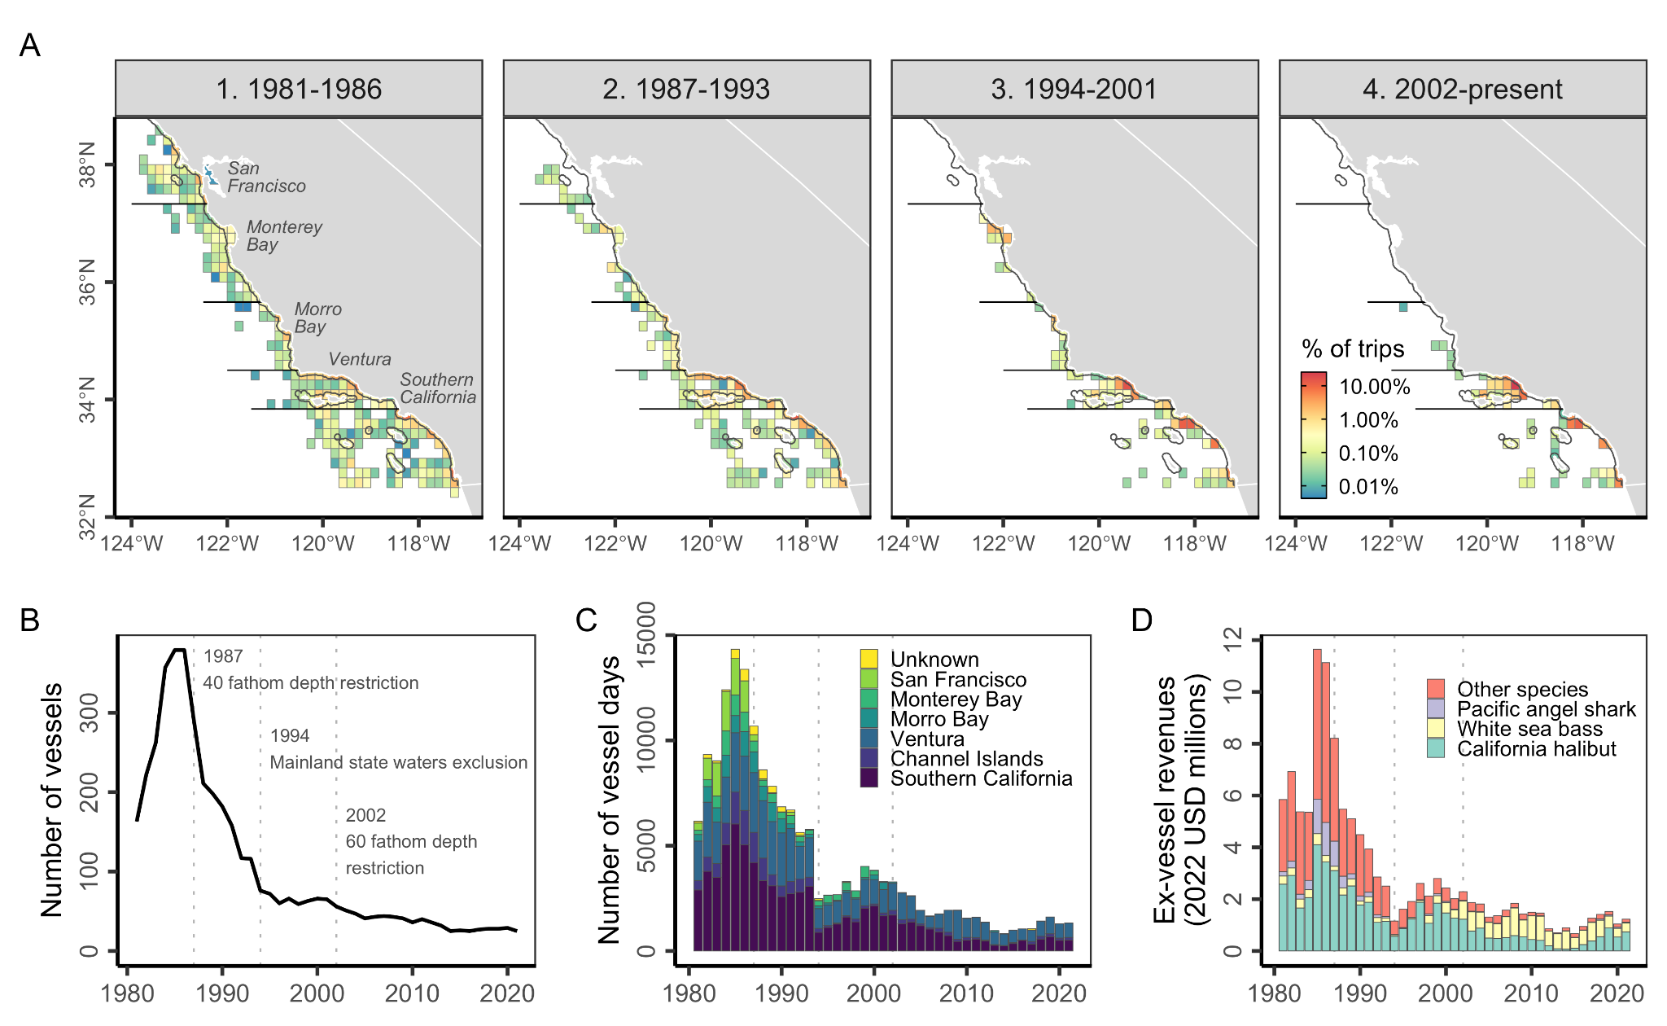**Fig. 1.** History of the California ≥3.5” set gillnet fishery. Panel **A** shows the spatial history of fishing effort during four regulatory periods. The horizontal lines delineate geographical strata used in the ratio estimation analysis; strata are labeled in the first plot. The thin coastal line marks state waters (less than 3 nautical miles from the coast). Blocks visited by fewer than three vessels during each regulatory period are hidden to maintain confidentiality and comply with the “rule-of-three.” The other panels show time series of fisheries **(B)** participation, **(C)** effort, and **(D)** revenues. Vertical lines mark years in which major regulations, labeled in Panel B, were implemented; these define the regulatory periods used in Panel **A**. These regulations became operative on April 15, 1987; January 1, 1994; and April 26, 2002. See **Fig. S1** and the supplemental methods for details on estimating ex-vessel revenues from the fishery.

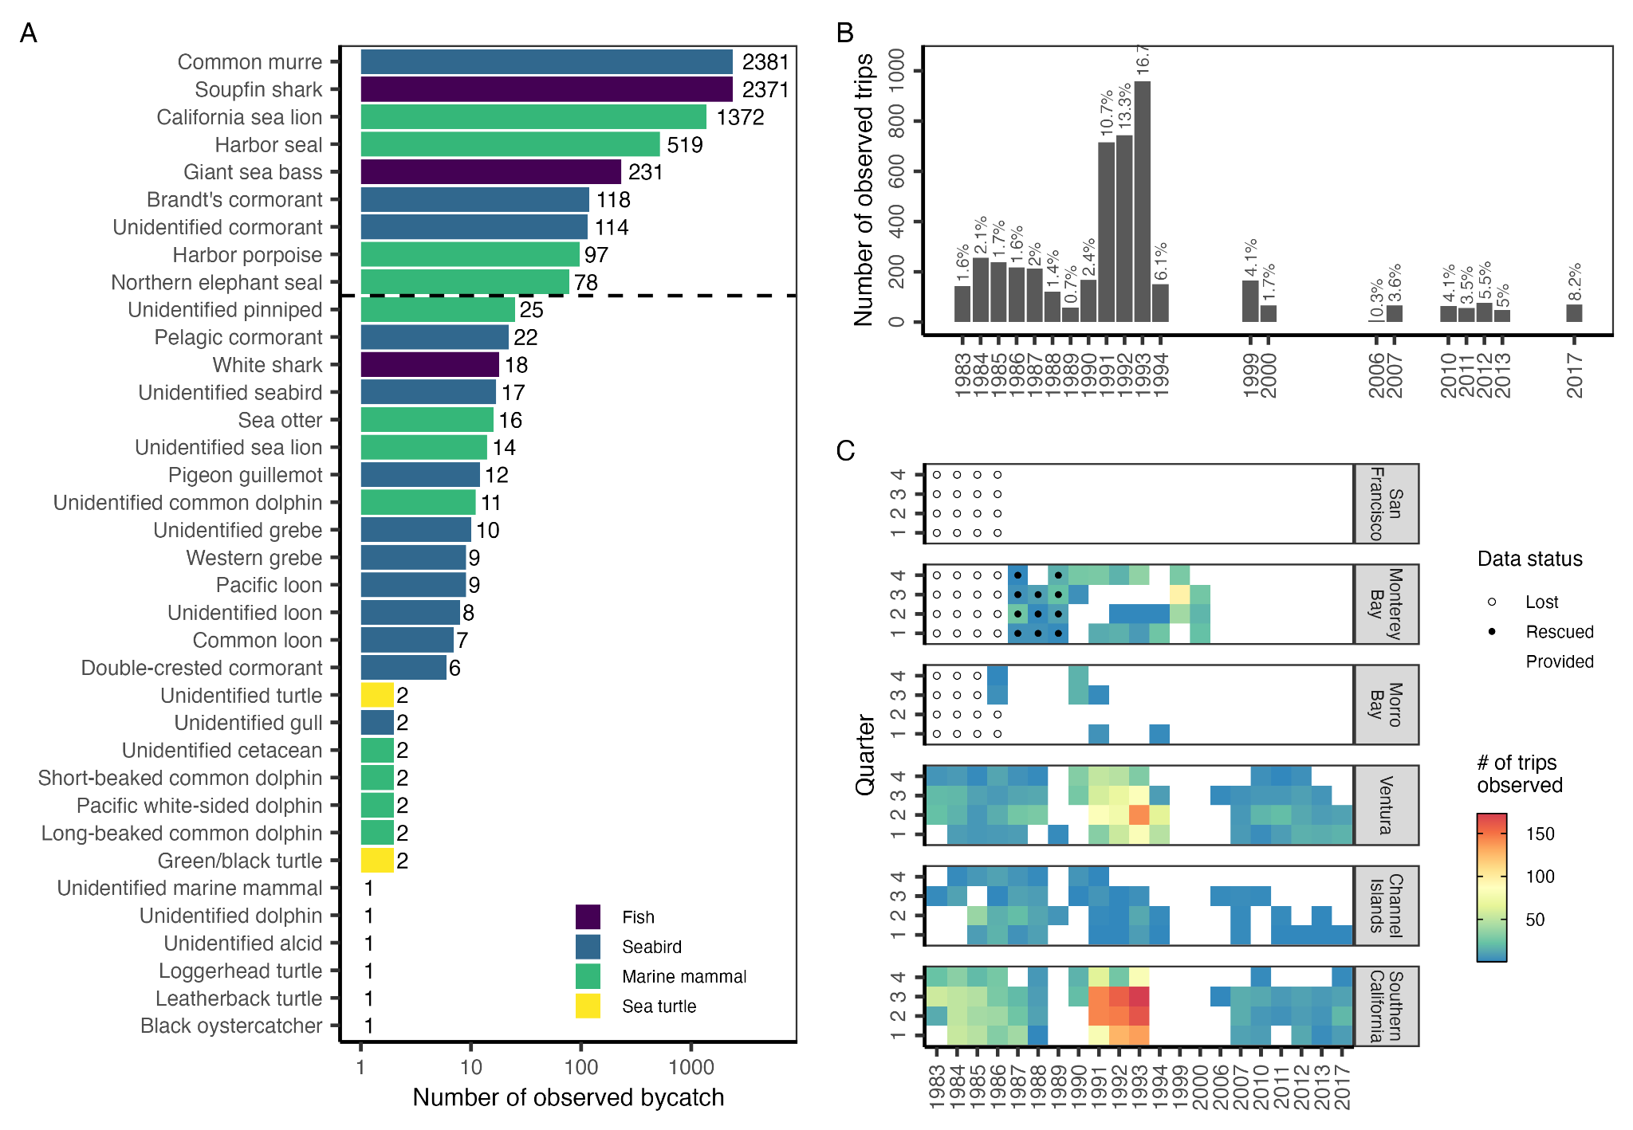**Fig. 2.** History of observer coverage in the California ≥3.5” set gillnet fishery. Panel **A** shows the total bycatch of marine mammals, seabirds, sea turtle, and three fish species of concern (soupfin shark, giant sea bass, white shark) recorded by observers from 1983-2017. We focus on marine mammal and seabird species with ≥50 observations, which are delineated by the horizontal dashed line. Note log-scale on x-axis. Panel **B** shows the number of observed trips (vessel-days) over time. The dark labels show the estimated percent of trips that were observed. Panel **C** shows the number of observed trips across the spatial (region) and temporal (quarters) strata considered in the ratio estimation analysis. See **Fig. S8** for a map of the spatial strata. Quarters are defined as: 1 = JFM (winter), 2 = AMJ (spring), 3 = JAS (summer), and 4 = OND (fall).

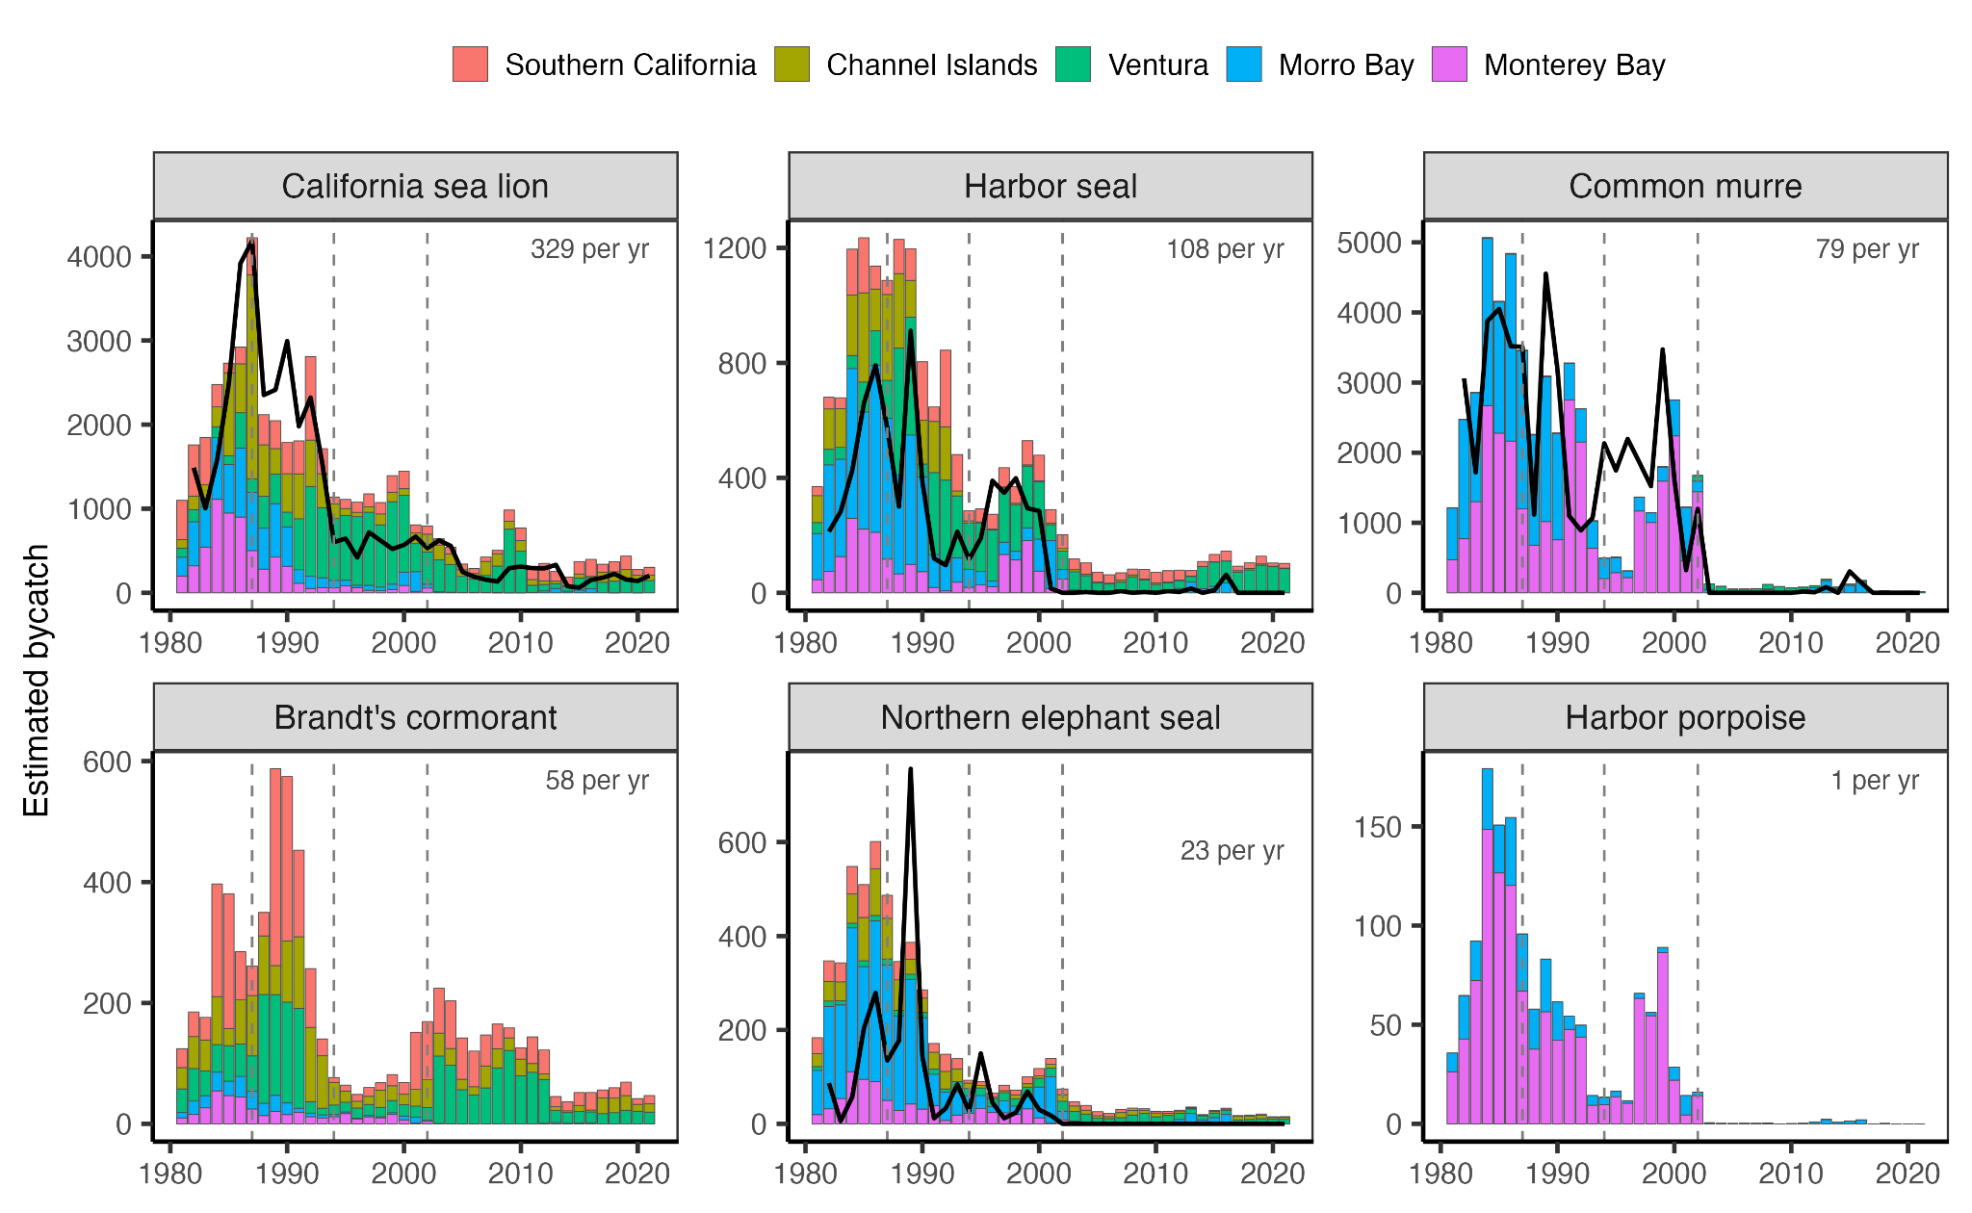

**Fig. 3.** Estimated bycatch in the California ≥3.5” set gillnet fishery from 1981-2021 predicted by the ratio estimation (bars) and random forest (line) modeling approaches. Error bars indicate the 95% confidence interval for estimates from the ratio estimation approach. Average estimated annual bycatch rates for the last 10 years (2012-2021) from the ratio estimator are marked in the top-right corner. Species are listed in order of decreasing recent bycatch rates.

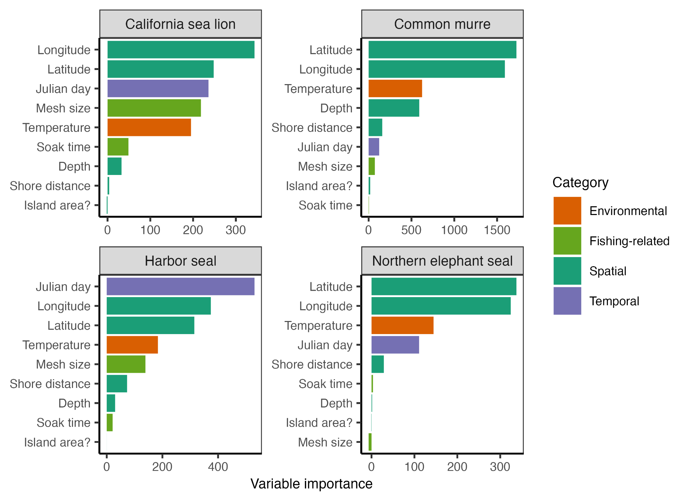

**Fig. 4.** Importance of the evaluated explanatory variables in the final random forest model for the study species with acceptable model performance. With the bias towards continuous variable corrected, variable importance is measured as the total decrease in node impurities from splitting on the variable averaged over all trees. Explanatory variables are colored based on the category of the variable.

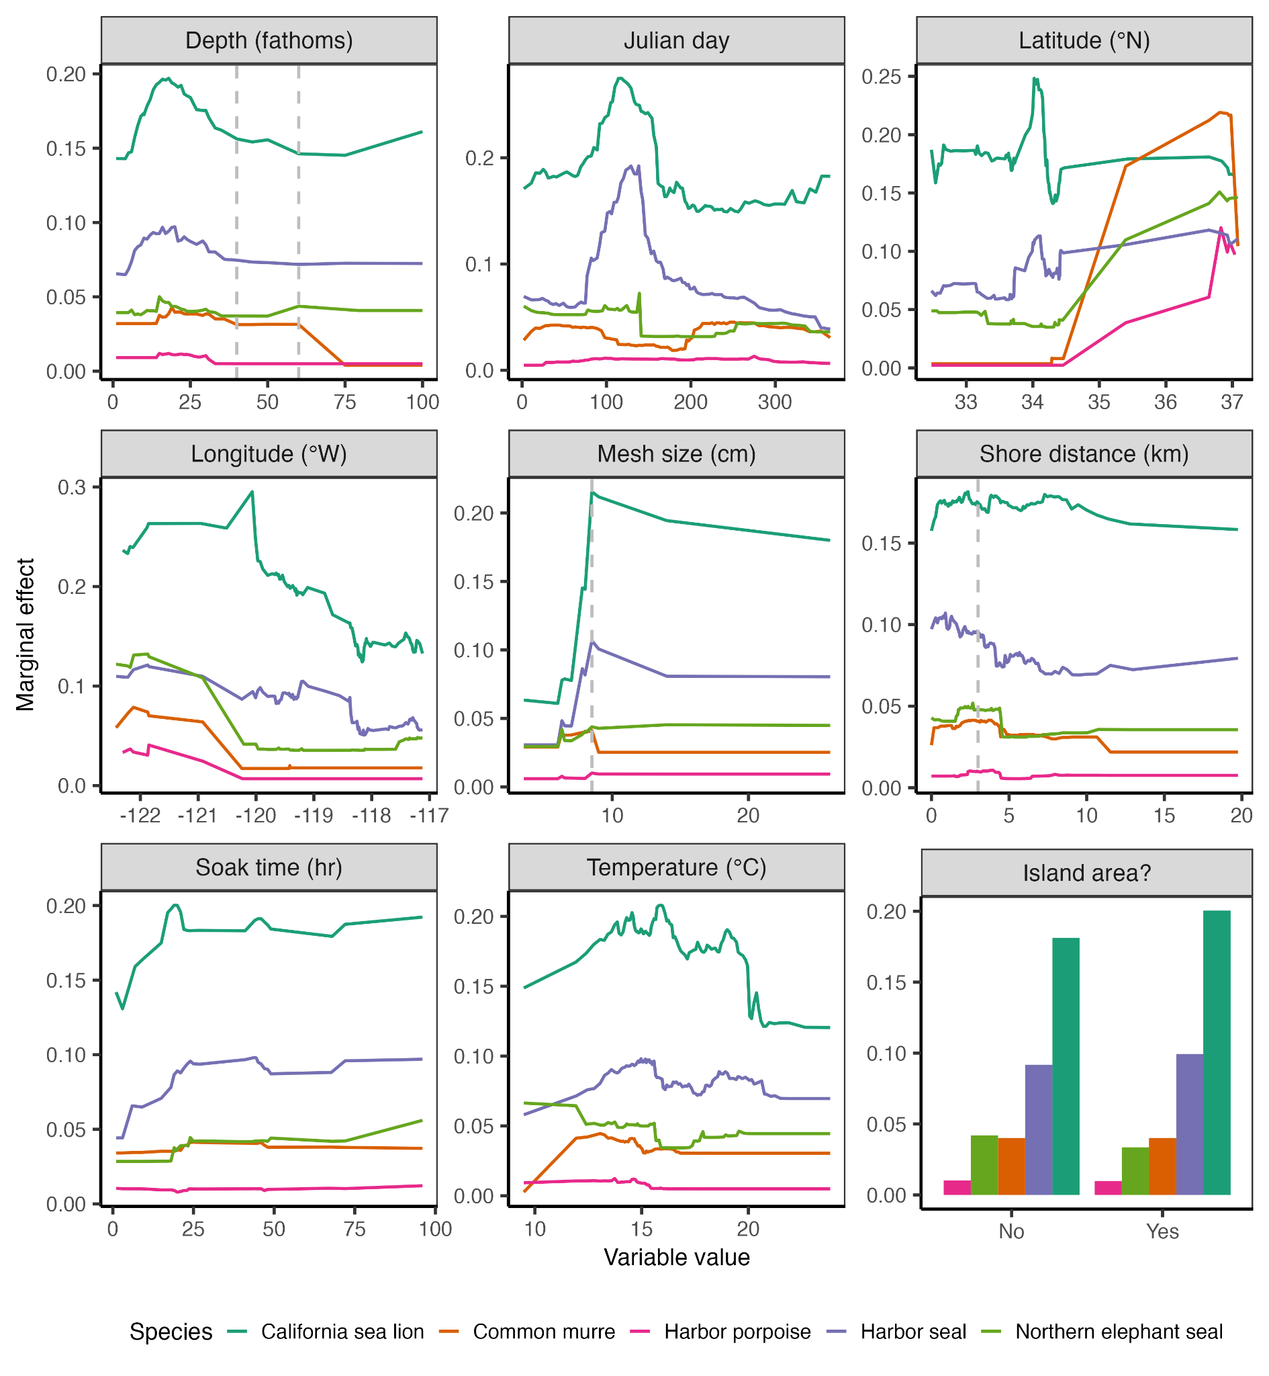

**Fig. 5.** Marginal effect of the evaluated explanatory variables on bycatch risk as estimated by the best fitting random forest model for the four study species with acceptable model performance. The marginal effect of each variable represents the effect of the variable when the other variables are held at their mean values. The dashed lines indicate 40 and 60 in Depth (fathoms), 8.5 in mesh size (cm), and 3 in shore distance (km).

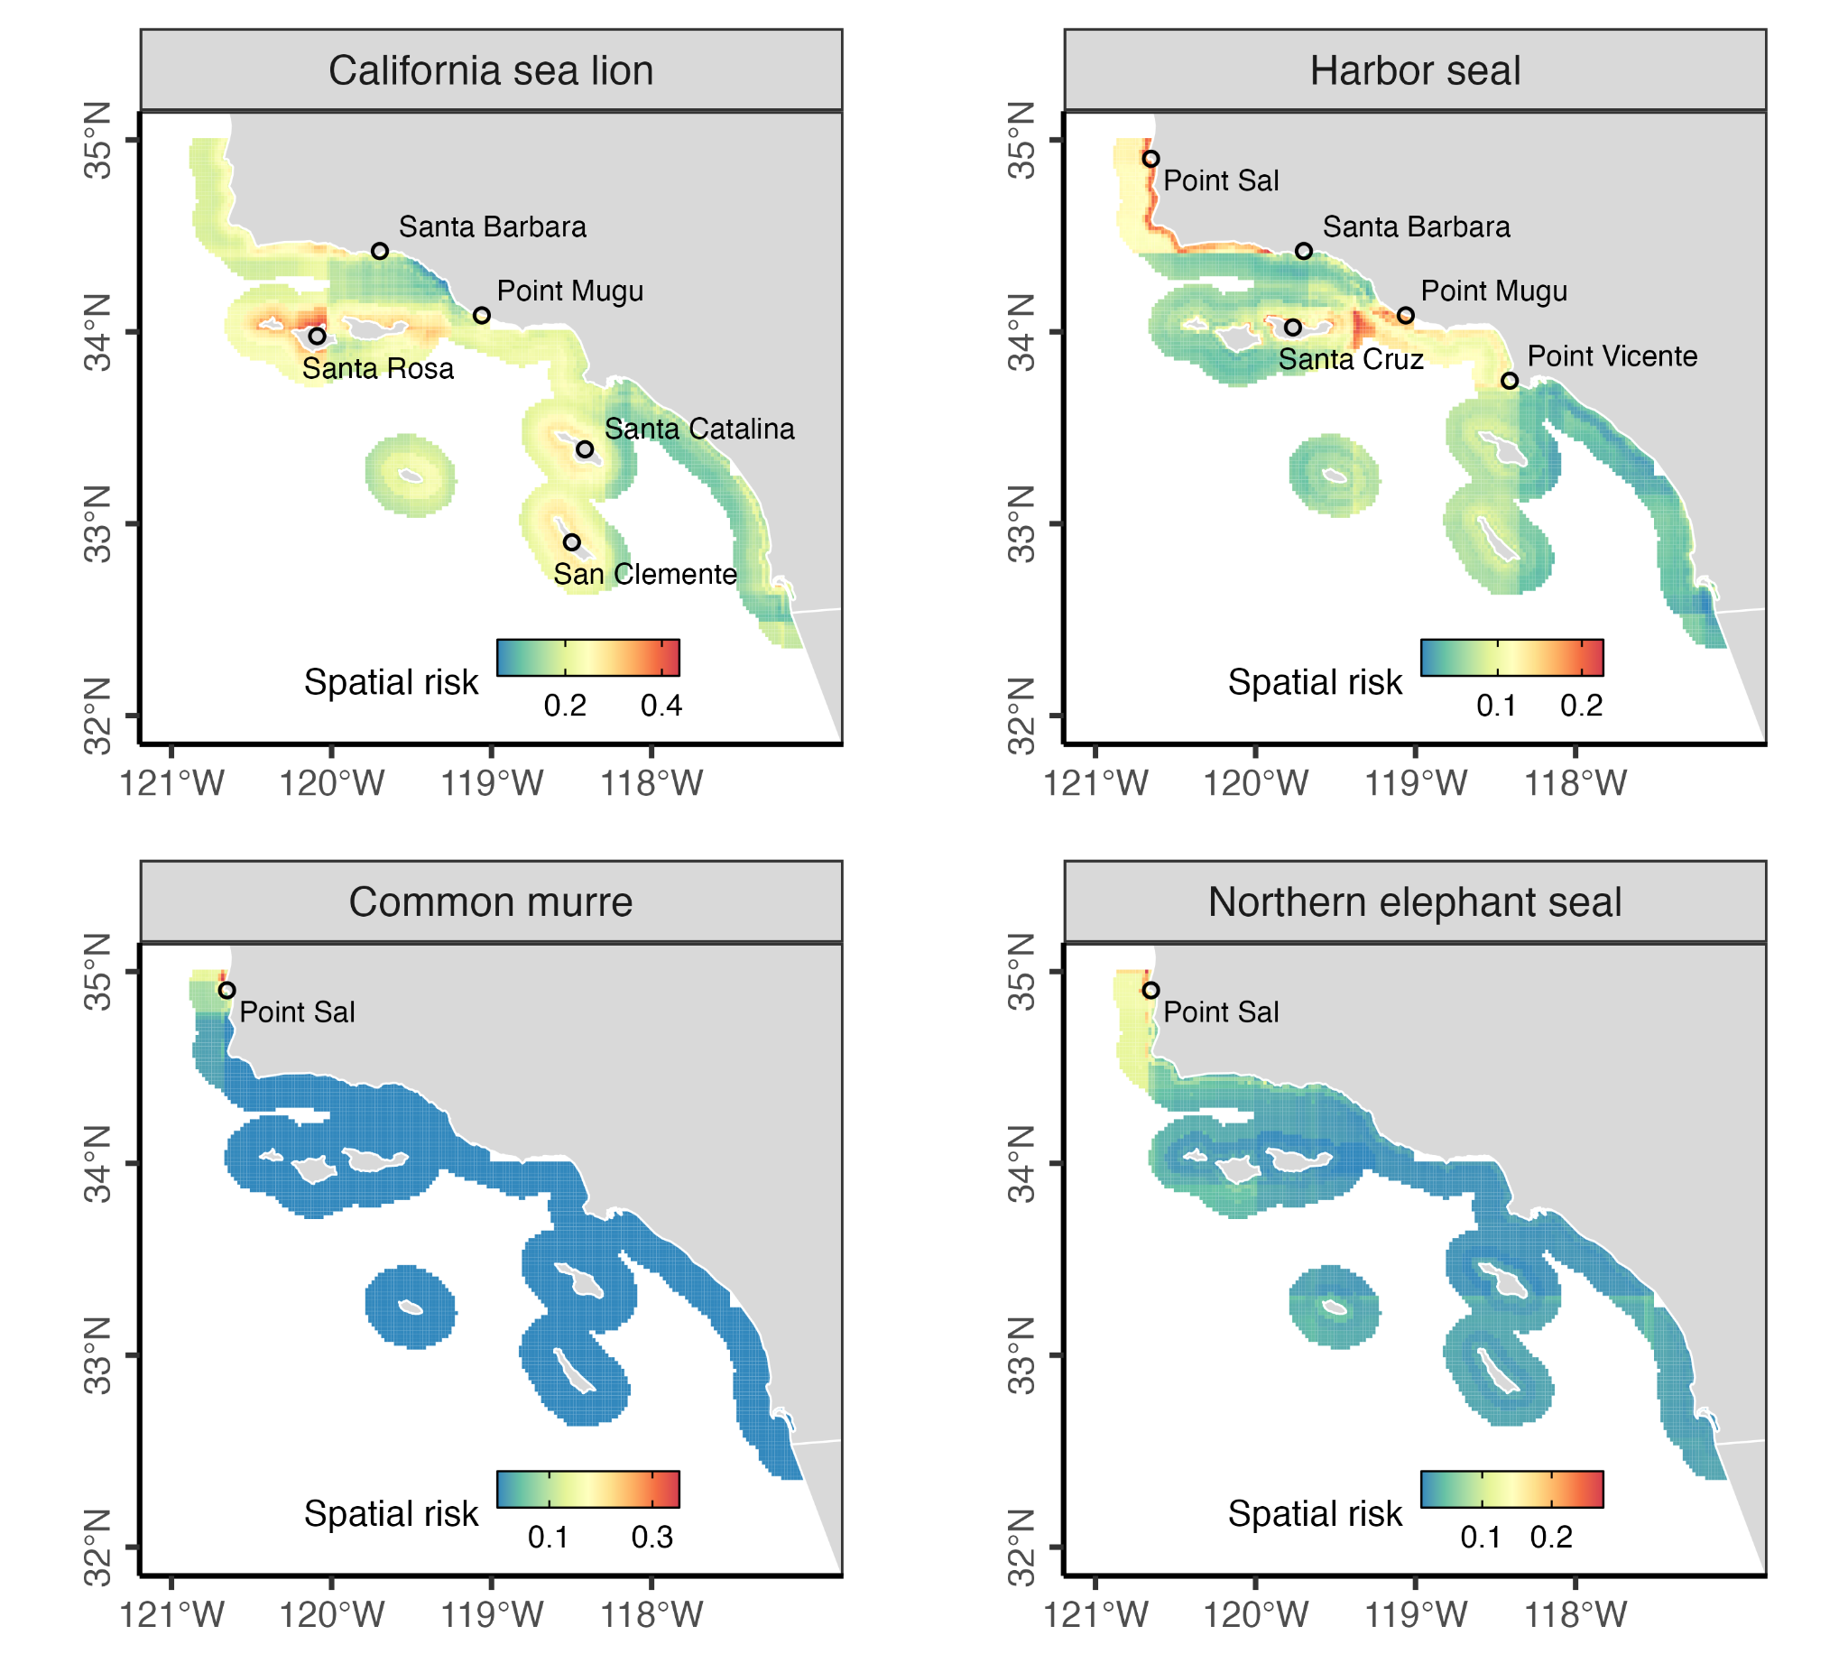

**Fig. 6.** Average spatial bycatch risk as estimated by the best fitting random forest model for the four study species with acceptable model performance. The spatial bycatch risk represents the probability of bycatch at a given location under recent (2010-2021) average conditions. Key landmarks for delineating bycatch hotspots are labeled in each panel.

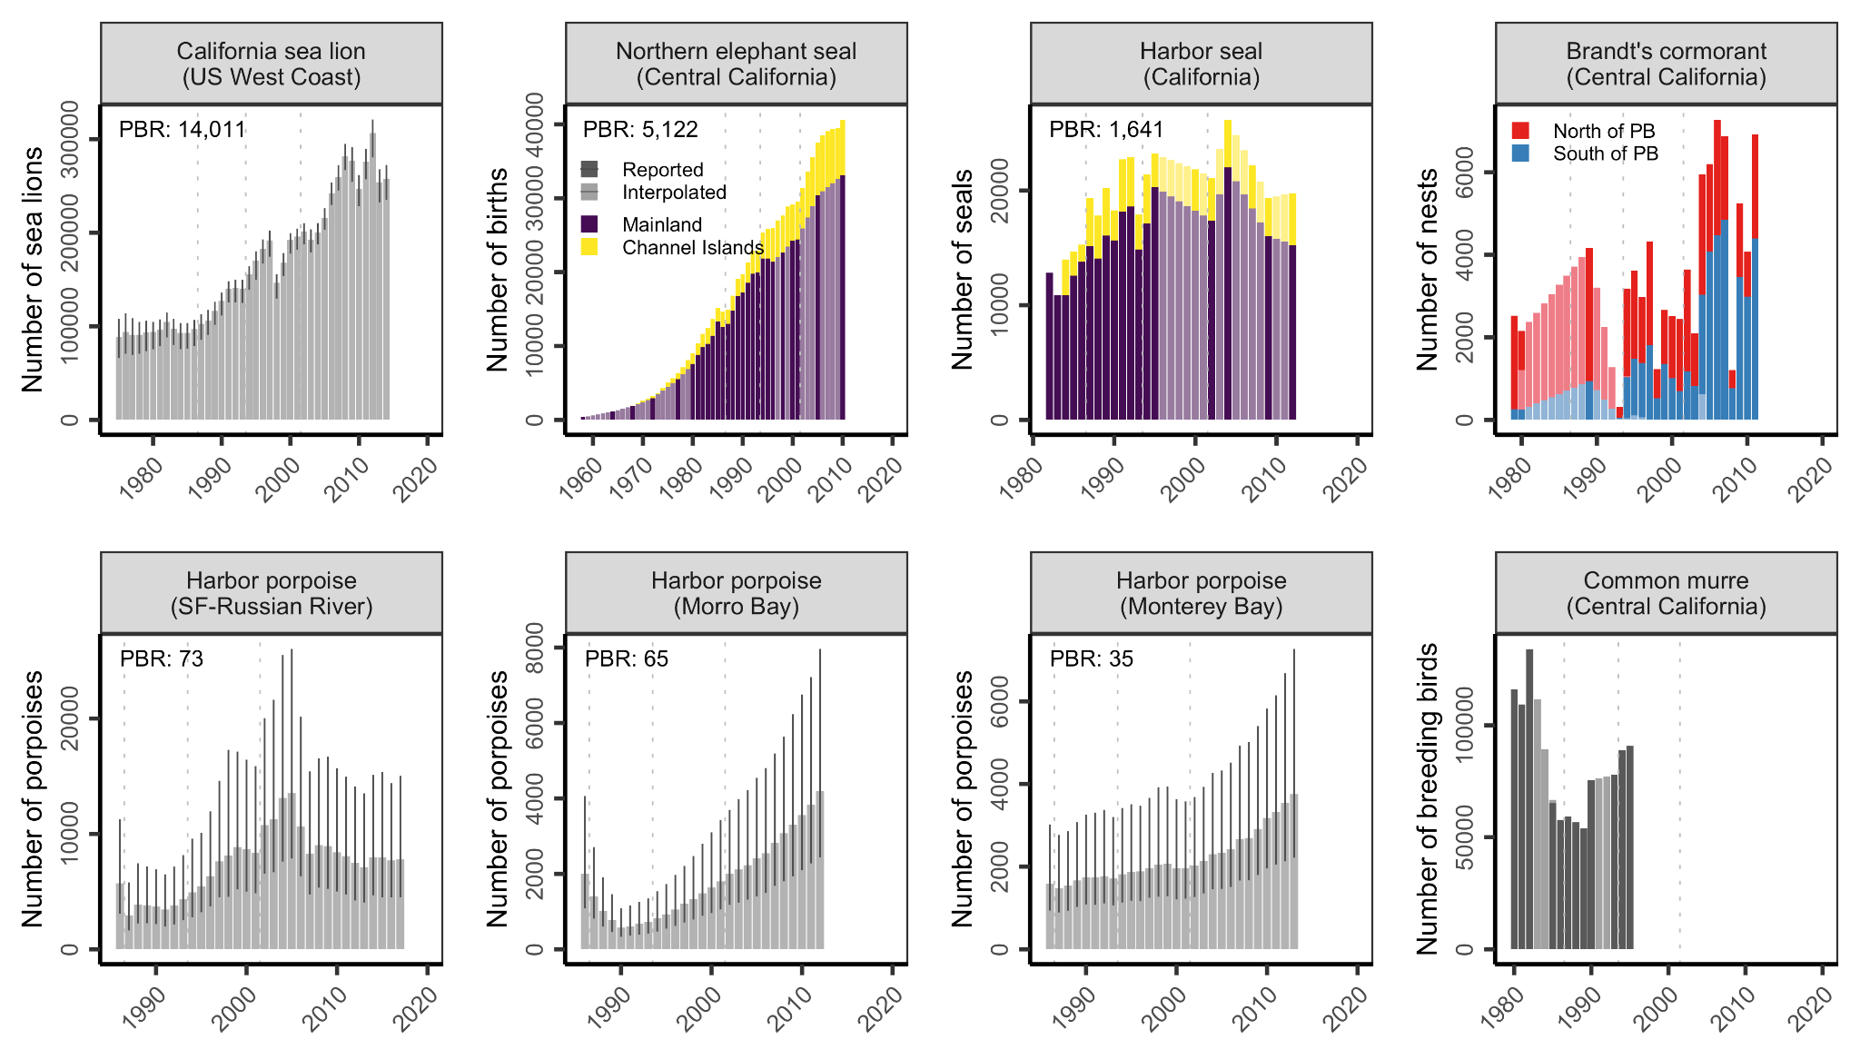**Fig. 7.** Estimated abundance of populations of the six study species. The potential biological removal (PBR) indicates the maximum number of animals, not including natural mortalities, that may be removed from a marine mammal stock while allowing the stock to reach or maintain its optimum sustainable population. PBRs are only calculated for marine mammals. Error bars indicate 95% confidence or credible intervals. Years without reported values were filled using linear interpolation. Vertical lines mark years in which major bycatch regulations were implemented. Population estimates are from the following sources: California sea lion [(Laake et al., 2018)](https://www.zotero.org/google-docs/?5rJnxa), northern elephant seal [(Carretta et al., 2022)](https://www.zotero.org/google-docs/?dgRTEd), harbor seal [(Carretta et al., 2022)](https://www.zotero.org/google-docs/?bPZaBU), harbor porpoise [(Forney et al., 2021)](https://www.zotero.org/google-docs/?NsHlCT), Brandt’s cormorant [(Capitolo et al., 2012)](https://www.zotero.org/google-docs/?HvkAEV), and common murre [(Carter, 2001)](https://www.zotero.org/google-docs/?uzwpn0). Data from Carretta et al. (2022) were graphically digitized.

**Table 1.** Historical bycatch estimation studies and their characteristics (the period column indicates month and year as MM/YY).

|  |  |  |  |  |  |  |
| --- | --- | --- | --- | --- | --- | --- |
| **Study** | **Seasons** | **Period** | **Species** | **Fishery definition** | **Stratification scheme** | **Sample unit** |
| [(Barlow et al., 1994)](https://www.zotero.org/google-docs/?kK3pgk) | 1983-87 | (see papers) | Pinnipeds/cetaceans | (see included papers) | (see included papers) | (see papers) |
| [(Hanan et al., 1988)](https://www.zotero.org/google-docs/?LZ7xaq) | 1983-85 | Apr 1-Mar 31 | Sea lion, harbor seals | Set nets for halibut/flounder/sharks | 5 regions | Sets |
| [(Diamond and Hanan, 1986)](https://www.zotero.org/google-docs/?oEuulS) | 1983 | 4/83 - 3/84 | Harbor porpoise | ≥8.0” set nets for halibut/flounder | 3 regions | Sets |
| [(Hanan et al., 1986)](https://www.zotero.org/google-docs/?22XaME) | 1984 | 4/84 - 3/85 | Harbor porpoise | Set nets for halibut/flounder/sharks | 3 regions | Sets |
| [(Hanan et al., 1987)](https://www.zotero.org/google-docs/?kRJobu) | 1985 | 4/85 - 3/86 | Harbor porpoise | Set nets (but not for croaker) | 3 regions | Sets |
| [(Hanan and Diamond, 1989)](https://www.zotero.org/google-docs/?EtNSTP) | 1986 | 4/86 - 3/87 | Sea lion, harbor seal, harbor porpoise | Set nets for halibut/flounder/sharks | 5 regions, seasons | Sets |
| [(Konno, 1990)](https://www.zotero.org/google-docs/?oaPrU2) | 1987 | 4/87 - 3/88 | Sea lion, harbor seal, harbor porpoise | Set nets for halibut/flounder/sharks | 5 regions, seasons | Sets |
| [(Perkins et al., 1994)](https://www.zotero.org/google-docs/?YspdrS) | 1988-90 | 4/88 - 3/89  4/89 - 12/89  1/90 - 12/90 | Pinnipeds/cetaceans | Set nets for halibut/angel shark | 3 regions | Vessel-day |
| [(Lennert et al., 1994)](https://www.zotero.org/google-docs/?gpyLuf) | 1990 | 7/90 - 12/90 | Marine mammals | Set nets for halibut/angel shark | 3 regions | Vessel-day |
| [(Perkins et al., 1992a)](https://www.zotero.org/google-docs/?gOKvLi) | 1990 | 7/90 - 6/91 | Pinnipeds/cetaceans | ≥8.0” nets for halibut/angel shark | 3 regions | Sets |
| [(Perkins et al., 1992b)](https://www.zotero.org/google-docs/?fJqup0) | 1991 | 1/91 - 12/91 | Pinnipeds/cetaceans | Set nets for halibut/angel shark | SCal/Ventura: Quarters  Other strata: Annual | Vessel-day |
| [(Julian, 1993)](https://www.zotero.org/google-docs/?u631Tz) | 1992 | 1/92 - 12/92 | Pinnipeds/cetaceans | Set nets for halibut/angel shark | 4 regions: quarterly | Vessel-day |
| [(Julian, 1994)](https://www.zotero.org/google-docs/?9QqPOV) | 1993 | 1/93 - 12/93 | Pinnipeds/cetaceans | Set nets for halibut | 4 regions | Vessel-day |
| [(Julian and Beeson, 1998)](https://www.zotero.org/google-docs/?K3Sj1c) | 1990-95 | 7/90-12/90  1-12, 91-95 | Mammals/seabirds/turtles | ≥8.5” nets for halibut/angel shark | SCal/Ventura: Quarters  Other strata: Annual | Vessel-day |
| [(Cameron and Forney, 1999)](https://www.zotero.org/google-docs/?h5VUi7) | 1997-98 | 1/97 - 12/97  1/98 - 12/98 | Cetaceans | ≥8.5” nets for halibut/angel shark | 1997: Geographical+seasonal  1998: Geographical only | Vessel-day |
| [(Cameron and Forney, 2000)](https://www.zotero.org/google-docs/?5PFvyT) | 1999 | 1/99 - 12/99 | Cetaceans | ≥8.5” nets for halibut/angel shark | Geographical+seasonal | Vessel-day |
| [(Carretta, 2001)](https://www.zotero.org/google-docs/?tF76Xo) | 2000 | 1/00 - 12/00 | Cetaceans | ≥8.5” nets for halibut/angel shark | SCal/Ventura: Quarters  Other strata: Annual | Vessel-day |
| [(Carretta, 2002)](https://www.zotero.org/google-docs/?3xI0sp) | 2001 | 1/01 - 12/01 | Cetaceans | Set nets for halibut/angel shark | SCal/Ventura: Quarters  Other strata: Annual | Vessel-day |
| [(Carretta and Chivers, 2003)](https://www.zotero.org/google-docs/?Fy1ktB) | 2002 | 1/02 - 12/02 | Cetaceans | Set nets for halibut/angel shark | SCal/Ventura: Quarters  Other regions: Annual | Vessel-day |
| [(Carretta and Chivers, 2004)](https://www.zotero.org/google-docs/?Vy51JV) | 2003 | 1/03 - 12/03 | Marine mammals | ≥8.5” nets for halibut/angel shark | SCal/Ventura: Quarters  Other regions: Annual | Vessel-day |
| [(Carretta and Enriquez, 2009)](https://www.zotero.org/google-docs/?xirlYk) | 2007 | 1/07 - 12/07 | Mammals/seabirds | Set nets for halibut/white seabass | No stratification | Sets |
| [(Carretta and Enriquez, 2012a)](https://www.zotero.org/google-docs/?sUmErr) | 2010 | 1/10 - 12/10 | Mammals/seabirds | Set nets for halibut/white seabass | No stratification | Vessel-day |
| [(Carretta and Enriquez, 2012b)](https://www.zotero.org/google-docs/?3L96T1) | 2011 | 1/11 - 12/11 | Mammals/seabirds | Set nets for halibut/white seabass | No stratification | Sets |
| [(Carretta et al., 2014)](https://www.zotero.org/google-docs/?eqwKVg) | 2012 | 1/12 - 12/12 | Mammals/seabirds/turtles | Set nets for halibut/white seabass | No stratification | Vessel-day |

**Table 2.** Performance of the best fitting random forest model by species.

|  |  |  |  |  |  |  |  |
| --- | --- | --- | --- | --- | --- | --- | --- |
|  |  |  |  | **Training data** | | **Test data** | |
| **Species** | **# of bycatch**  **observed** | **Best model** | **Mtry** | **Kappa** | **AUC** | **Kappa** | **AUC** |
| California sea lion | 1372 | Weighted-25 | 3 | 0.24 | 0.78 | 0.23 | 0.78 |
| Harbor seal | 519 | Weighted-75 | 2 | 0.25 | 0.83 | 0.15 | 0.81 |
| Harbor porpoise | 97 | Weighted-50 | 2 | 0.34 | 0.98 | -0.005 | 0.98 |
| Common murre | 2381 | Weighted-25 | 6 | 0.71 | 0.99 | 0.61 | 0.97 |
| Brandt’s cormorant | 118 | Weighted-25 | 8 | 0.06 | 0.68 | 0.07 | 0.63 |
| Northern elephant seal | 78 | Weighted-25 | 1 | 0.23 | 0.87 | 0.21 | 0.86 |

## Supplemental Methods

### Identifying set gillnet landing receipts and revenues

We used landing receipts (a.k.a., fish tickets) to estimate ex-vessel revenues generated by the California ≥3.5” set gillnet fishery from 1981-2022. Among other information, landing receipts report the date, value, species, and gear of commercial landings. We identified landing receipts associated with the ≥3.5” set gillnet fishery through a multi-step filtering process. First, we filtered the landing receipts to the five gear types that could include ≥3.5” mesh set gillnets: trammel nets, set gillnets, small-mesh set gillnets, large-mesh set gillnets, or entangling nets (**Fig. S1A**). Entangling nets, which encompass both set and drift gillnets, were a widely used gear type from 1984-1993. As a result, this filter retained many swordfish landings and other landings associated with drift gillnets. It also retained many herring landings and other landings associated with set gillnets with mesh sizes smaller than 3.5 inches. To remove landing receipts associated with drift gillnets and set gillnets with mesh sizes smaller than 3.5 inches, we used gillnet logbooks to identify landing receipts associated with known set gillnet vessels and logged set gillnet trips. We began by further filtering to only include vessels documented as using ≥3.5” set gillnets in the gillnet logbooks (**Fig. S1B**). After this filter, a large amount of swordfish and herring landings remained, indicating that many ≥3.5” set gillnet vessels use other gears. Thus, to further tie landing receipts with known ≥3.5” set gillnet trips, we explored four related approaches for linking landing receipts to logged ≥3.5” set gillnet trips. The first approach was the most strict and only considered landing receipts reported on the exact day of logged ≥3.5” set gillnet trips (**Fig. S1C**). This filter eliminated swordfish and herring landings but is likely to be overly restrictive. The date of landing may differ from the date of fishing because of misreporting, multi-day trips, or delayed sales. Thus, we explored three progressively less restrictive rules, which attributed landing receipts recorded within one (**Fig. S1D**), two (**Fig. S1E**), or three (**Fig. S1F**) days of logged ≥3.5” set gillnet trips to the fishery. We selected the landing receipts associated with the 3-day buffer as the final set of landing receipts associated with the fishery because it effectively eliminated landings of species not associated with the ≥3.5” set gillnet fishery (i.e., swordfish and herring) while being inclusive-within-reason of potential ≥3.5” set gillnet fishery landings. Finally, we adjusted daily ex-vessel landings values for inflation by converting all values to January 1, 2022 US dollars using the *priceR* package in R [(Condylios, 2023)](https://www.zotero.org/google-docs/?jaeQNt).

### Mapping species ranges

We mapped the range of the study species using range maps from the California Wildlife Habitat Relationships (CWHR) System [(CDFW, 2021)](https://www.zotero.org/google-docs/?ALF6RZ). The CWHR ranges were developed by species-specific experts. Range maps were not developed for harbor porpoise as part of the CWHR effort. We developed a range map for harbor porpoise assuming that harbor porpoise occur primarily in waters shallower than 50 fathoms (92 meters) north of Point Conception [(Forney et al., 2014)](https://www.zotero.org/google-docs/?b5z5ge). Harbor seal haulouts were mapped using the CDFW Harbor Seal Haulout GIS dataset [(CDFW, 2014)](https://www.zotero.org/google-docs/?gmtcWb). CDFW conducted aerial surveys of all known haulout sites in 2001, 2002, and 2003 and counted the number of harbor seals observed in aerial photographs of each site. We mapped northern elephant seal rookery size in 2010 using a database of counts developed by [(Lowry et al., 2014)](https://www.zotero.org/google-docs/?9t4AQh). Counts were generated through a review of ground and aerial photographic surveys. We mapped California sea lion haulouts using data from [(Lowry, 2021)](https://www.zotero.org/google-docs/?cVixmX). Haulouts were mapped in the Channels Islands between 2016-2019 using aerial photographic surveys. Sea lion haulouts occur along the California coast but were not mapped to single sites in this study and therefore not plotted in our range maps. We mapped seabird colonies using the 2010 CDFW Seabird Colonies Database [(CDFW, 2010)](https://www.zotero.org/google-docs/?apk0f1). These data were collected as part of the Marine Life Protection Act (MLPA) planning process and report the maximum number of seabirds of 26 species at all known colonies.

## Supplemental Tables & Figures

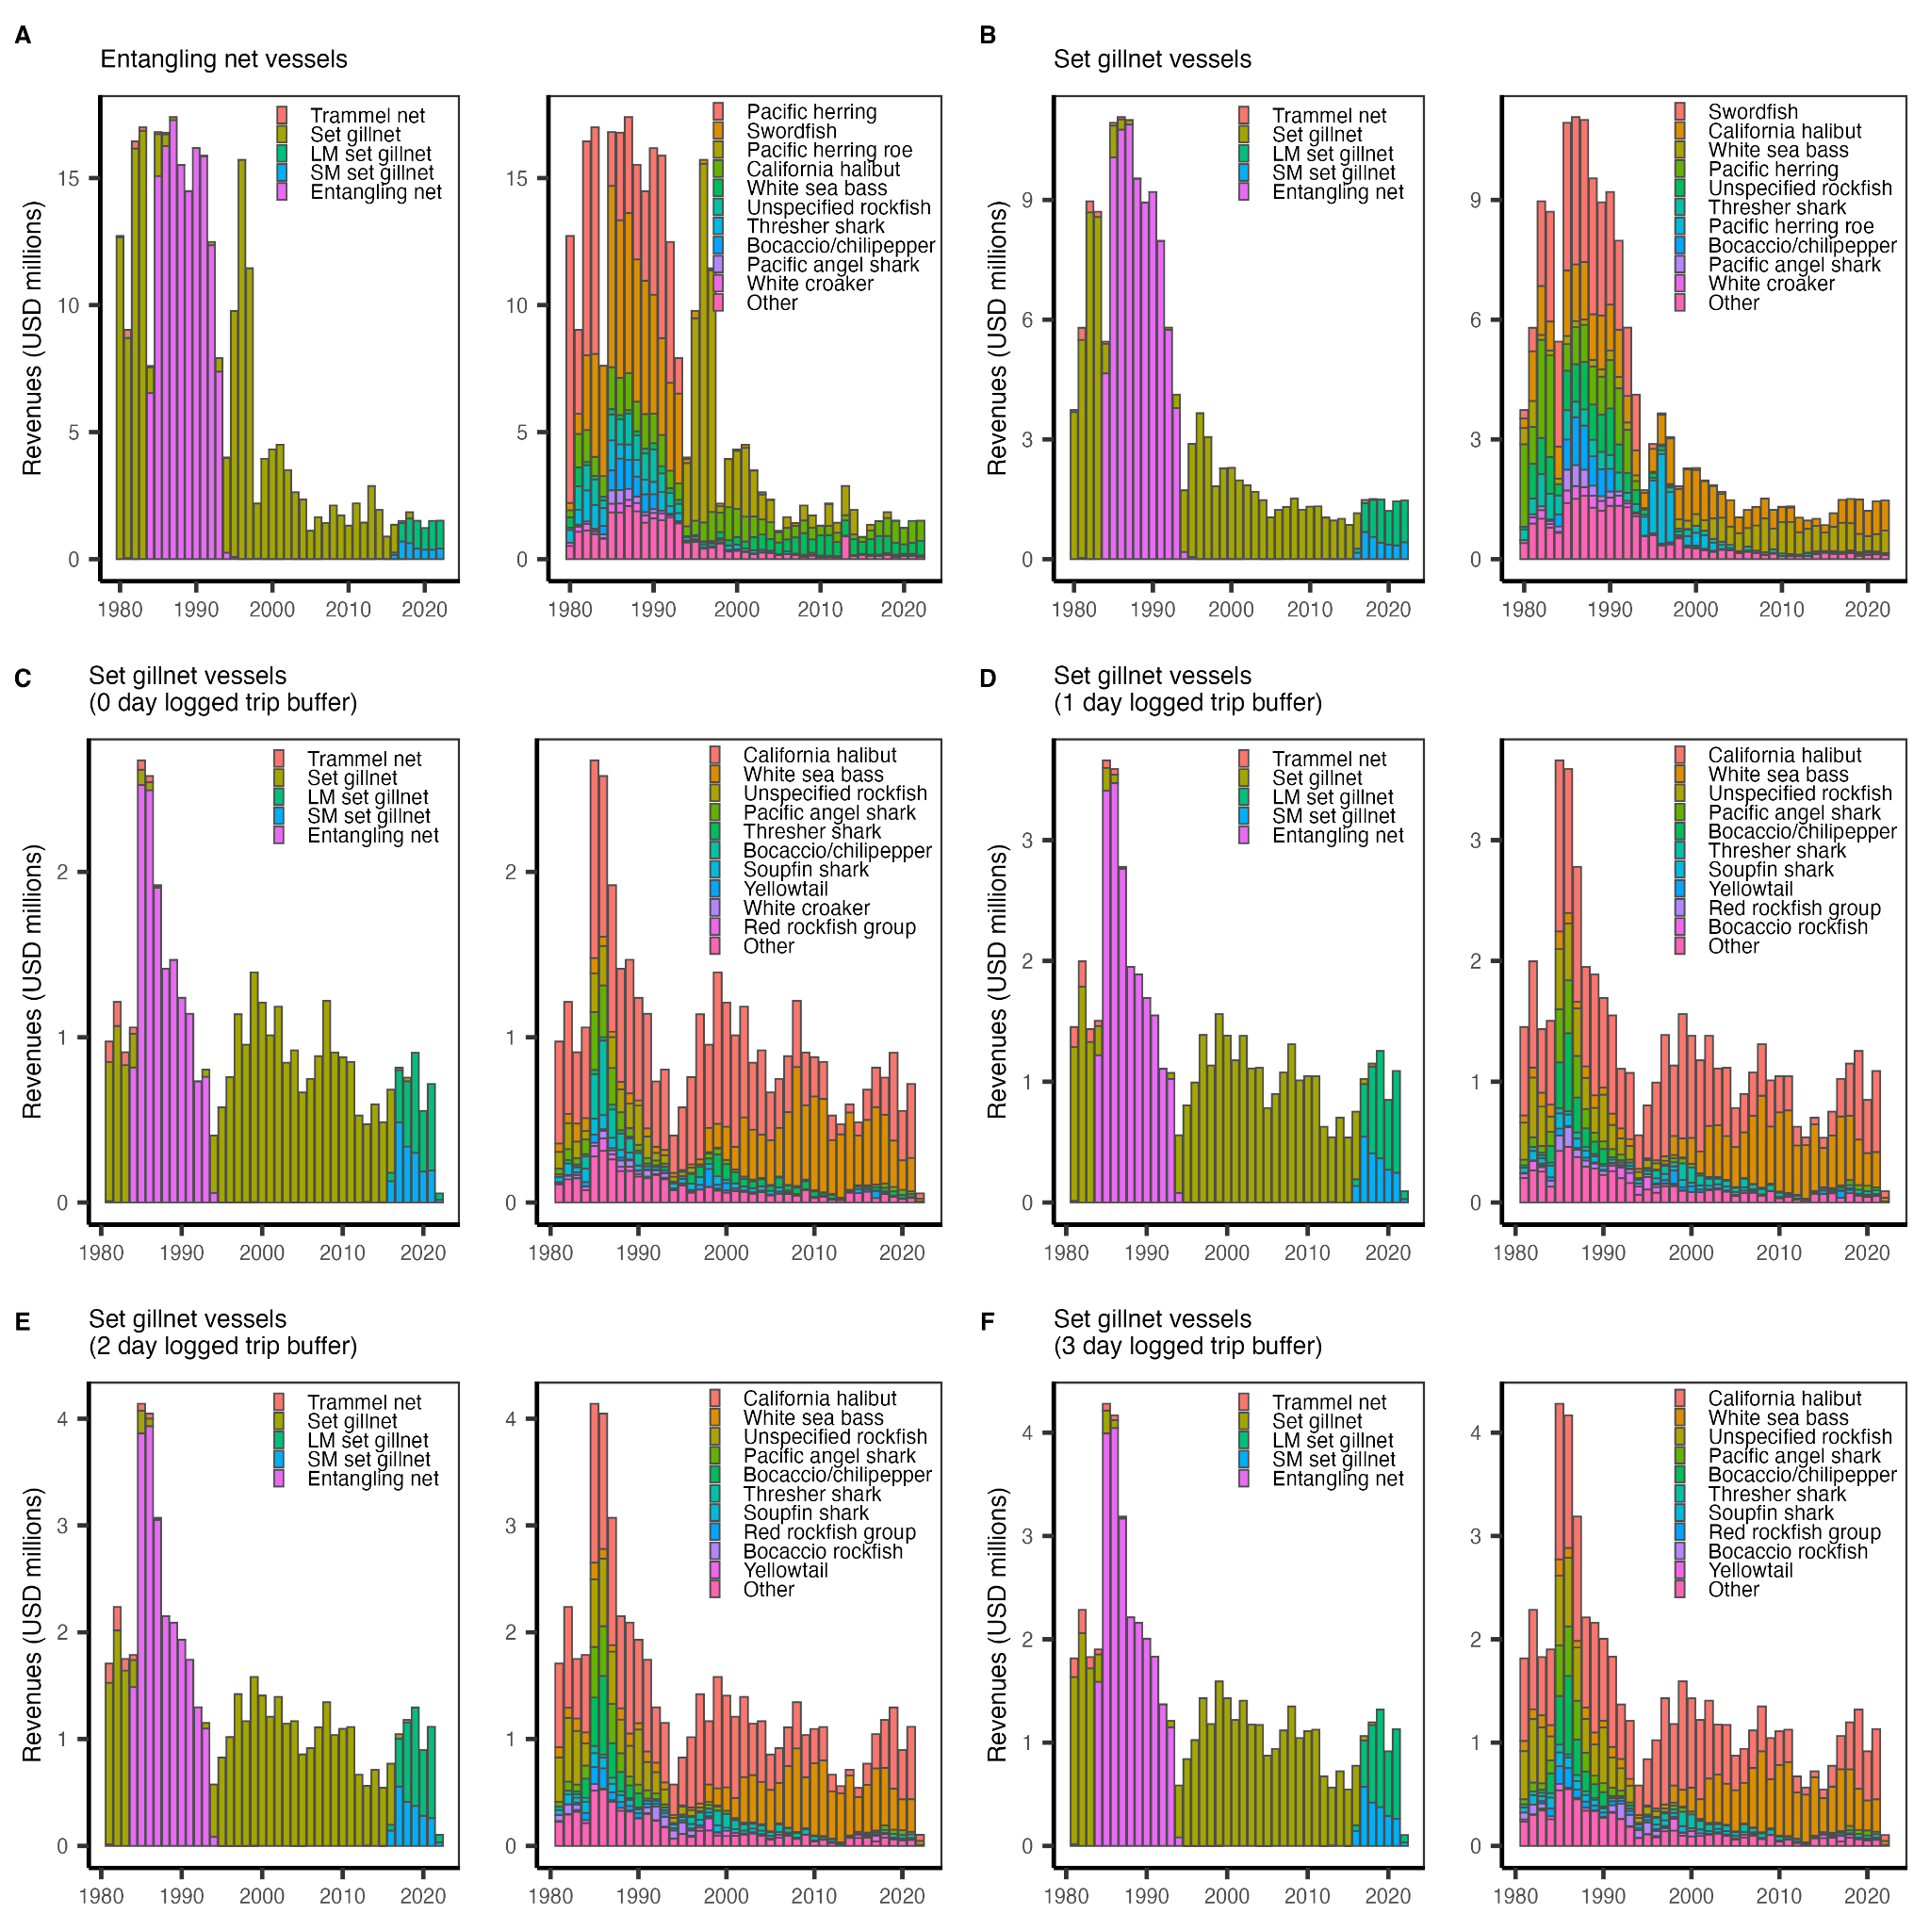**Fig. S1.** Estimated ex-vessel revenues generated by the California ≥3.5” set gillnet fishery as estimated through six different filtration procedures. The filtration procedures examine the sum annual ex-vessel revenues reported on landing receipts from **(A)** vessels using various reported entangling net gears (which varied through time); **(B)** vessels using various entangling net gears that are known to use set gillnets based on logbooks; and **(C-F)** vessels known to use set gillnets based on logbooks that are dated within various buffers of a logged set gillnet trip. We adopted the final filter, which sums landing receipts date within 3 days of logged set gillnet trip, as the best estimate of ex-vessel revenues for the fishery. Revenues have not been adjusted for inflation (see **Fig. 1D** for the inflation adjusted ex-vessel revenues).

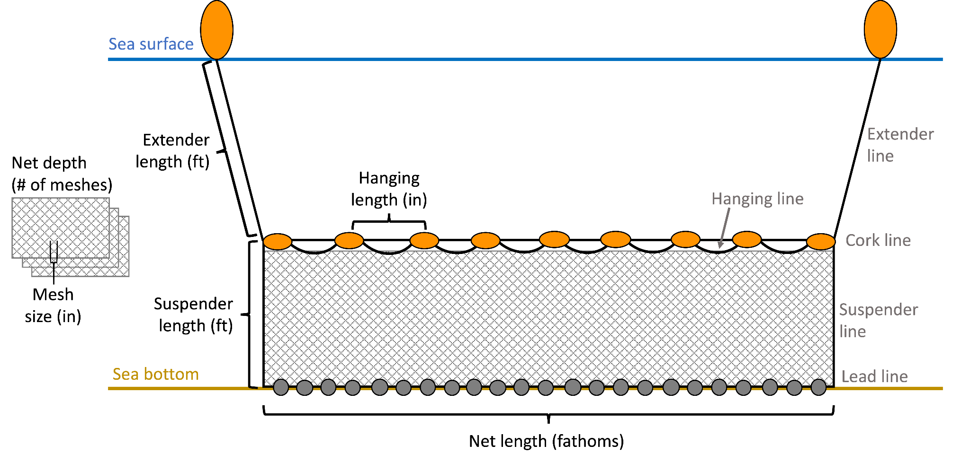

**Fig. S2.** Diagram of a typical California set gillnet illustrating the measurements reported in the logbook and observer data. Grey text indicates parts of the gillnet and black text indicates the reported measurements. The material, strength, and color of the net is also reported. Finally, the hanging ratio, a percentage that is calculated as the length of the mesh web divided by the length of the cork line, is reported.

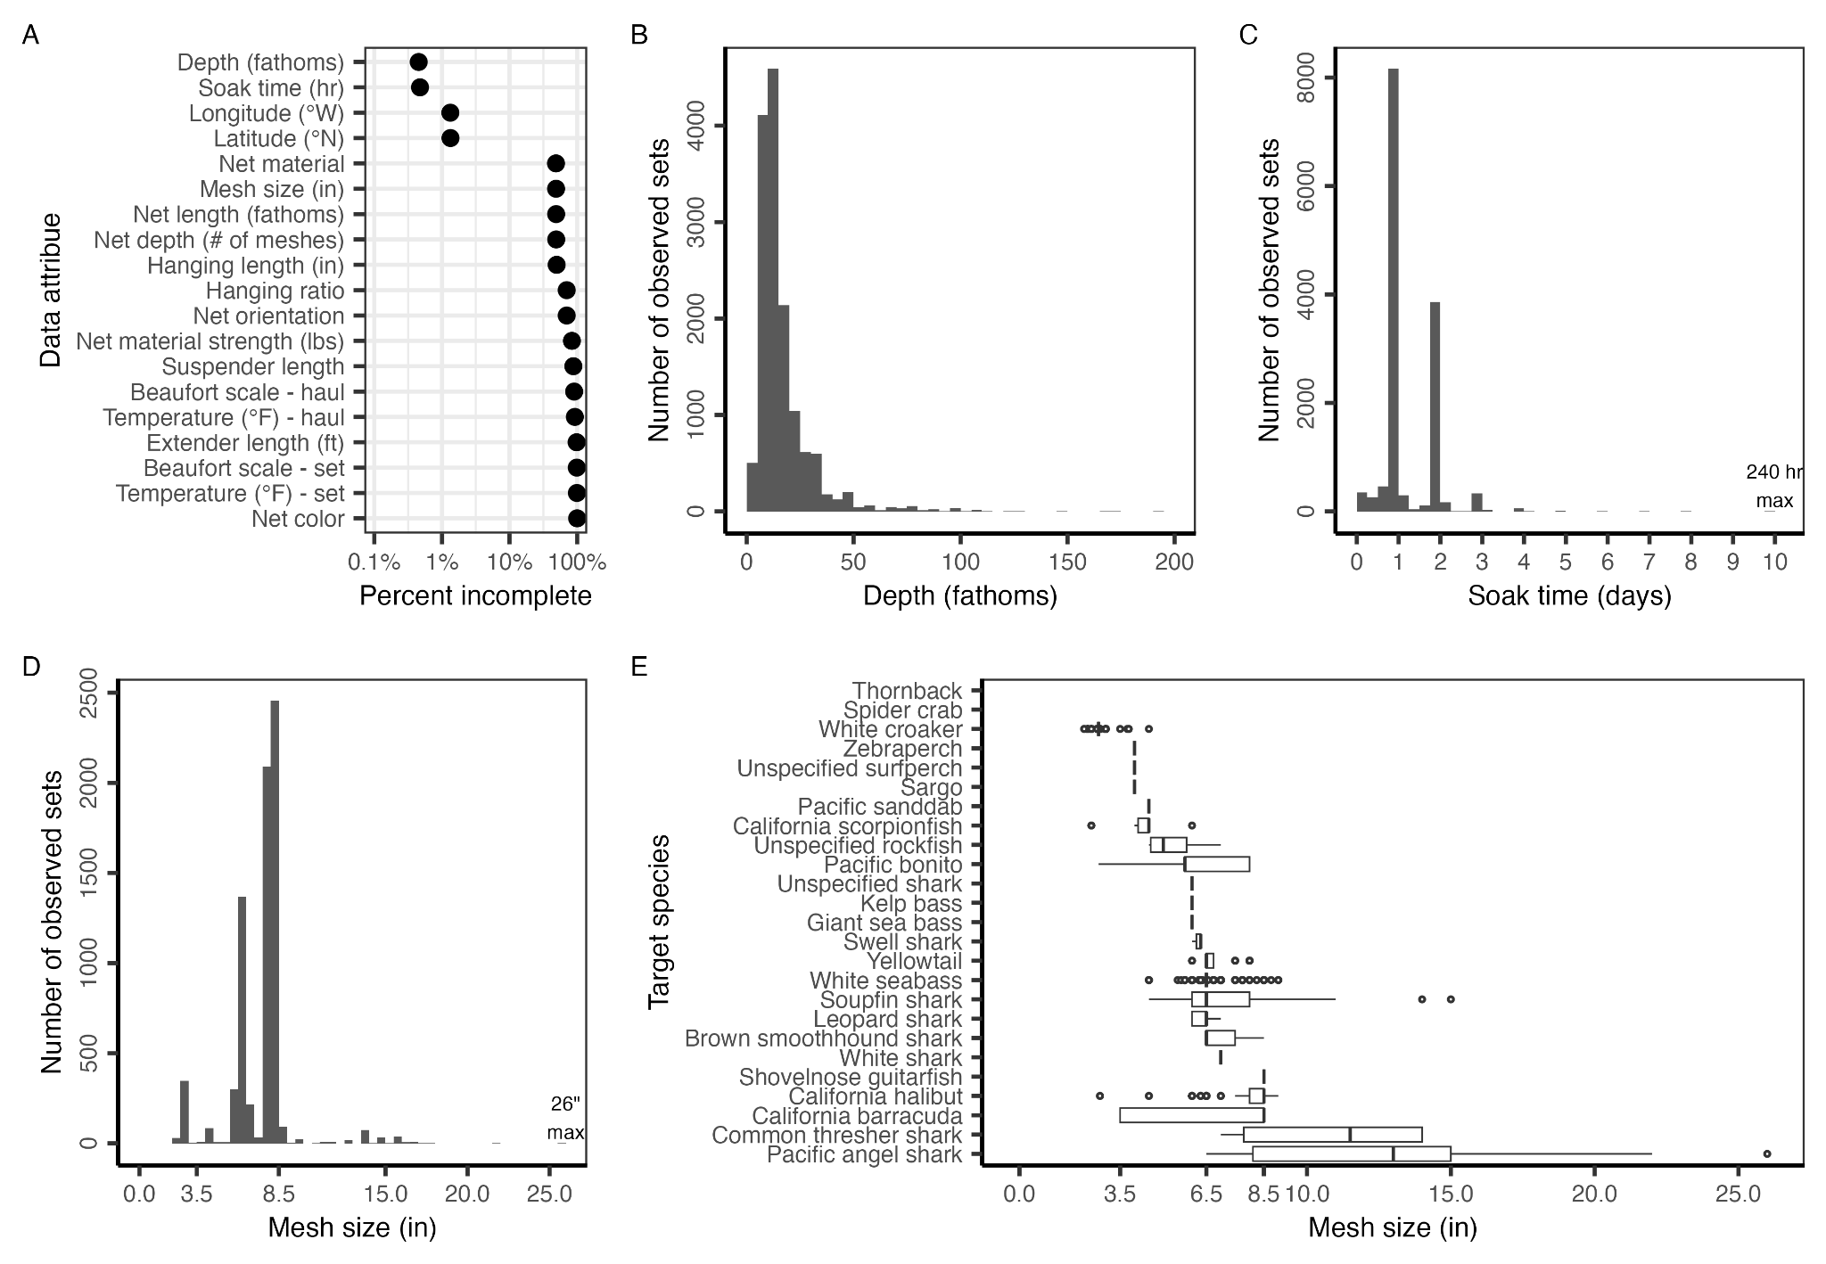**Fig. S3.** Traits of the observed set gillnet metadata. Panel **A** shows the level of completeness of gillnet metadata. Panel **B** shows the distribution of reported depths. Panel **C** shows the distribution of reported soak times; the maximum reported soak time is 240 hours (10 days). Panel **D** shows the distribution of reported mesh sizes; the maximum reported mesh size is 26 inches. Panel **E** shows the distribution of reported mesh sizes by reported target species. In the boxplots, the solid line indicates the median, the box indicates the interquartile range (IQR; 25th to 75th percentiles), the whiskers indicate 1.5 times the IQR, and points indicate outliers.

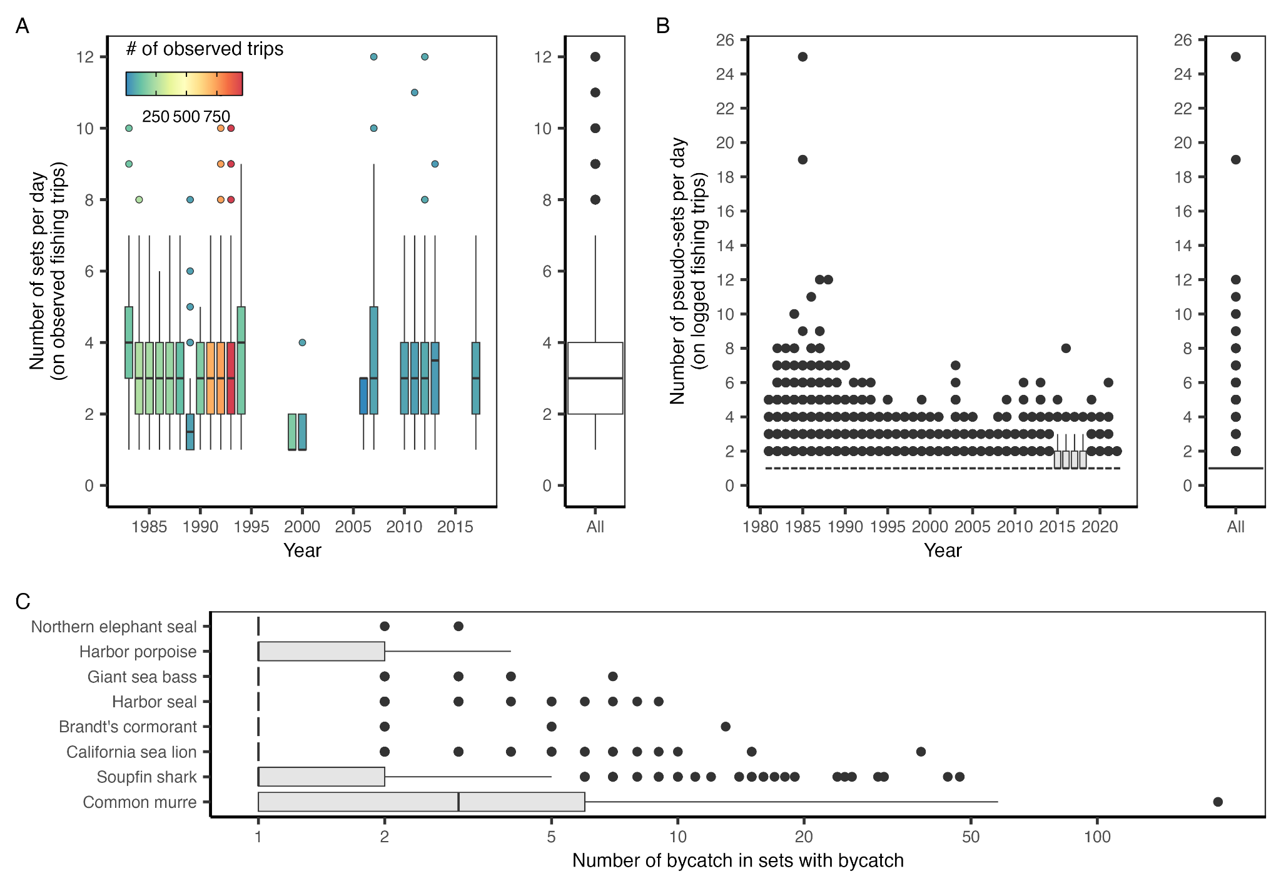**Fig. S4.** The **(A)** number of sets per observed fishing trip by year and overall; **(B)** number of pseudo-sets per logged fishing trip by year and overall; and **(C)** number of bycatch in sets with bycatch of each of the species of interest. In the boxplots, the solid line indicates the median, the box indicates the interquartile range (IQR; 25th to 75th percentiles), the whiskers indicate 1.5 times the IQR, and points indicate outliers. In **(A)**, the fill color indicates the number of observed fishing trips contributing to the annual distribution.

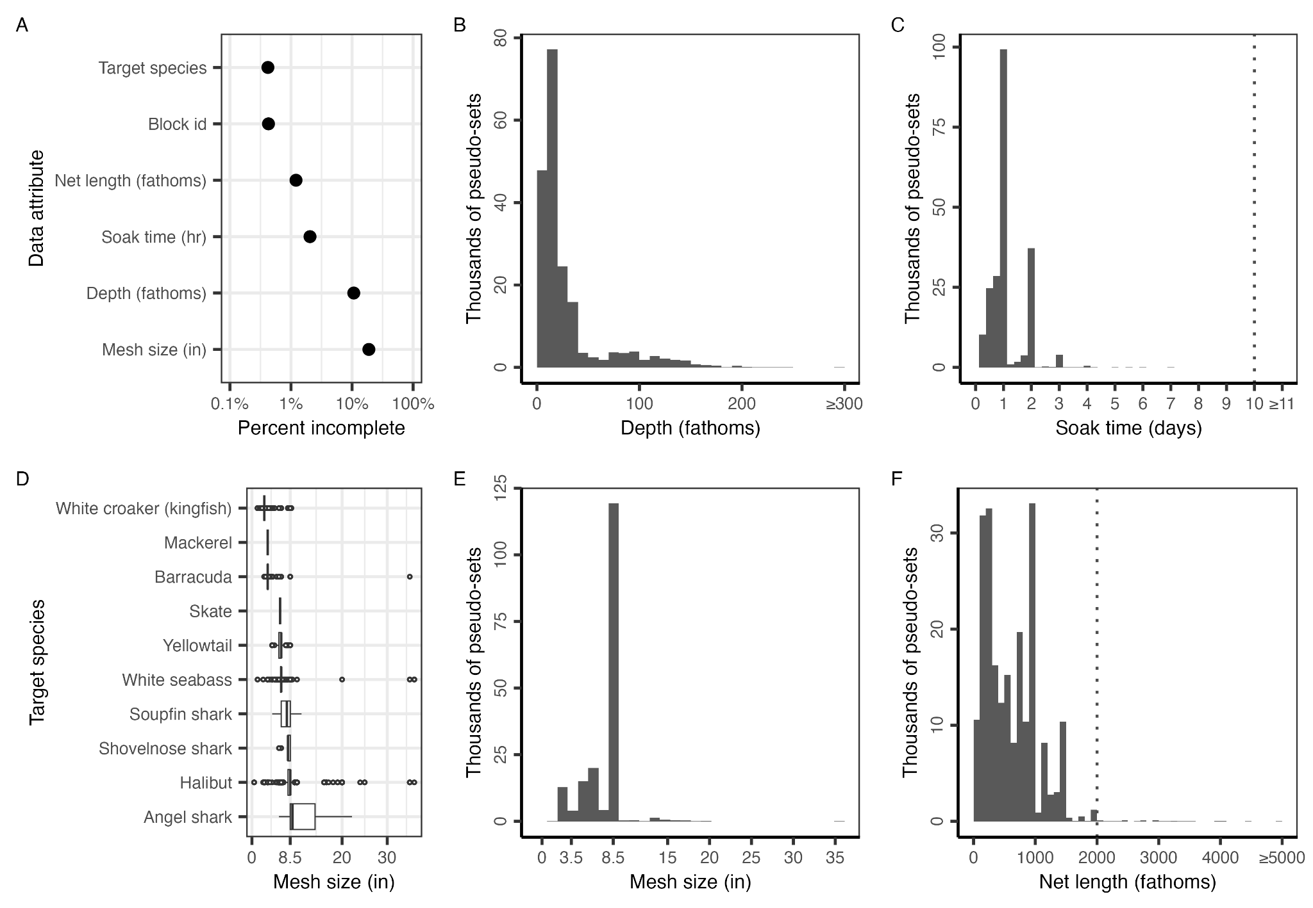**Fig. S5.** Traits of the set gillnet sets documented in the logbook data. Panel **A** shows the level of completeness of gillnet logbook metadata. Panel **B** shows the distribution of reported depths. Panel **C** shows the distribution of reported soak times. The maximum reported soak time in the observer data is 10 days; rare values larger than this value were assumed to be unrealistic and were capped at the maximum. Panel **D** shows the distribution of reported mesh sizes by reported target species. In the boxplots, the solid line indicates the median, the box indicates the interquartile range (IQR; 25th to 75th percentiles), the whiskers indicate 1.5 times the IQR, and points indicate outliers. Panel **E** shows the distribution of reported mesh sizes. Panel **F** shows the distribution of reported net lengths.

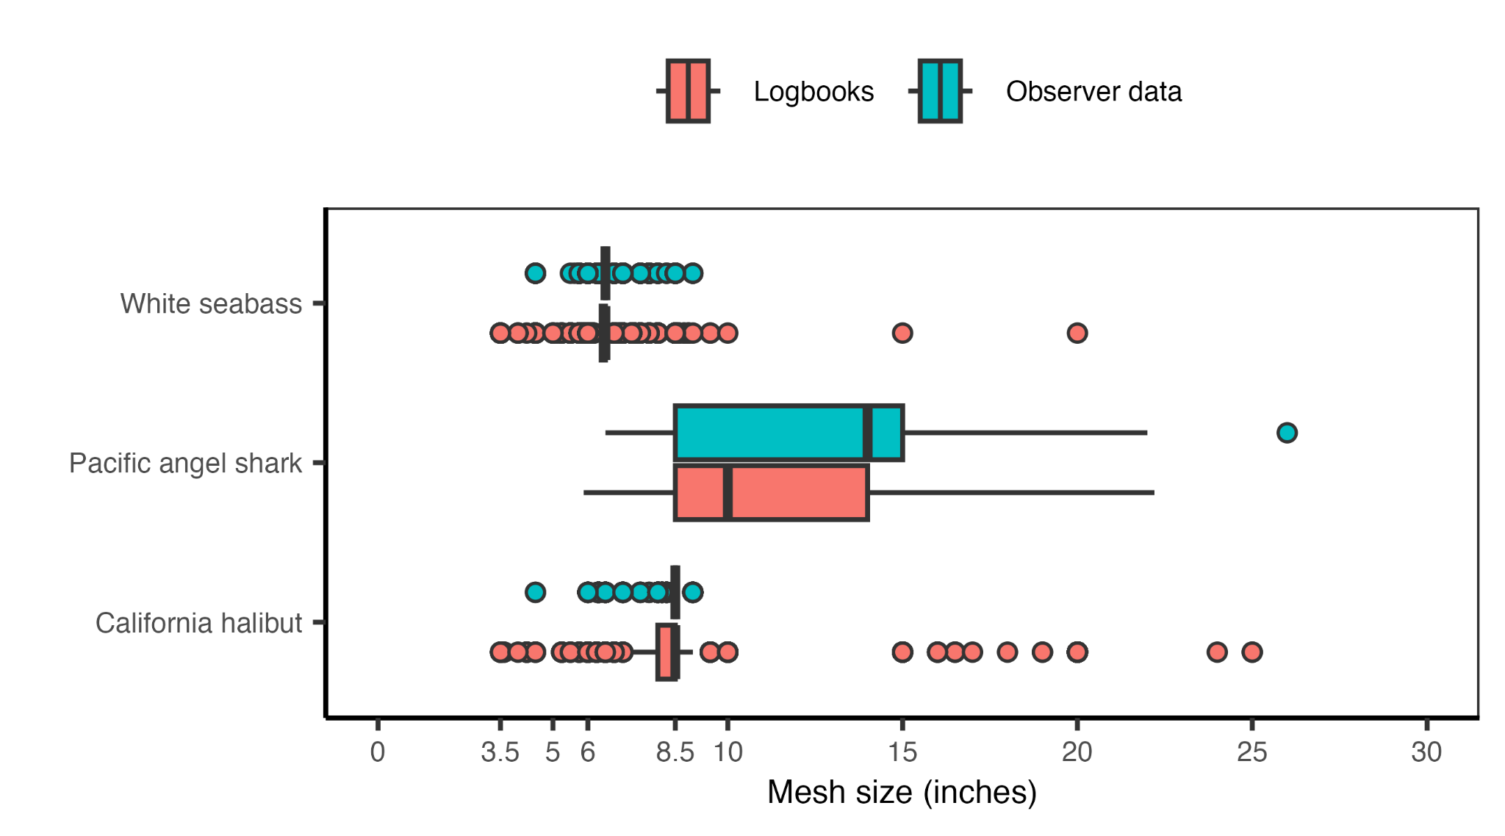

**Fig. S6.** Mesh size (inches) by target species in the logbook (red) and observer (blue) data. Since 1989, California halibut and Pacific angel shark can only be targeted using mesh sizes larger than 8.5 inches. White seabass are typically targeted using a minimum mesh size of 6.0 inches; however, a small amount of incidental take (<20% of catch and ≤10 individuals) in mesh sizes between 3.5 to 6.0 inches is allowed from June 16 to March 14 (14, § 155.10).

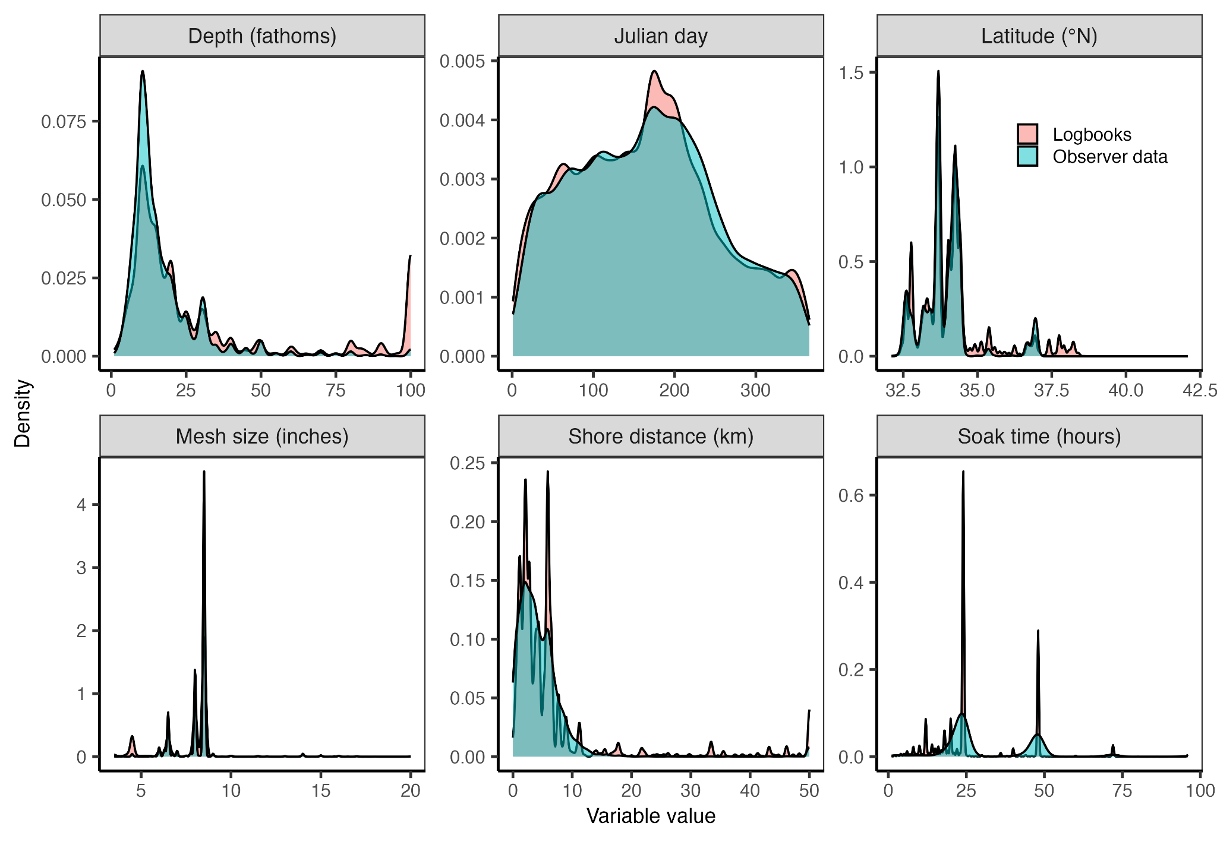**Fig. S7.** Comparison of key set traits in the logbook (red) and observer (blue) data. We used a two-sided Kolmogorov-Smirnov test to confirm that the traits of the logbook and observer data could have come from the same probability distribution (all p-values < 0.001).

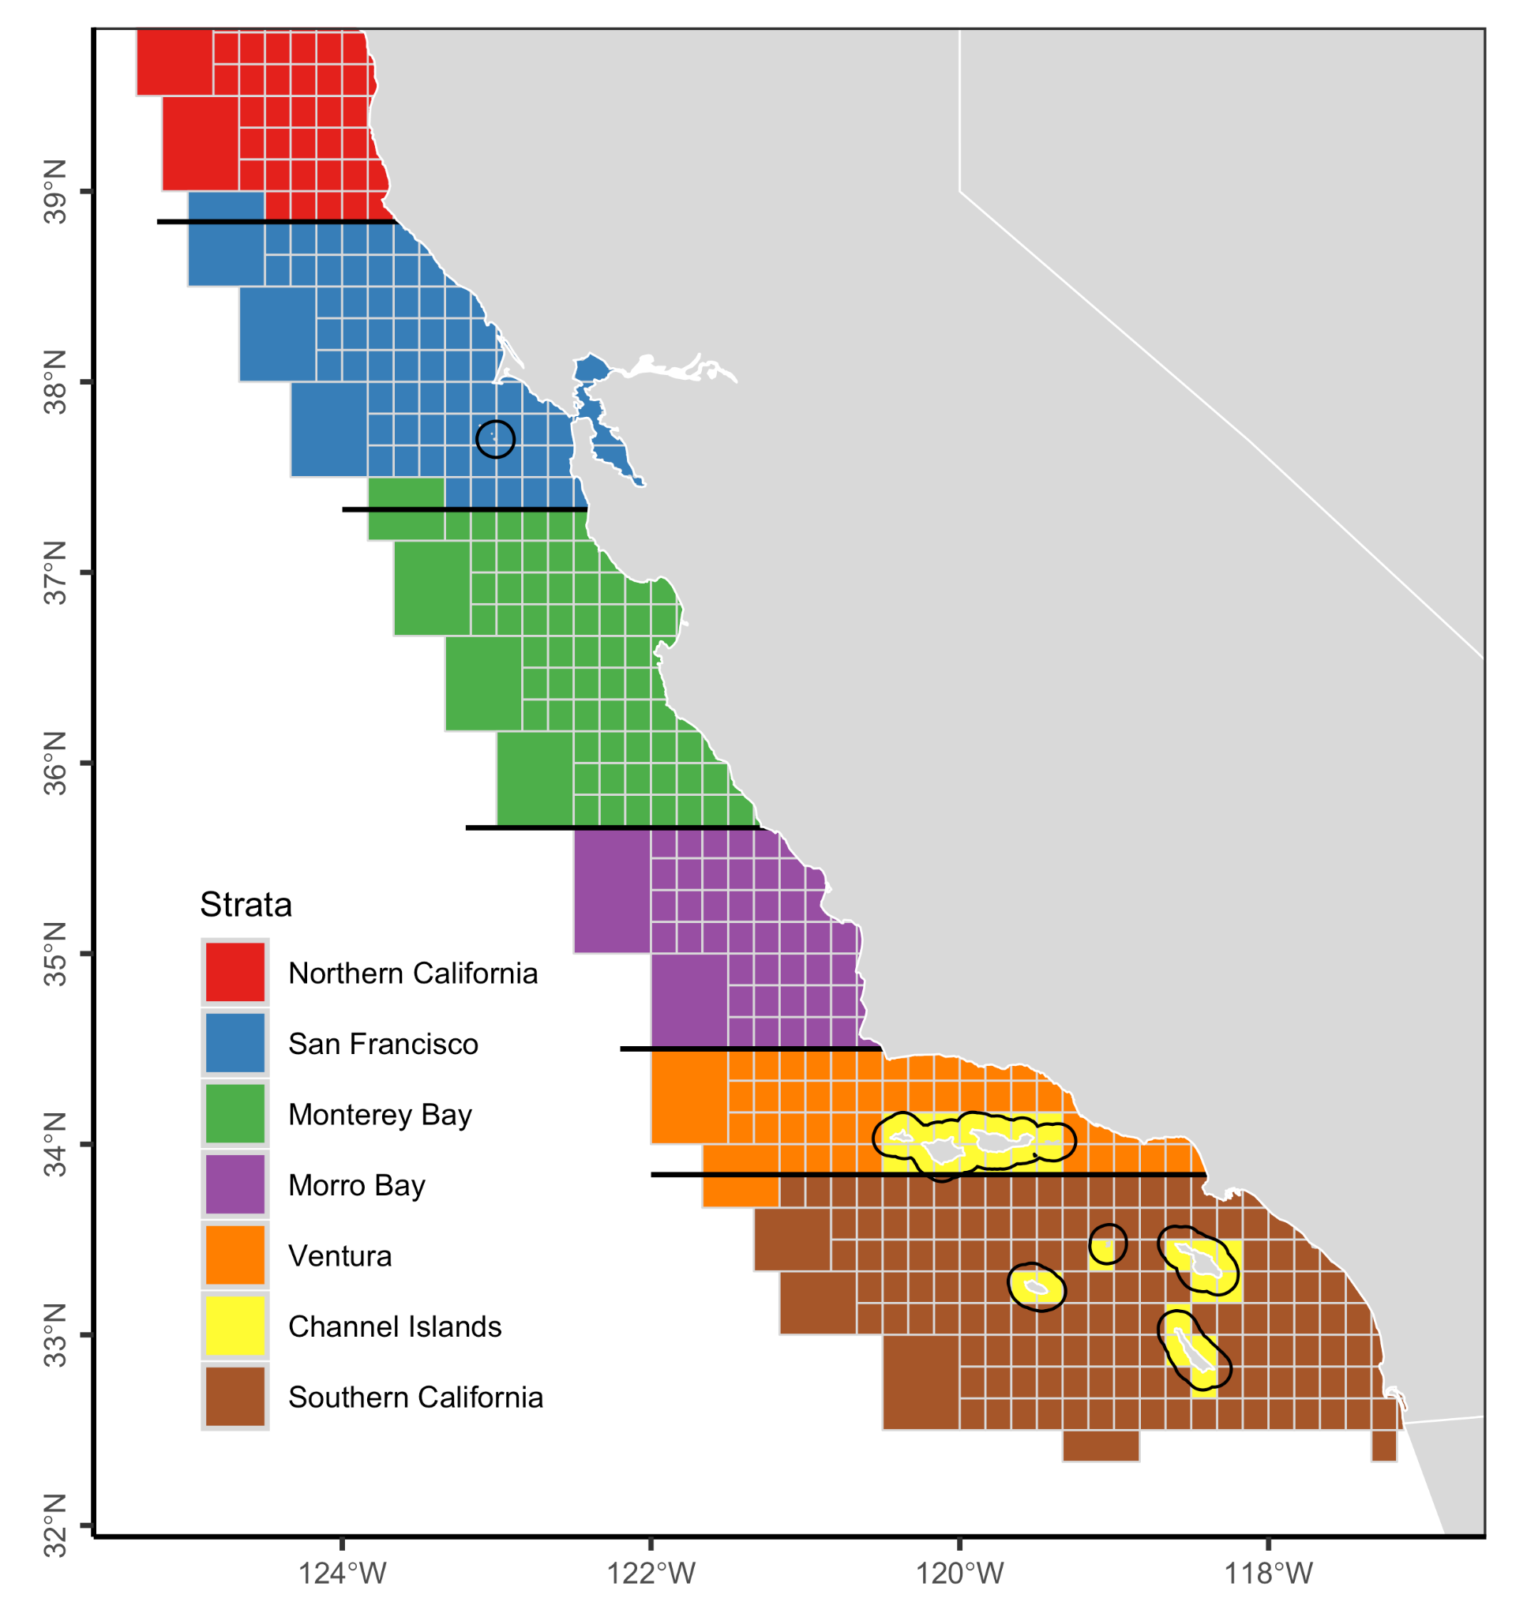

**Fig. S8.** The regional stratification scheme used throughout the analysis. The stratification scheme north of Point Conception was originally proposed by Diamond and Hanan (1986). The stratification scheme south of Point Conception was originally proposed by Julian (1993). The dark black lines around the Channel Islands show the 10 km buffer used to identify island-associated fishing trips.

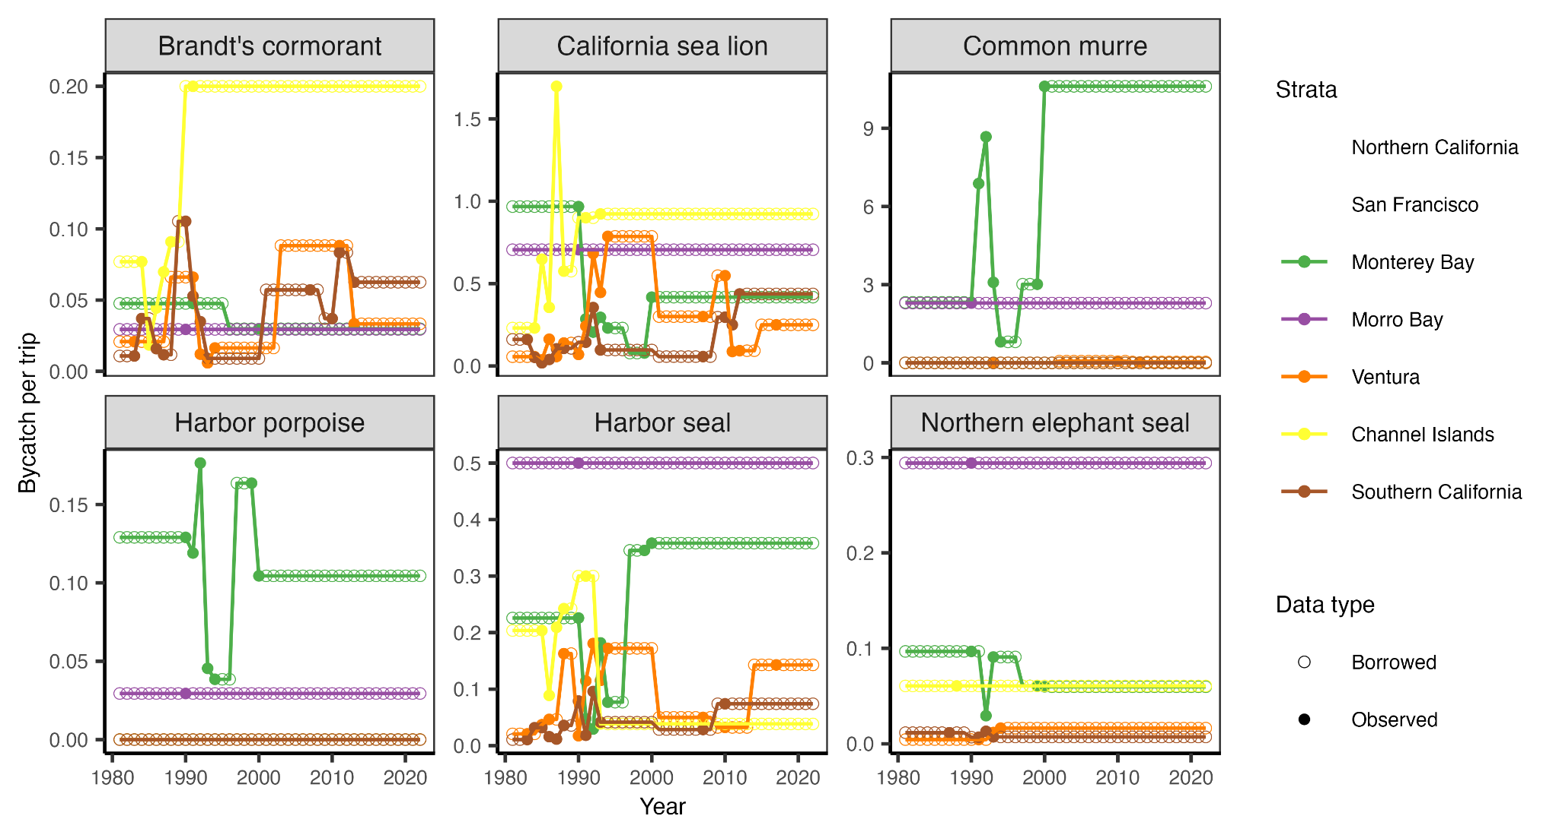**Fig. S9.** Annual bycatch rates by species and regional strata as assumed in the ratio estimation analysis. Solid circles indicate years with observer data and open circles indicate years whose bycatch rates are borrowed from the closest year with observer data. See **Figs. 1A** **and S8** for maps of the regional strata.

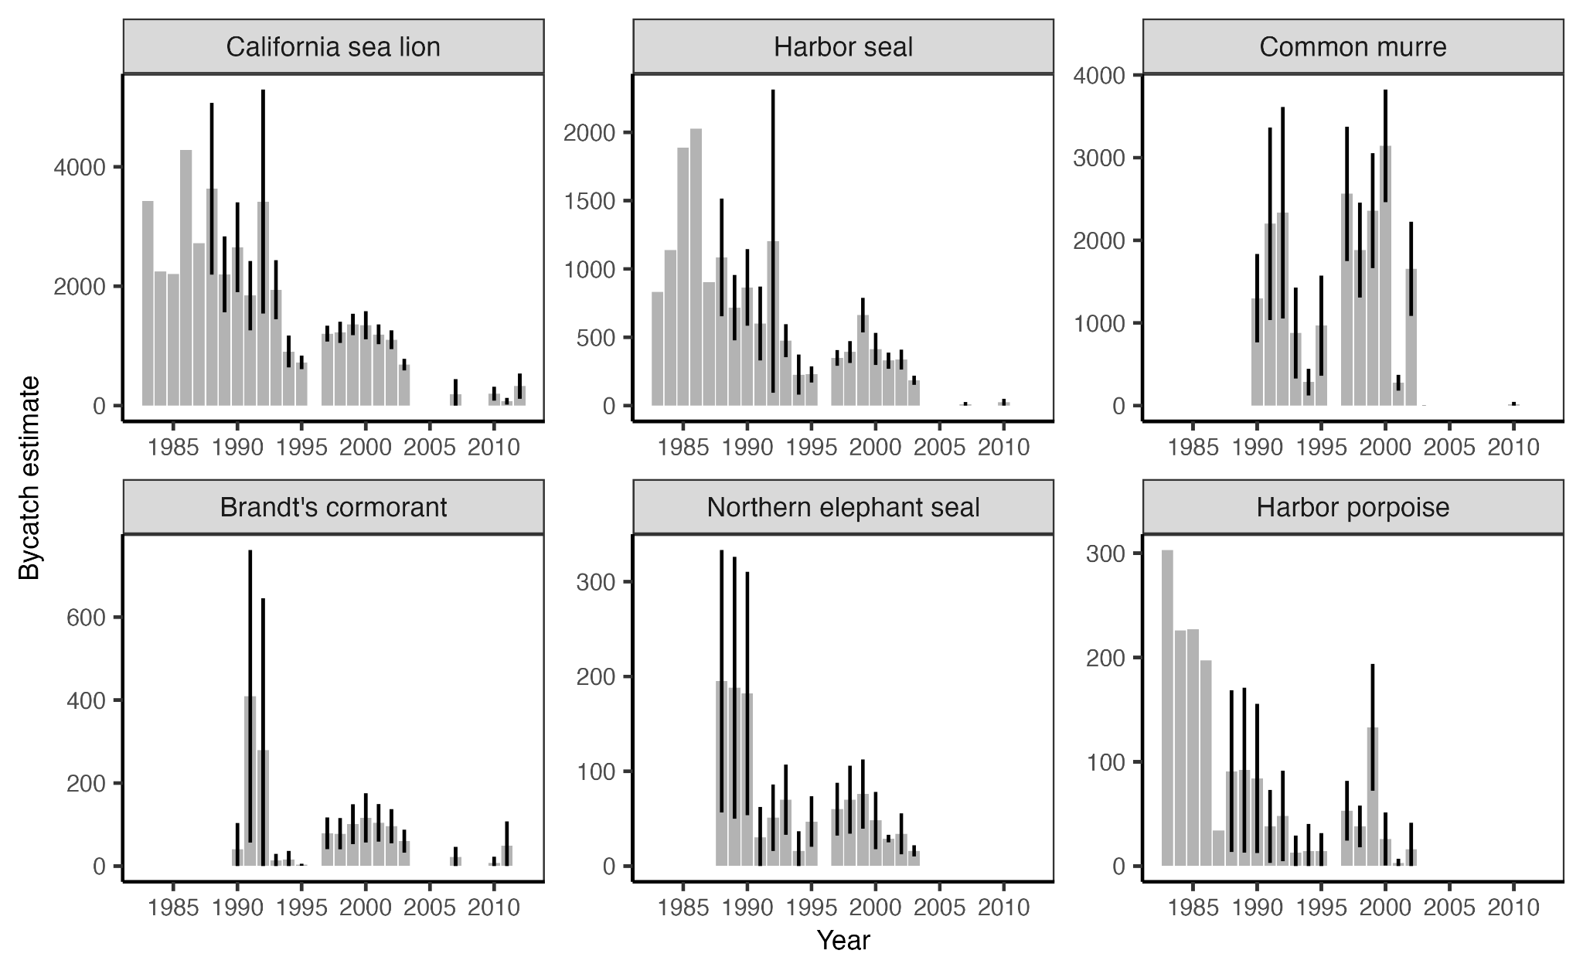

**Fig. S10.** Estimates of annual bycatch from historical studies. Error bars indicate 95% confidence intervals. See **Table 1** for the sources of these estimates.

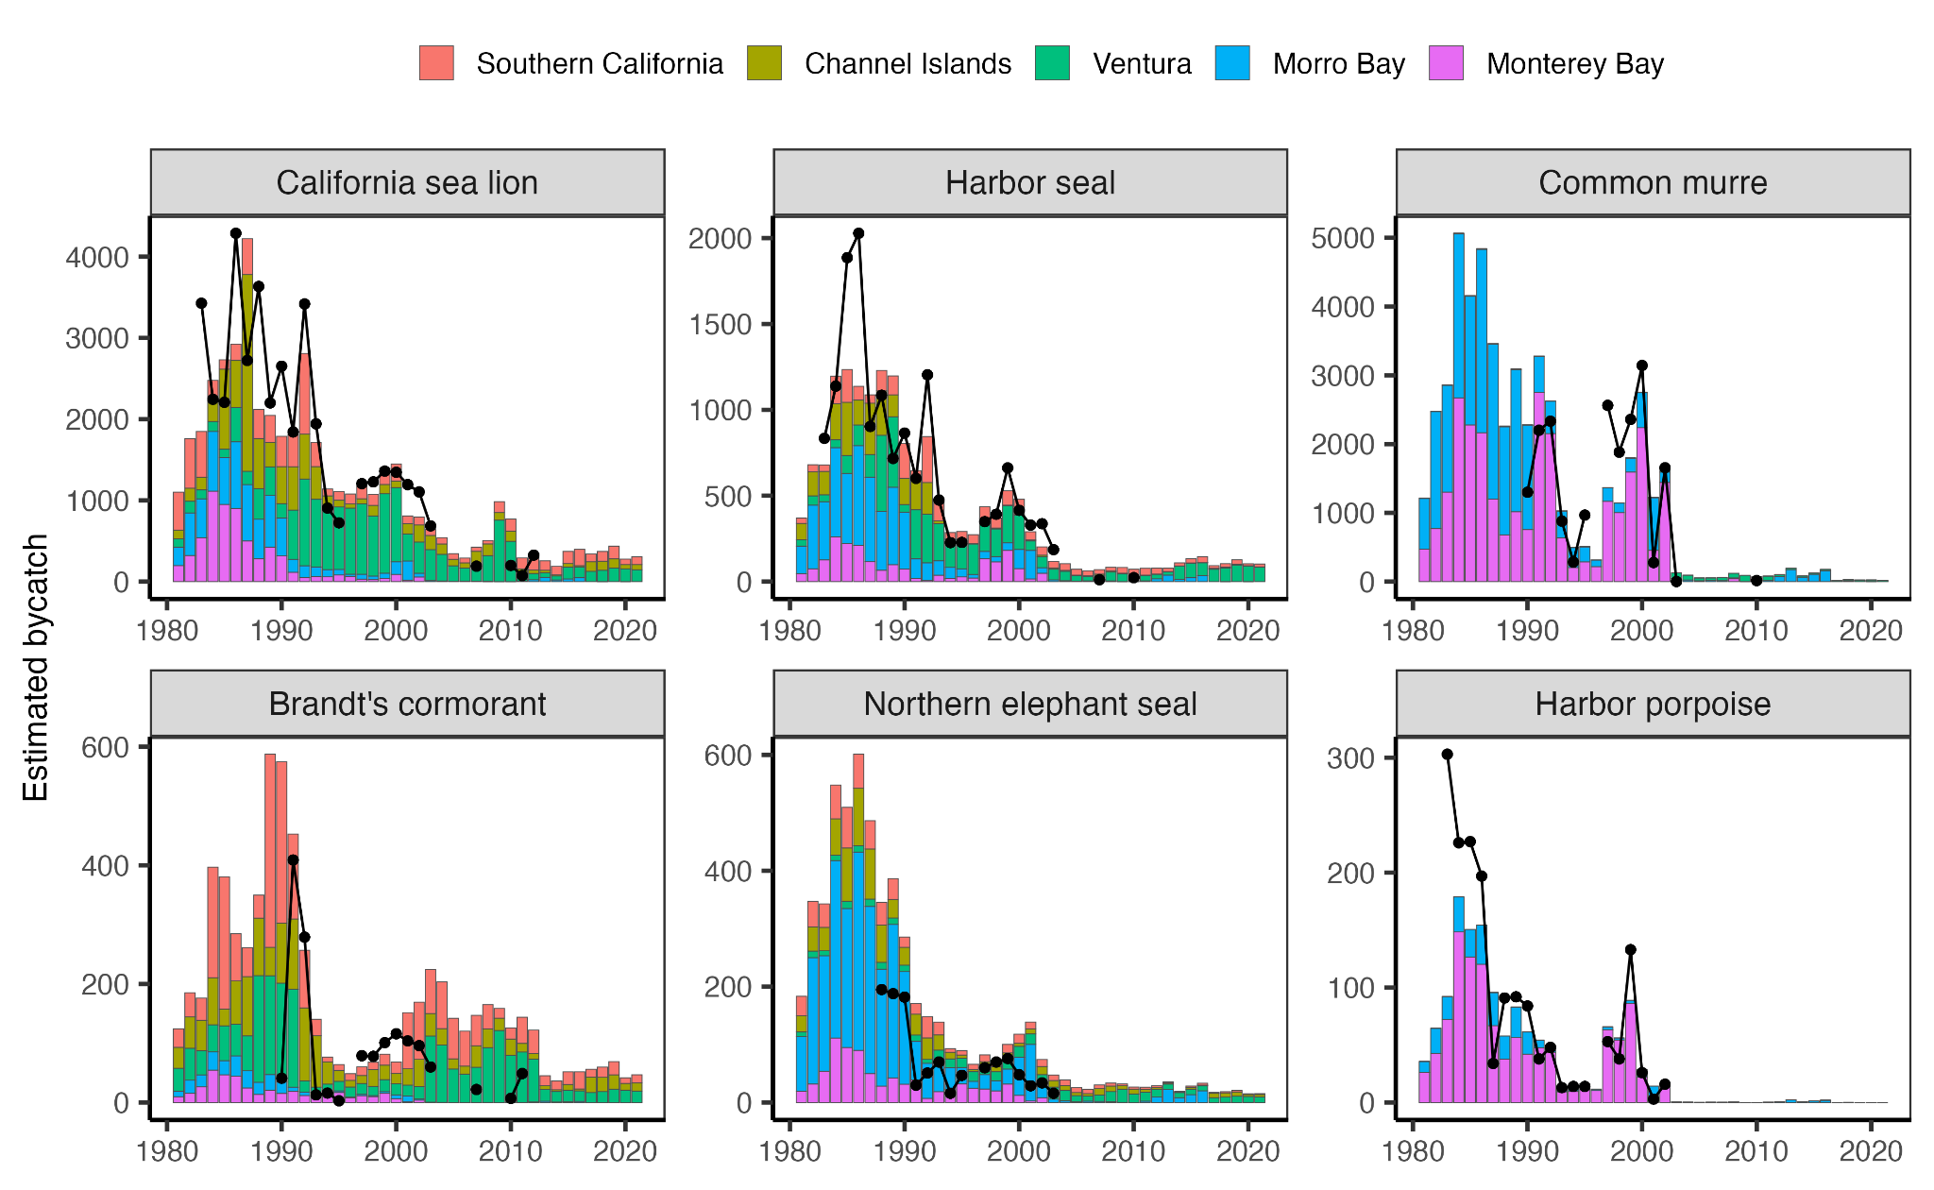**Fig. S11.** A comparison of estimates of annual bycatch from our study (bars) and historical studies (points and lines). Potential reasons for these differences are explored in **Fig. S12**.

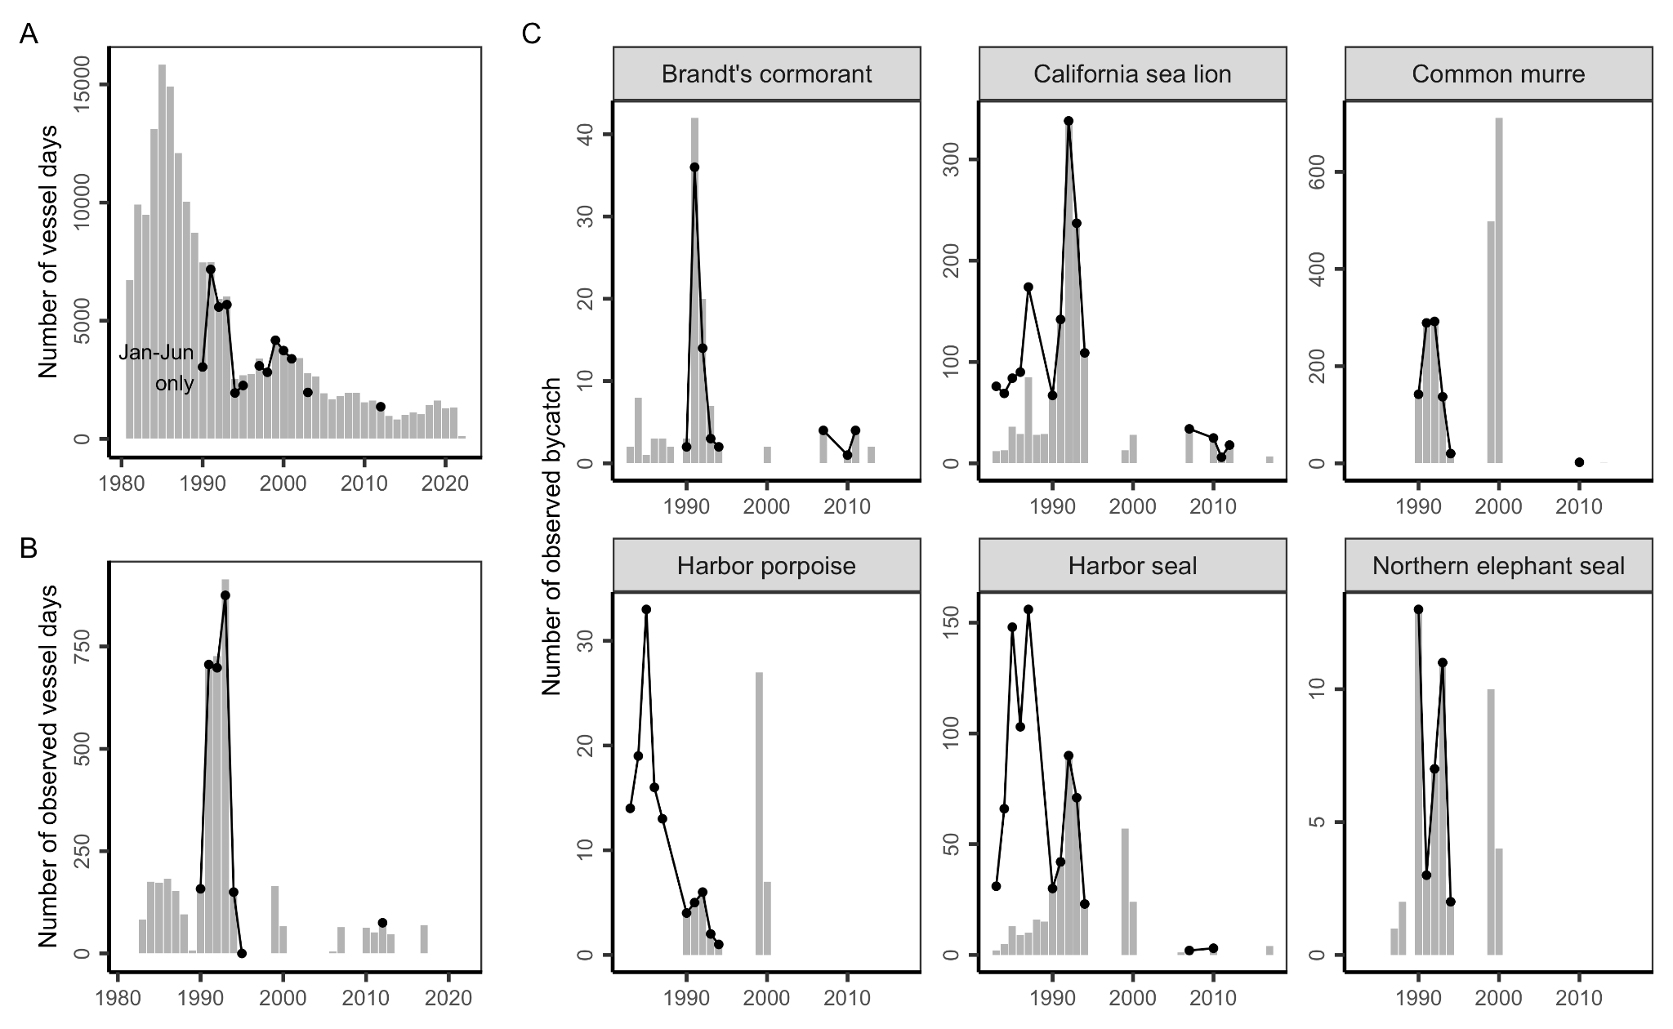

**Fig. S12.** A comparison of historical **(A)** fishing effort (number of vessel days); **(B)** observer coverage (number of observed vessel days); and **(C)** observer records (number of observed bycatch) derived in our analysis (bars) and reported in historical studies (points and lines). These time series represent the key inputs into the ratio estimation analysis and help to explain the differences between the estimates of annual bycatch derived in our study as compared to historical studies (see **Fig. S11**). See **Table 1** for additional details on historical studies.

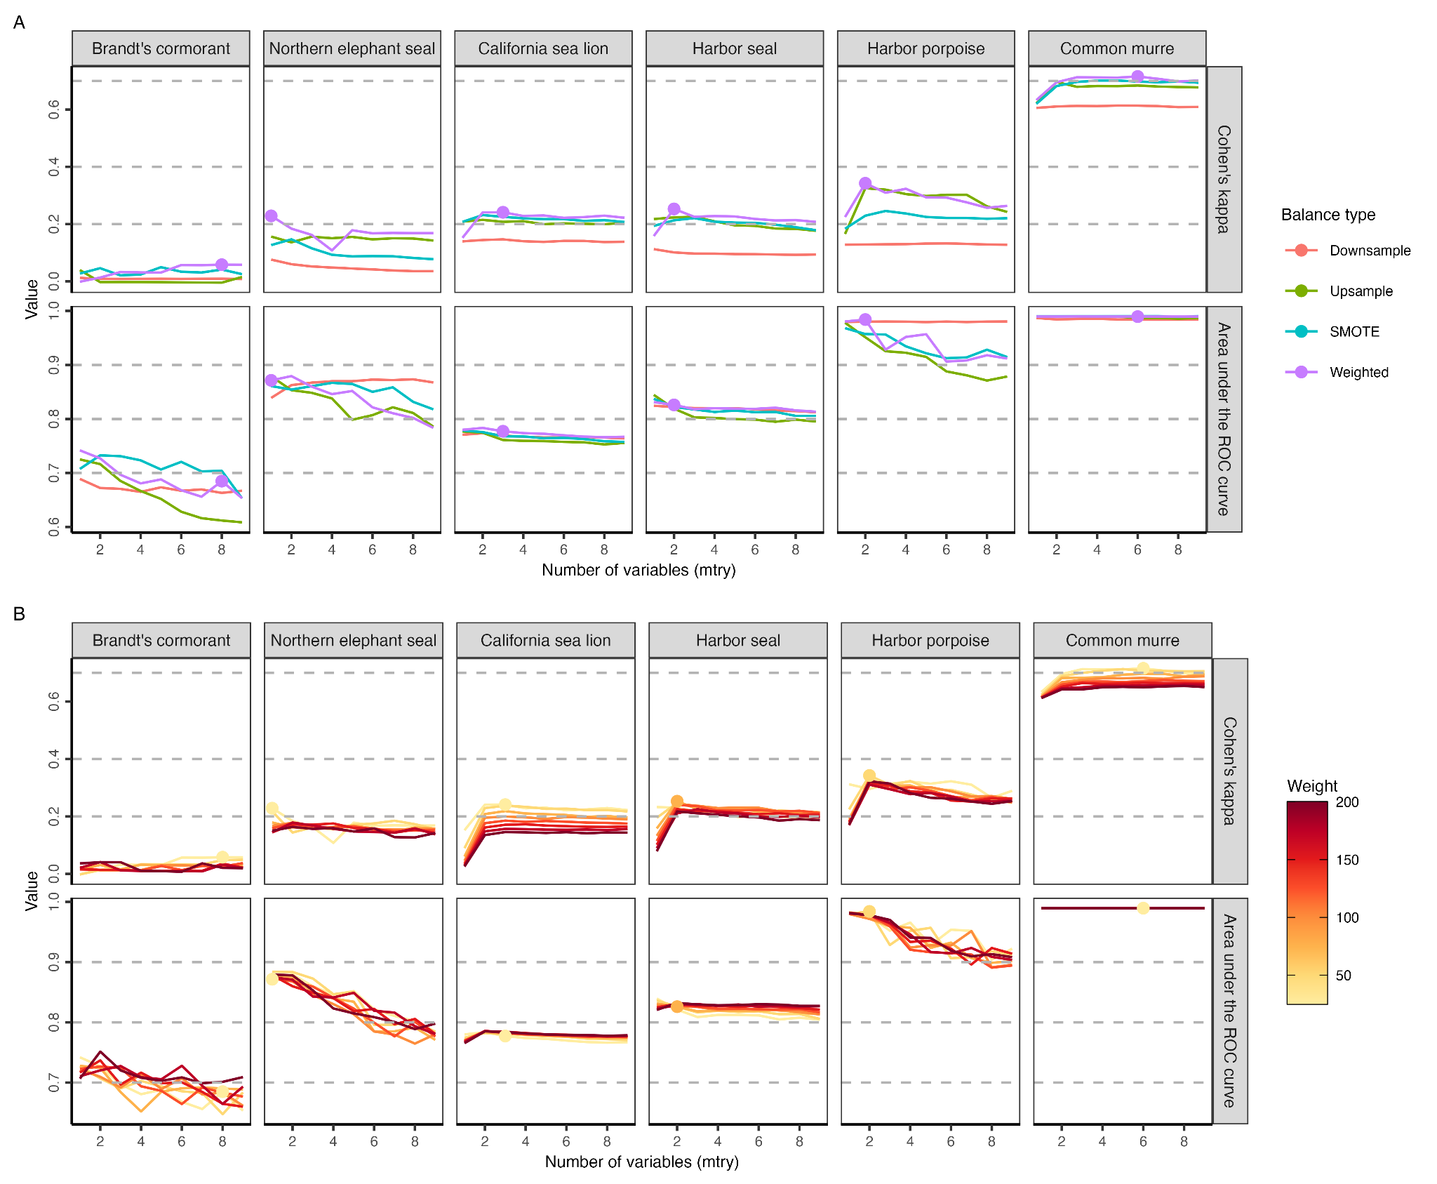

**Fig. S13.** A comparison of the model performance as measured through cross-validation on the training dataset between (**A**) balanced random forest modeling approaches and (**B**) weighted random forest modeling approaches for all candidate bycatch species (i.e., observer records > 50). We evaluated the model performance using Cohen’s kappa and area under the receiver operator curve (ROC) and selected the model with the highest Cohen’s kappa as the best performing model (labeled in the plot). We excluded Brandt’s cormorant in the model prediction as their Cohen’s kappa (<0.1) is too low to produce reliable predictions.

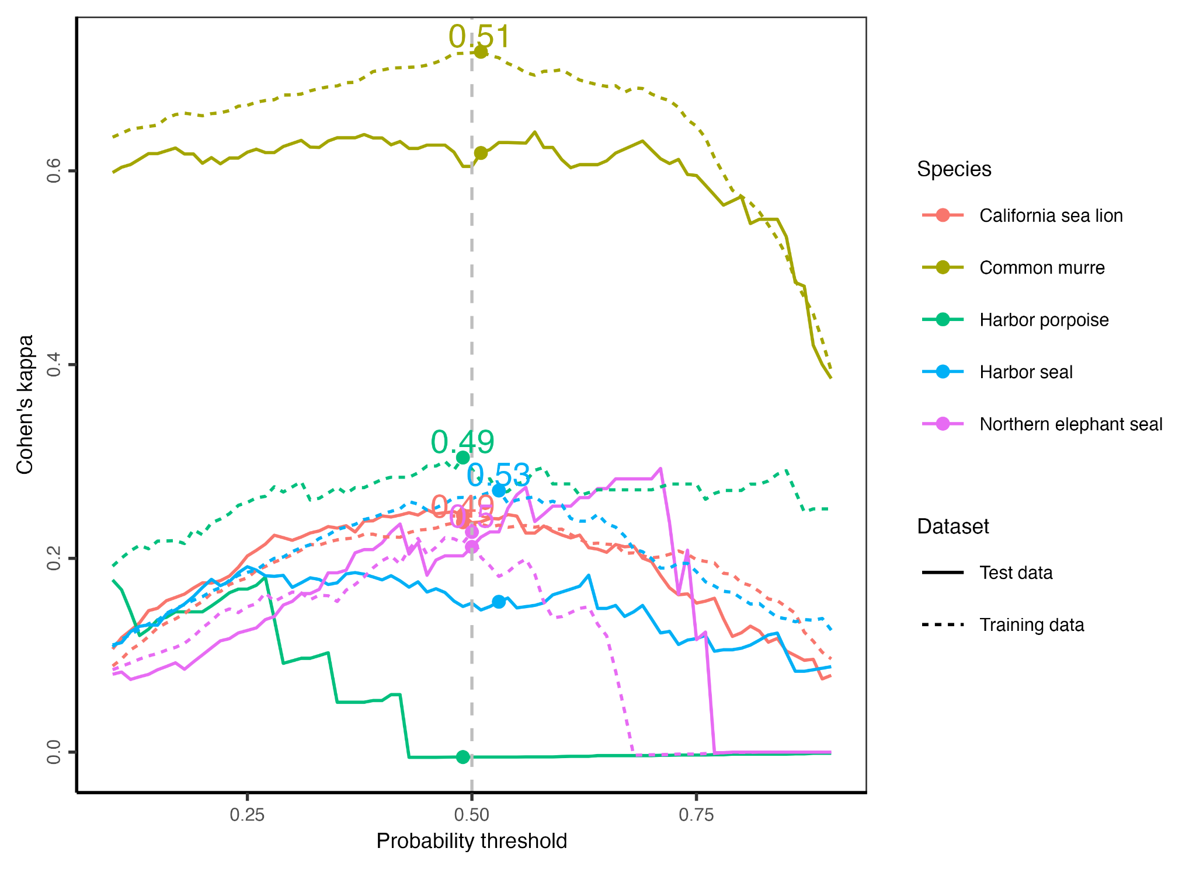

**Fig. S14.** Illustration of the methods used to select a probability threshold for classifying a logged set as having or not having bycatch. We selected the probability threshold that maximizes Cohen’s kappa when applied to the training data as the optimal threshold (labeled in plot). We highlight the performance of this threshold when used on the independent test data to illustrate performance on out-of-sample data.

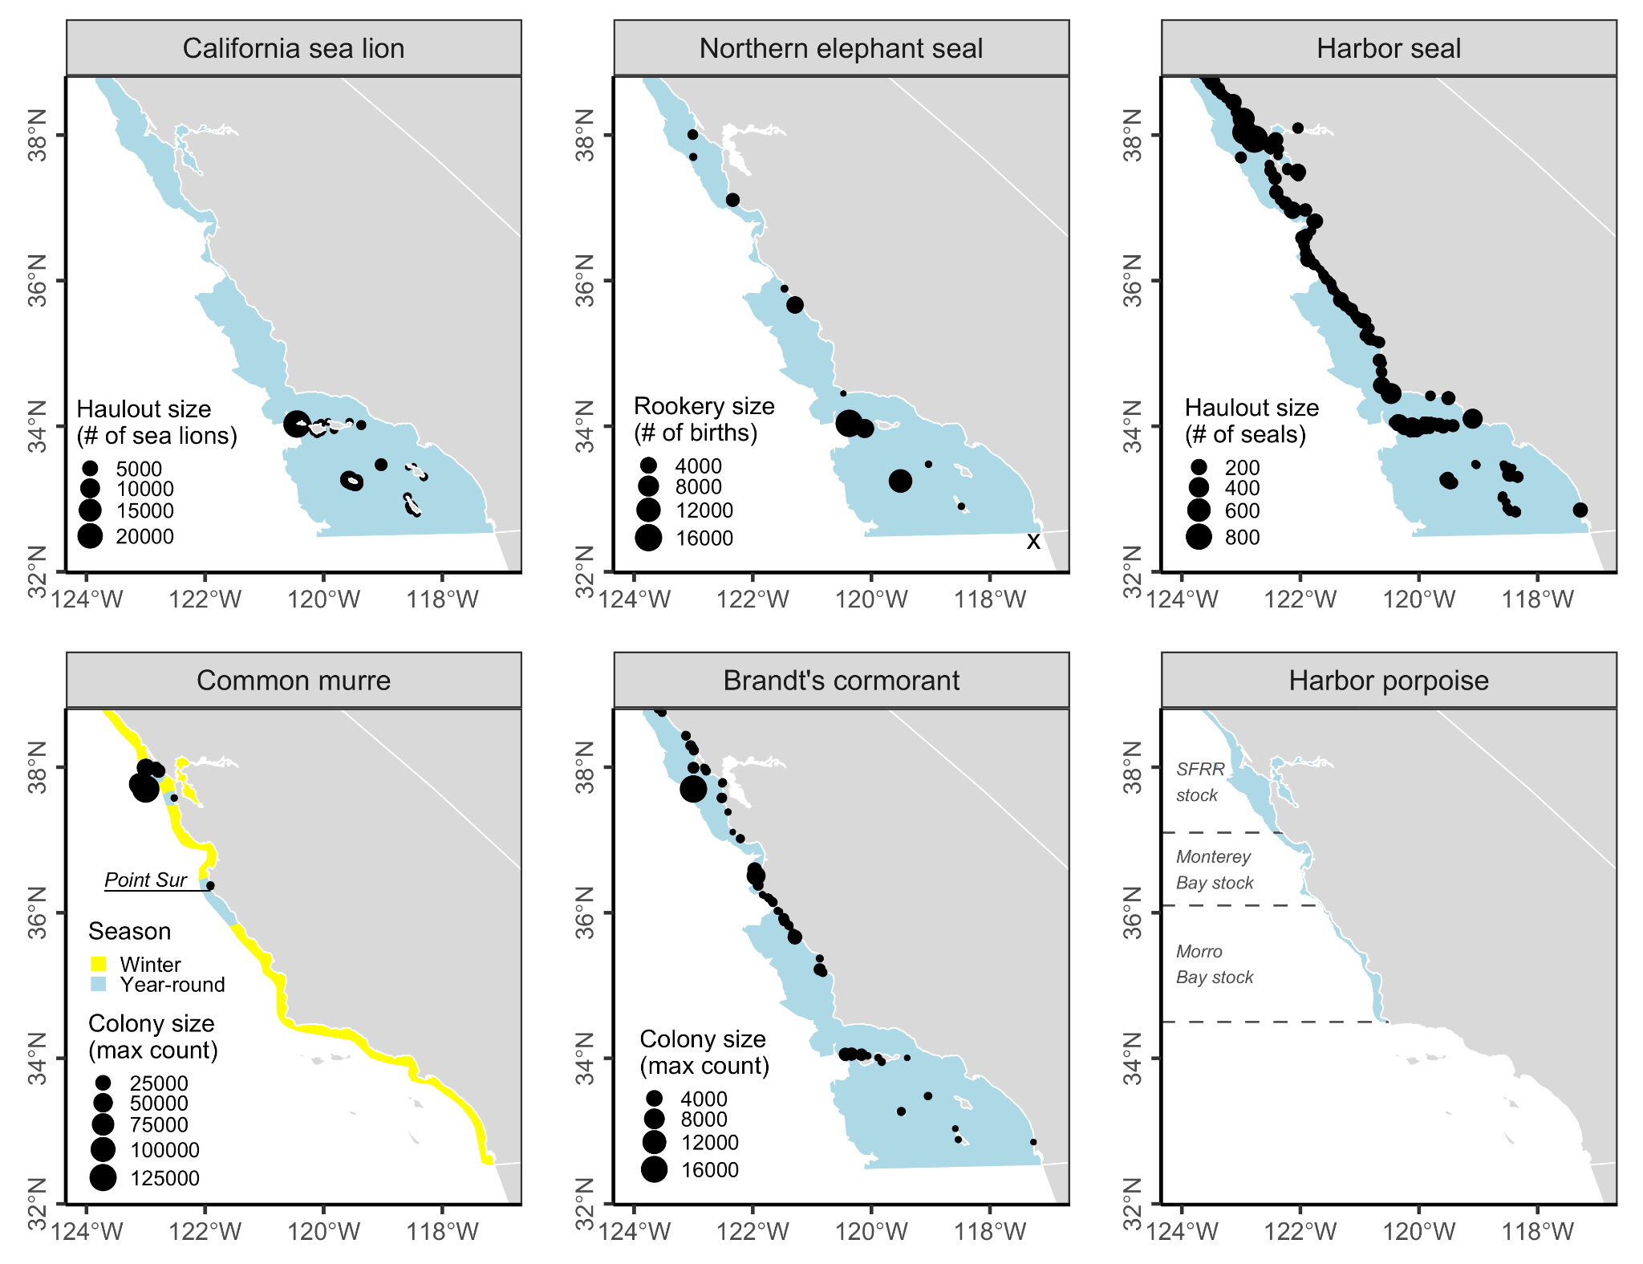

**Fig. S15.** Ranges of the six study species and information on haulout and colony size for selected species. Blue colors indicate year-round ranges and yellow colors (common murre only) indicate winter ranges. The range maps for all species except harbor porpoise are from the California Wildlife Habitat Relationship System [(CDFW, 2021)](https://www.zotero.org/google-docs/?IsKU5j). Harbor porpoises occur in waters less than 50 fathoms (92 meters) deep north of Point Conception [(Forney et al., 2014)](https://www.zotero.org/google-docs/?5GJgFb). SFRR indicates the San Francisco-Russian River harbor porpoise stock. Common murre and Brandt’s cormorant colony counts are from the California Seabird Colony Database [(CDFW, 2010)](https://www.zotero.org/google-docs/?BEfy3C). There are no historical breeding records for common murre south of Point Sur except for at the Prince Island colony in Cuyler Harbor of San Miguel Island. Harbor seal haulout counts are from the CDFW Harbor Seal GIS dataset [(CDFW, 2014)](https://www.zotero.org/google-docs/?LBFdsX).

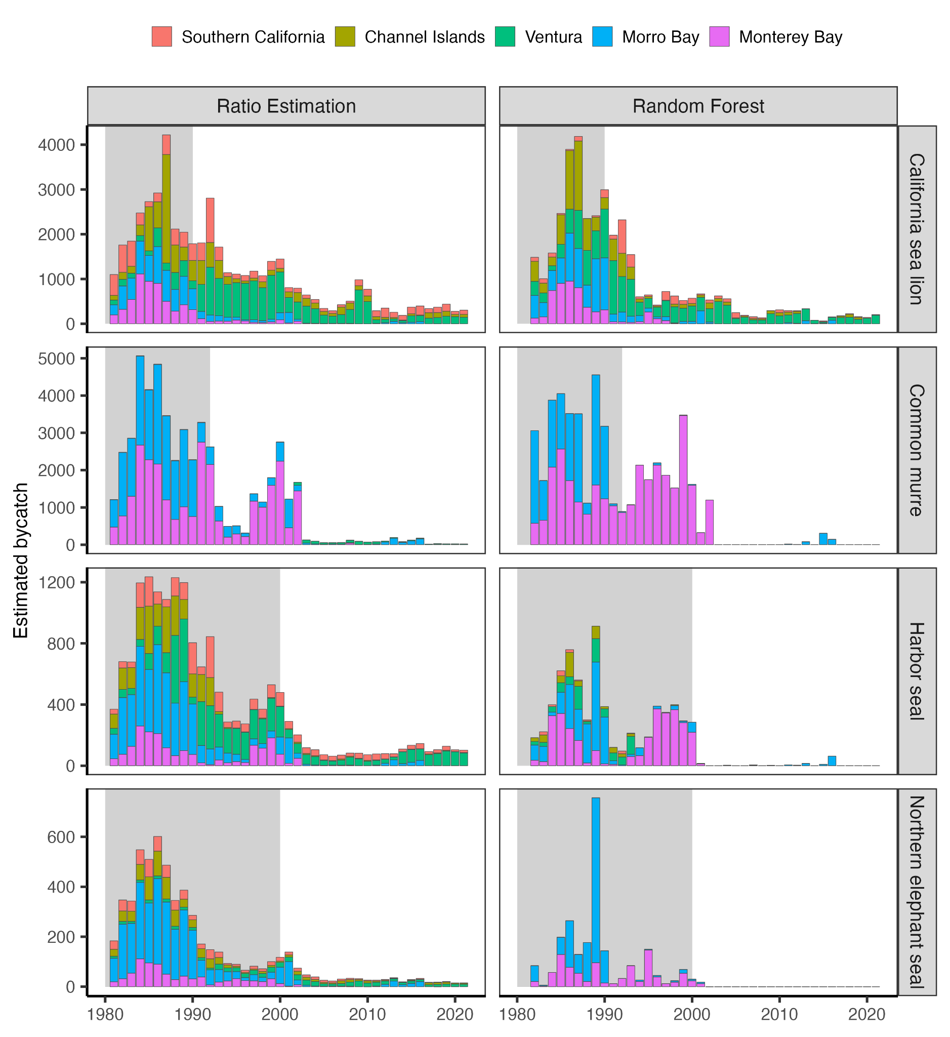

**Fig. S16.** A comparison of estimated bycatch numbers between ratio estimation and random forest stratified by regions (**Fig. S8**). The major differences between years are highlighted in gray.

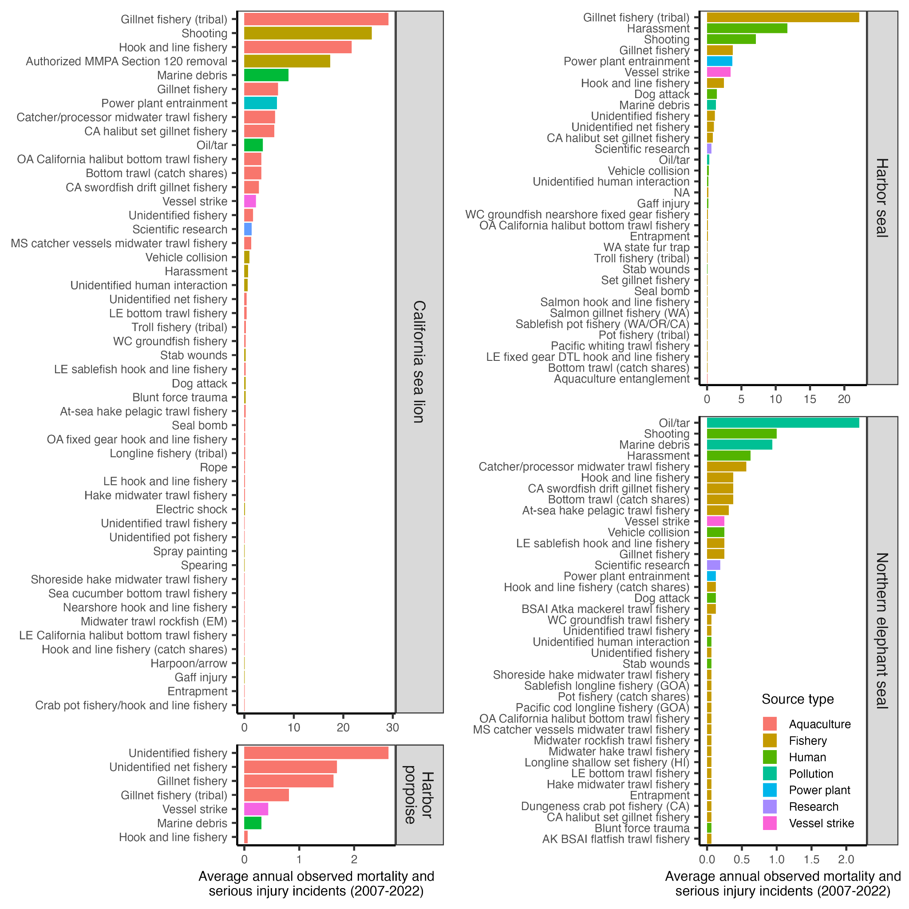

**Fig. S17.** Average annual observed mortality and serious injury incidents by source on the entire U.S. West Coast between 2007-2022 [(Carretta, 2023)](https://www.zotero.org/google-docs/?gmH6mU).